Further Studies of Roundabouts:
Hutchinson, Kansas Study

Sudhakar Sathyanarayanan, Graduate Student,
Civil Engineering
Eugene R. Russell, Professor, Civil Engineering
Margaret J. Rys, Associate Professor, Industrial and Manufacturing Systems Engineering
Kansas State University

Table of Contents
List of figures 8
List of Tables 10
Acknowledgements 11
Dedication 12
1 Introduction 13
1.1 General 13
1.2 Study objective 17
1.3 Organization of the report 18
1.4 Units of measure 19
2 Literature Review 20
2.1 General 20
2.2 Intersection design characteristics 20
2.3 Types of intersection controls 23
2.4 Modern roundabouts 27
2.4.1 Characteristics of modern roundabouts 28
2.4.2 Appropriate and inappropriate sites for modern roundabouts 33
2.5 Two-way stop control (TWSC) 35
2.6 All-way stop control (AWSC) 36
2.7 Traffic signal control (TSC) 37
2.7.1 Types of Traffic Signal controller 38
2.8 Intersection with wider medians 41
2.9 Measures of effectiveness (MOE) 42
2.10 Computer software – Analysis tools 44
2.10.1 SIDRA 46
2.10.2 TRANSYT - 7F 51
2.11 Safety 52
2.12 Public opinion about modern roundabouts 57
2.13 Summary 59
3 Experimental Design 60
3.1 General 60
3.2 Data collection 60
3.3 Data analysis 63
3.3.1 Statistical analysis overview 65
3.4 Summary 66

4 Data Collection 68
4.1 General 68
4.2 Site description 68
4.2 State fair traffic flow 70
4.3 Two-way stop control - Before condition 70
4.3.1 Crash History- Before condition 71
4.3.2 Geometric parameters - Before condition 72
4.4 The Hutchinson Modern roundabout – After Condition 73
4.4.1 Crash history - After condition 73
4.4.2 Geometric parameters- After condition 74
4.5 Hourly volumes 75
5 Data analysis i -operational analysis 79
5.1 General 79
5.2 Operational analysis 80
5.3 Comparison analysis 80
5.4 Approach performance 84
5.5 Level of service (LOS) 86
5.6 Summary 87
6 Data analysis ii –safety analysis 88
6.1 General 88
6.2 Safety evaluation for the study site 88
6.3 Summary 89
7 Data analysis iii – Theoretical analysis 90
7.1 General 90
7.2 Comparability of the intersection types 90
7.3 Data and Analysis 91
7.3.1 Approach performance 95
7.3.2 Level of service 98
7.4 Data analysis – theoretically increased traffic loading 101
7.4.1 95th Percentile queue length 102
7.4.2 Average intersection delay 103
7.4.3 Level of service (LOS) 104
7.5 Design life analysis 104
7.6 Summary 105
8 Summary and Conclusions 106
8.1 Summary 106
8.2 Conclusions 108
8.3 Area of further research 110
References 111
Appendix A-Initial statistical analysis 117
A.1 General 117
A.2 Summary of statistical test to check for the assumptions of F-Test 117
A.3 Summary 123
Appendix B - Traffic Signal Design 124
B.1 General 124
B.2 Summary of data and assumptions 124
B.2 Design hourly volume 125
B.3 Type of signal operation 125
B.5 Left-turn movements 128
B.5 Phase plan 128
B.6 Timings 129
B.7 Summary 130

List of figures

Figure 1.1 Intersection physical and functional areas 14
Figure 2.1 Intersection traffic control types and peak-hour volumes 26
Figure 2.2 View of Columbus circle, Circa 1915 27
Figure 2.3 Roundabout, neighborhood traffic circle and rotary 29
Figure 2.4 Geometric elements of a modern roundabout 30
Figure 2.5 Conflicts points at conventional intersection and a roundabout 54
Figure 2.6 Common crash patterns in a singlelane modern roundabout 56
Figure 3.1 Camera mounted on a lamp pole 61
Figure 3.2 VCR/TV signal steel cabinet 61
Figure 3.3 Pre-prepared volume counts mark sheet 63
Figure 3.4 Excel spreadsheet: Summary of visual data extracted from videotape 64
Figure 4.1 Two-way stop control at 23rd Ave and Severance St view from south approach 69
Figure 4.2 Hutchinson Modern roundabout 69
Figure 4.3 Routes for the traffic from east to the fair parking lots 71
Figure 4.4 Collision diagram-Before condition 72
Figure 4.5 Two-way stop control at 23rd Ave and Severance St view from east approach 73
Figure 4.6 Hutchinson modern roundabout at 23rd and Severance: view from the east exit 74
Figure 4.7 Collision diagram - After condition 75
Figure 4.8 Traffic volume variations on an average day 78
Figure 5.1 Maximum proportion stopped approach (TWSC) 85
Figure 5.2 Maximum proportion stopped approach (RA) 85
Figure 5.3 Level of service (TWSC) 87
Figure 7.1 Maximum proportion stopped approach (RA) 96
Figure 7.2 Maximum proportion stopped approach (TWSC) 96
Figure 7.3 Maximum proportion stopped approach (AWSC) 97
Figure 7.4 Maximum proportion stopped approach (TSC) 97
Figure 7.5 Level of service (TWSC) 98
Figure 7.6 Level of service (AWSC) 99
Figure 7.7 Level of service (TSC) 99
Figure 7.8 95th Percentile queue lengths for varying flow scales for various intersection types 102
Figure 7.9Average intersection delay (sec) for varying flow scales for various intersection types 103
Figure 7.10 Degree of saturation for varying flow scales for various intersection type 105
Figure A.1 Shapiro-Wilk Normality Test for Before condition 119
Figure A.2 Shapiro-Wilk Normality Test for After condition 120
Figure A.3 Shapiro-Wilk Normality Test for After fair condition 120
Figure A.4 Levene equality of variance test (Before and After) 121
Figure A.5 Levene equality of variance test (Before and After fair) 122
Figure B.1 Volume and segment length combinations that define isolated and non-isolated operation 127
Figure B.3 Phase diagram 129

List of Tables

Table 2.1 Intersection measures of effectiveness 49
Table 4.1 Descriptive statistics for the observed hourly traffic volumes 77
Table 5.2 Minitab output: Kruskal Wallis summary comparing 95th percentile queue length between TWSC and RA 80
Table 5.1 Descriptive statistics of the moes 81
Table 5.4 Summary of comparison results (TWSC vs RA) 82
Table 5.3 Summary of statistical test to compare TWSC and RA 83
Table 5.5 Summary of intersection performance with respect to hourly entering volume & los - twsc 86
Table 7.1 Summary of statistical test to compare RA, TWSC, AWSC and TSC 93
Table 7.2 Summary of results (TWSC and RA) 94
Table 7.3 Summary of results (AWSC and RA) 94
Table 7.4 Summary of results (TSC and RA) 95
Table 7.5 Summary of intersection performance with respect to hourly entering volume (twsc) 100
Table 7.6 Summary of intersection performance with respect to hourly entering volume (awsc) 100
Table 7.7 Summary of intersection performance with respect to hourly entering volume (TSC) 100
Table A.1 Overview of statistical test 118
Table A.2 Summary of anova (before vs after) 122
Table A.3 Summary of anova (before vs after fair) 123
Table B.1 Typical peak hour turning movement counts at 23rd Avenue and Severance street Condition: TWSC 126
Table B.2 Design turning movement counts (50% increased) used for optimizing the cycle length at 23rd Ave and Severance St 126
Table B.3 Transyt-7F output: traffic signal timing table 130

Acknowledgements
Dr. Eugene R. Russell is thanked for giving me an opportunity to work as a graduate research assistant, for supporting me throughout my Master of Science program at Kansas State University, and for making me realize and understand my academic limitations. Mack-Blackwell National Rural Transportation Study Center, Fayetteville, Arkansas, and the Kansas Department of Transportation are thanked for sponsoring this research study. I would also like to thank my committee members, Dr. Margaret R. Rys and Dr. Robert W. Stokes for their guidance and suggestions in this research. Thanks to all graduate research assistants who assisted in the data collection process. I would like to extend my thanks to the staffs in the Engineering Department, City of Hutchinson, KS and Engineering Department, City of Manhattan, KS, who were gracious enough to share information.
I would like to thank my parents, family members and friends who helped me receive a good education in the United States of America. Finally, I would like to express my sincere thanks to Dr. N.T. Rao, who gave me extra motivation to work in the field of Traffic and Transportation Engineering during my undergraduate studies. . .

Dedication

This study is dedicated to those who lost their life or suffered incapacitating injuries as a result of automobile crashes at highway intersections in the United States of America. .

1 Introduction

1.1 General
An intersection in highway engineering may be defined in many ways. The American Association of State Highway and Transportation Officials (AASHTO) refer to an intersection by its physical and functional areas [AASHTO 2001]. The physical area of the intersection is the area where two or more highways join or cross including the roadway and roadside facilities for traffic movements. The functional area of the intersection includes the areas of any auxiliary lanes and their associated channelization (see Figure 1.1). The Highway Capacity Manual (HCM) implies that highway intersections are subsets of interrupted-flow facilities that have controlled and uncontrolled access points that can interrupt the traffic flow [HCM 2000]. These access points include intersections without any control, traffic signals controls, stop signs controls, yield signs controls, modern roundabouts or other controlling devices that predominantly stops/slows traffic irrespective of the amount of traffic. Others define intersections as an area of concentrated conflicts points between vehicles and, between vehicles and pedestrian [Kuciemba and Cirillio 1992].
In general, a roadway intersection can be said to be a junction where three or more roads/legs meet and provide an option for motorists to change directions. The result of the traffic flow through the intersection can otherwise be called the capacity of the intersection, i.e., “the maximum hourly rate at which persons or vehicles can reasonably be expected to traverse a point or uniform section of a lane or roadway under the prevailing roadway, traffic and control conditions” [HCM 2000]. The maximum hourly rate depends on the interactions between the vehicles at the intersection, geometry, intersection control and the environmental characteristics of the roadway [AASHTO 2001; HCM 2000].
The main objective of a traffic control device (TCD) at an intersection is to provide appropriate regulatory, warning and guidance information to the motorists approaching or using the intersection, such that there is little or no violation in the expectancy of the drivers [TCD Handbook 1983].

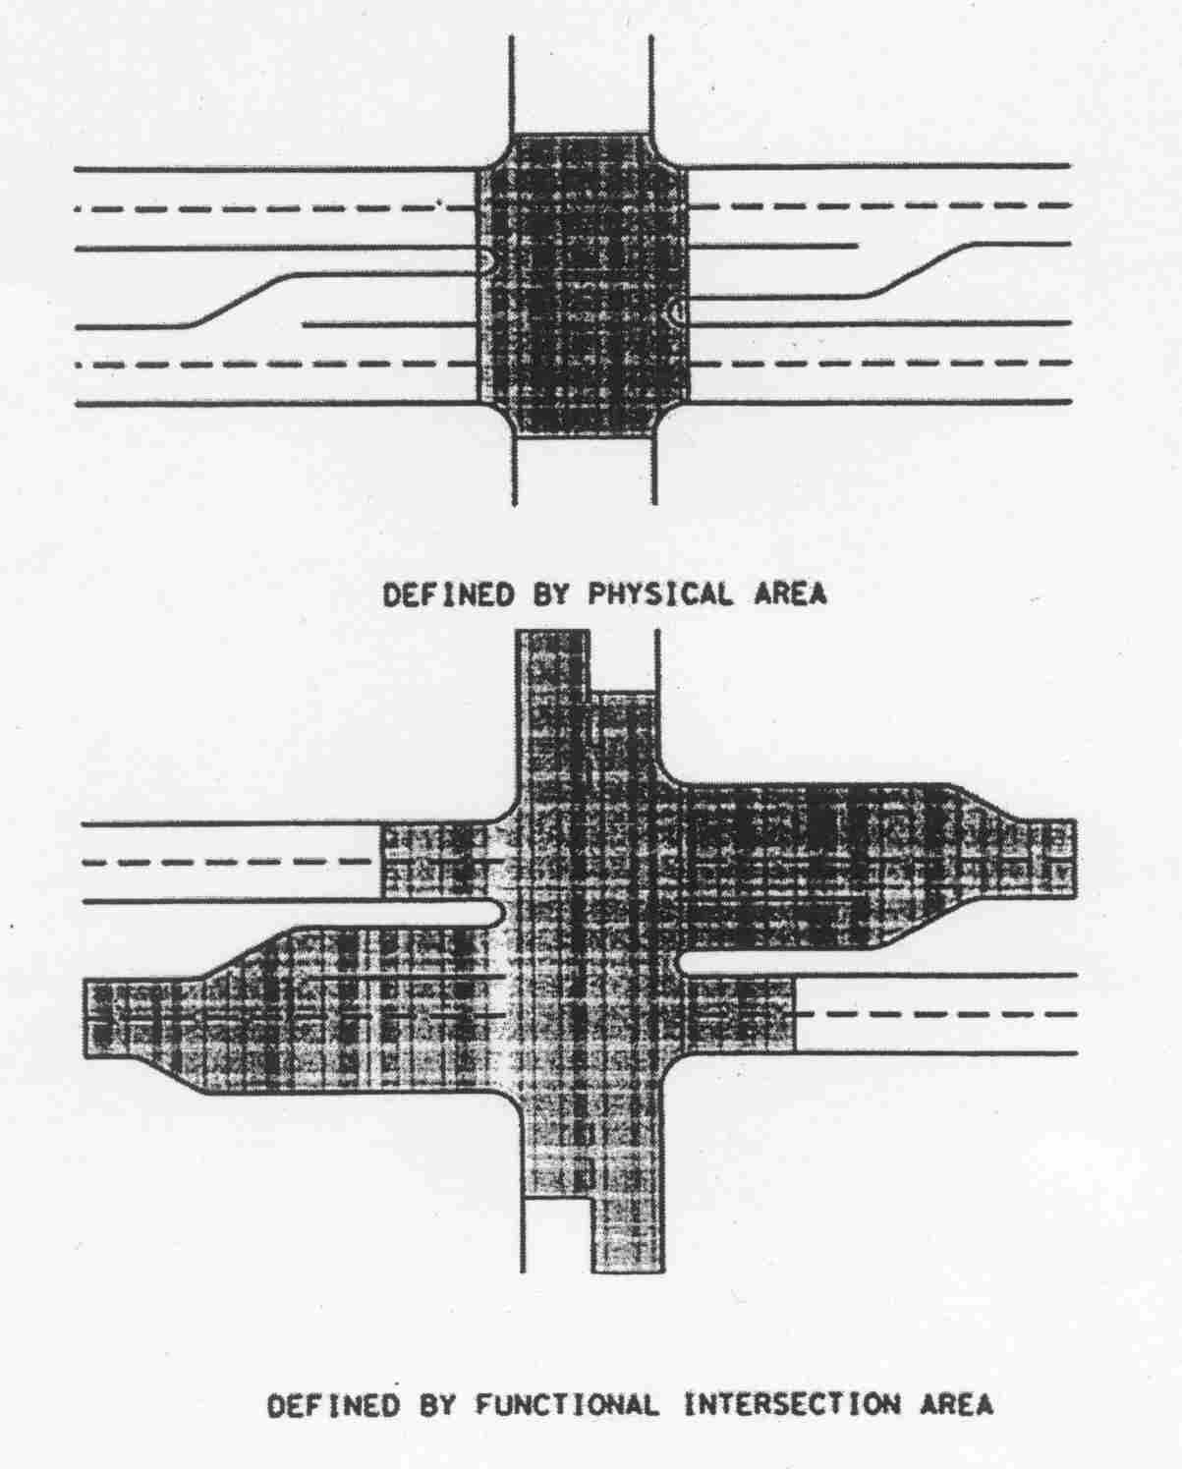
Figure 1.1 Intersection physical and functional areas (taken from AASHTO 2001)

Therefore, for proper operation of the intersection relating to safety, cost and efficiency, an appropriate and well-designed TCD should be properly installed at appropriate intersections. The conventional types of intersection control are yield control, two-way stop control (TWSC), all-way stop control (AWSC) and traffic signal control (TSC). Apart from these conventional types of TCDs, a unique type of intersection control -“the modern roundabout”- is being considered an alternative for intersection traffic control in the USA today. In Kansas, the Kansas Department of Transportation (KDOT) has been promoting the use of modern roundabouts. Modern roundabouts have been a great success in the United Kingdom (UK), Europe and Australia and in many situations are a better alternative than conventional intersection traffic control types such as stop controls, yield controls and traffic signal controls [Austroads 1993; Brown 1995].
Delay is considered to be a critical measure for evaluating the performance of the intersection [HCM 2000; Wallace et al., 1998]. Many studies comparing the viability of various alternatives for intersection control have been made since the introduction of modern roundabouts in the USA [Moe et al., 2000; FDOT 1996; MDOT 1995; Russell, et al., 2000].
A study that compared the performance of various conventional intersection types with modern roundabouts using Signalized and Unsignalized Intersection Design and Research Aid (SIDRA) concluded that modern roundabouts are a better form of intersection control than other intersection types for many conditions [Sisiopiku and Heung-Un Oh 2001]. The conditions in the comparison included variations in volume levels, turning volume splits, number of approach lanes and lane width. The signalized intersection included a simple two-phase design; permitted left turns; right turns on red; and shared turn lanes.
This study concluded: [Sisiopiku and Heung-Un Oh 2001]
- AWSC resulted in greater delay under all conditions than compared with other intersection types.
- Yield and TWSC performed better than other intersection types under light traffic demand.
- Roundabouts and TSC alternatives with single lane approaches and heavy traffic volumes are viable alternatives when the flare effect is maximized.
- For intersections with two-lane approaches and heavy traffic volumes roundabouts show a better performance than other intersection types.
- For three lane approaches, especially with heavy traffic volumes, roundabouts are no longer good alternatives and traffic signals serve better than other types.
- For heavy left turns demands, roundabouts show superior performance than other types of intersection control in terms of delay and capacity.
- Roundabouts with two or three-lane approaches provide increased capacity.
The Florida Roundabout Design Guide [FDOT 1996] also compared roundabouts to signalized intersections and found that the performance of signalized intersections is superior under higher entering volumes in terms of delay; however, Akcelik (1997) reported that the FDOT study failed to consider the flare effects correctly [cited in Sisiopiku and Heung-Un Oh 2001].
An Informational Roundabout Guide implies that roundabouts may offer a better performance and capacity at places were minor road traffic is more than 10% of the entering volume [FHWA Guide 2000]. Also, the guide states that roundabouts are favorable alternatives for TWSC at intersections with significant left turners. When compared with an AWSC, the modern roundabout always performs better for any given traffic condition [FHWA Guide 2000]. When the major street approaches dominate, roundabout delay is usually lower than the delay incurred by the TSC operation particularly where there is a high proportion of left turns [FHWA Guide 2000]. More studies concerning this research are cited in the Chapter II of this report.
This research study adds more evidence that modern roundabouts are capable of performing better and safer, handle higher traffic loading more efficiently and have a higher design life (based on degree of saturation) than other conventional types of intersection controls. Also, modern roundabouts can be potential candidates for intersections that have wide medians.

1.2 Study objective
The objective of this study is to further develop a methodology developed by Kansas State University (KSU) researchers [Russell, Rys and Luttrell 2000] for analyzing the performance of a modern roundabout. Also, to compare a modern roundabout with other conventional intersection traffic control types at a high-crash, problematic intersection with a wide raised median, in a city where opposition to modern roundabouts was very strong before it was built. This research report covers a comparison of the operational and the safety performance at the study intersection (23rd Avenue and Severance street, Hutchinson, Kansas) for the before (TWSC) and after (modern roundabout) conditions. Also, other conventional intersection traffic control types (excluding the yield sign control) were assumed and results simulated and compared with the performance of the modern roundabout that was constructed at this site.
The fact that this was the first modern roundabout in Kansas at the intersection of two arterials and the first with an oval central island that accommodated a divided roadway due to a wide, raised median in the minor approach, contributed to making this a desirable research subject. In addition, the study intersection had unacceptable crash problems and a group of local citizens had high reluctance towards modern roundabouts before it was built at the study intersection. All the information about the history and facts about the study intersection were obtained from the Engineering Department, City of Hutchinson unless otherwise stated.

1.3 Organization of the report
Chapter 1: Introduction
Chapter 2: Literature Review: This chapter covers the summary of the literature review done for conducting this research study.
Chapter 3: Experimental Design: This chapter covers a comprehensive summary of the study methodology adopted in this study.
Chapter 4: Data Collection: This chapter describes the study site and the summary of the data collected for this study.
Chapter 5: Data Analysis I – Operational Analysis: This chapter covers the summary of the operational analysis results obtained, both before and after the construction of the modern roundabout. The before condition was controlled by TWSC.
Chapter 6: Data Analysis II – Safety Analysis: This chapter covers the safety evaluation done for the study site both before and after the modern roundabout was built.
Chapter 7: Data Analysis III - Theoretical Analysis: This chapter presents the summary of the results for the theoretical analysis conducted to compare various types of intersection traffic control (TWSC, AWSC and TSC) including the modern roundabout operating under state fair traffic. Also, comparison of operational performance under increased traffic loading and a design life analysis for these intersection traffic control types are presented.
Chapter 8: Summary, Conclusions and Areas of additional research needs are presented in this chapter.

1.4 Units of measure
The units of measure to convert from foot-pound-second (US customary units) to meter-kilogram-second scale and vice-versa are given in the equations below:
meters = 0.30 * feet..………………………………….………………………..(1.1)

km/h = 1.61 * mph ………………………………………………..…………...(1.2)

2 Literature Review

2.1 General
The primary objective of this study is to compare the performance of the modern roundabout with the previous intersection control device (TWSC), installed at the study intersection based on operational and safety benefits. The secondary objective is to assume other conventional intersection types and determine which among them would be an appropriate traffic control at the study intersection based on the operational benefits. This chapter summarizes the literature review done for this study.

2.2 Intersection design characteristics

It is understandable that any traffic related phenomena is a direct or indirect result of the interaction between ‘the driver’, ‘the roadway’, ‘the vehicle’ and ‘the environment’. Every year it is estimated that more than 40,000 people are being killed in the USA due to traffic crashes and in 1999, nearly 10,000 people were killed, and 1.5 million people were injured at intersections in the USA. [FHWA 1999]. To a great extent motorists’ safety at intersections exists in the proper design of geometric elements and controls, which assist in providing guidance for the driver to make a safe maneuver through the intersection. Some of the prime design elements to be considered while designing any intersection* is as follows: [AASHTO 2001]
Design Vehicle: A selected representative class of vehicles of certain weight, dimensions and operating characteristics such as turning radii, vehicle performance, acceleration, deceleration, etc., that are used for establishing highway design controls for accommodating them on the highway is known as a design vehicle. There are four general classes of design vehicles:
- passenger cars: This includes cars of all sizes, sport/utility vehicles, minivans, vans and pick-up trucks.
- buses: Inter-city motor coaches, city transit, school and articulated buses
- trucks: This include single-unit truck, truck tractor semi-trailer and full trailers, and
- recreational vehicles: This includes motor home, cars with camper trailers, boat trailers etc.
Each of the above mentioned classes of vehicles have different qualities. In the design of any highway facility, the AASHTO design guide (2001) recommends using the largest design vehicle likely to use the intersection. The knowledge of design vehicle is important when the curb radii are designed for an intersection.
Design Driver: Driver error is one of the prime reasons for auto crashes [Pline 1992]. Human factors relating to highways is concerned with the capabilities and limitations of the road user. A great many differences exist in humans; for example, information handling for older drivers may take more time than younger drivers for the same situation on a highway. An intersection design is said to be compatible for the driver if he/she feels safe and comfortable in using the intersection, otherwise, it is not compatible.
“In traffic engineering, 85th percentile is often used as a cut-off for determining things such as speed limits, sight distance etc. There is no such person as “average driver” or 85th percentile driver, as all individuals will vary in driving abilities”. Therefore, sufficient care should be taken to make the design is suitable for all users [Pline 1992].

Design speed: Speed reduces the visual field, restricts peripheral vision, and limits the time available for drivers to receive and process information. Speed at which drivers can easily process information within a cone of clear vision is known as the design speed. This is usually considered in designing the approaches of intersections, curves and placements of signboards.
Sight distance: Sight distance is provided continuously along each highway or street so that drivers have a view of the roadway ahead that is sufficient for them to make safe driving decisions and take proper actions. AASHTO design guide (2001) recommends that each quadrant of an intersection should contain a triangular area free of obstruction that might block an approaching driver’s view of potential conflicting vehicles.
According to AASHTO design guide (2001), the intersection design should consider the following five basic elements:
- Human factors: This includes driving habits, ability of drivers to make decisions, drivers expectancy, decision and reaction time, conformance to natural paths of movement, pedestrian use and habits and bicycle traffic use and habits
- Traffic considerations: This includes design and actual capacities, design-hour tuning movements, size and operating characteristics of vehicle, variety of movements (weaving, diverging, merging and crossing related to driving habits), vehicle speeds, transit involvement, crash experience and bicycle & pedestrian movements
- Physical elements: This features character and use of abutting property, vertical alignments at the intersection, sight distance, angle of the intersection, conflict area, speed-change lane, geometric design features, traffic control device, lighting equipment, safety features, bicycle & pedestrian traffic, environmental factors and cross walks.
- Economic factors: This includes cost of improvements, and effects of controlling or limiting right-of-way on abutting residential or commercial properties where channelization restricts or prohibits vehicular movements
- Functional intersection area: Illustrated previously in Figure 1.1

2.3 Types of intersection controls
Intuitively, the most economical method to control the intersection is to allow the drivers themselves to control all movements. In the beginning of automobile travel this was acceptable. However, an increase in the number of road users led to chaos and conflicts that ultimately ended in crashes leading to property damages/injuries/loss of life. In order to enhance safety and operational efficiency, stop controls were introduced. This promoted an orderly flow and also increased operational efficiency more than at the uncontrolled intersection. TWSCs were introduced at intersections where there were low volumes on the minor roads. AWSCs were used at intersection if the TWSC caused excessive delays for the users on the minor roads or if the volumes on all the approaches were about equal. Also, AWSC was introduced to reduce right angle collisions and severity of crashes [Brigla Jr, 1982]. TSCs were provided if there were excessive traffic volumes such that AWSC would create significant delays to all the approaches. Yield signs were also placed as a control at intersections where there were lower volumes.
After many studies and experience focusing on the operational improvement of the intersection and the safety of the road users, the Manual for Uniform Traffic Control Device (MUTCD) specifies warrants such that a specific traffic control device at intersections could be installed. Stop signs come under the category of regulatory signs that inform traffic laws or regulations and indicate the applicability of legal requirements that would not otherwise be explicit to the highway users. The warrants for a stop sign is intended for application at places where traffic movement is unduly hazardous, where roads enter a through highway or street, where a signalized intersection is unsignalized and where serious crash records indicate need for regulatory signs [MUTCD 2000]. The current MUTCD (2000) provides eight warrants or thresholds to justify a traffic signal at a particular location. The following section highlights the purpose or the intentions for a specific warrant and cites some thresholds for specific conditions from the manual [MUTCD 2000]. The readers are requested to refer to the MUTCD 2000 for comprehensive and specific considerations.
Warrant 1: 8-hour vehicular volume: This is intended for application where a heavy traffic volume at the intersection is a primary reason for traffic signal control (condition A) or where traffic volume on the major street is so heavy that the minor street experiences excessive delay (condition B). For example: Condition A - The minimum vehicular volume during an eight hour period for an intersection with single lane approaches must exceed 500 vehicles per hour on the major street and 150 vehicles on the higher-volume side street. Condition B – The total vehicles per hour on the major streets (both approaches) during an eight-hour period must exceed 750 and exceed 75 vehicles per hour on the higher-volume minor approach.
Warrant 2: 4-hour vehicular volume: This is also intended for application where heavy traffic volume at intersection is a primary reason for traffic signal control. Here it takes into account the four-hour traffic volume on an average day. It requires a minimum of 80 vehicles per hour for the minor road with a single lane
Warrant 3: Peak-hour vehicular volume: This warrant accounts for intersections where the minor road faces more delays when entering or crossing the major street during a one hour period on an average day. It requires a minimum of four vehicle-hours of delay for a one lane approach on the minor approach controlled by stop signs, a minimum of 100 vehicles per hour on the delayed approach (>4 vehicle-hours) or 150 vehicles per hour for two moving lanes and a minimum of 800 vehicles serviced during that hour for intersections with four or more approaches.
Warrant 4: Pedestrian volume: This is intended for intersections where the pedestrians experience more delay due to heavy traffic volume on the major street. It requires 100 pedestrians during any four hours or 190 pedestrians or more during one-hour. Also a minimum of 60 gaps per hour of adequate length in the traffic stream to allow pedestrian to cross, during the same period for the pedestrian volume criterion mentioned above must be satisfied.
Warrant 5: School crossing: This is to determine if a traffic signal needs to be installed near schools. It requires a minimum of 20 students during the highest crossing hour and also the frequency and the adequacy of gaps in the vehicular traffic stream is less than the number of minutes in the same period.
Warrant 6: Coordinated Signal System: This is intended to address progressive movement of traffic (i.e. proper platooning of vehicles). Coordination between the signals shall be provided if the signalized intersection is less than 300 m (1000 feet)
Warrant 7: Crash experience: This warrant is intended for intersections where severity and frequency of crashes are the prime reasons for the implementation of a traffic signal. It requires a minimum of 5 crashes that are susceptible to correction by a traffic signal within one year.
Warrant 8: Roadway network: This is intended at intersections where the need for concentration and organization of traffic flow exists.
Traffic volume, as discussed in the earlier part of this section, constitutes a prime criterion in the choice of a particular traffic control device. Figure 2.1 shows the type of intersection control required for an observed peak hour volume on the major and minor roads of an intersection [HCM 2000]. It is to be noted that modern roundabouts can also be appropriate within those ranges.
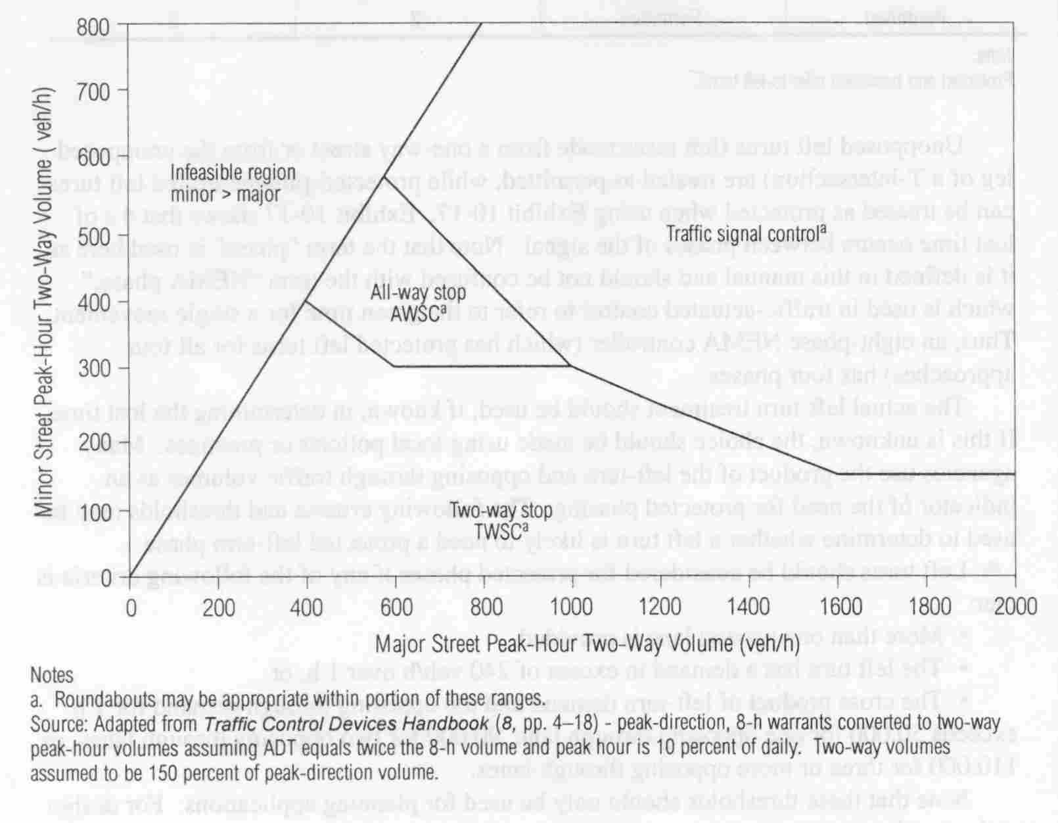
Figure 2.1 Intersection traffic control types and peak-hour volumes
(Source: taken from HCM 2000)

Though the abovementioned, conventional intersection controls may increase the operational efficiency under certain, specific conditions, all are less effective than a modern roundabout when safety issues are considered [Sisiopiku and Heung-Un Oh 2001; UTM 1996]. Flannery and Datta (1996) made an effort to determine the effectiveness of modern roundabouts as a treatment for intersecting roadways. Their study concluded that the reduction in crashes for roundabout sites was between 60 and 70 percent and a modern roundabout would be an appropriate intersection safety treatment [Flannery and Datta 1996]. Recent research [IIHS July, 2001] reports that modern roundabouts perform better than other conventional intersection traffic control types by reducing the delay and proportion of vehicles stopped under a range of traffic conditions in the USA. This study supports previous research performed at Kansas State University (KSU) that reported similar results [Russell et al., 2000].

2.4 Modern roundabouts
Most of the contents in this section are paraphrased from Modern Roundabout Practice in the United States, National Cooperative Highway Research Program Synthesis of Highway Practice (NCHRP) No. 264, [Jacquemart 1998] unless otherwise stated.
The idea of a one way rotary system was first proposed in the USA in 1903 for the Columbus circle in New York city (see Figure 2.2) and was implemented around 1904 by William Phelps Eno. Though the concept of circulating traffic flows was tried in the USA in the early 20th century, it did not gain prominence due to inefficient methods of design and operating rules that caused congestion. The design methods and practices that existed in those periods led to the construction of traffic circles and rotaries that encouraged high entry speeds and safety concerns.
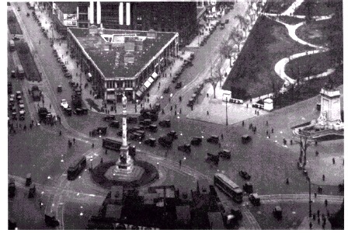

Figure 2.2 View of Columbus circle, Circa 1915 (Courtesy: New York Department of Planning) (Source: Jacquemart 1998)

In 1929, Eno recognized that traffic in a traffic circle locks up at higher volumes and pointed out that the main drawback could be due to the yield-to-right rule (i.e. vehicles in the traffic circle yielded to the entering traffic) and recommended a yield-to-left rule (i.e. entering vehicles yielded to the circulating traffic). Instead, as an attempted solution to the locking problem, larger rotaries were built with longer storage distances between successive entries, but retaining the right-of-way rule. The locking problem remained as the traffic volume increased. A negative effect was that these larger circles led to (perhaps even encouraged) high-speed entering vehicles, higher speeds on the circulating roadways, high-speed weaving maneuvers and increased crash risk. Reluctant to reverse the right-of-way rule, and unable to solve operational and locking problems, the USA gave up on the use of traffic circles around the mid 1950’s. TSCs and grade separated interchanges became the preferred alternative. Some old traffic circles were subsequently removed in favor of TSCs.
However, the United Kingdom (UK) continued research on traffic circles and came to a consensus, that a ‘give way’ rule for circulating traffic, otherwise called the offside priority rule in the UK, would make traffic circles operate more efficiently. Further research done by the Transport Research Laboratory (TRL) in the UK proved that the offside priority rule (entering vehicles yield to the circulating vehicles) would eliminate locking problems, increase capacity, reduce delay and also increase safety [Todd 1988, cited in Jacquemart 1998].
Studies and experiences in various developed countries, dating back to the beginning of the 20th century, have reshaped the concept of the older traffic circles, rotaries and gyratories into a more refined form of intersection control, known today as a “Modern Roundabout”.

2.4.1 Characteristics of modern roundabouts

Modern roundabouts are beginning to be considered an alternative traffic control device (TCD) that can improve safety and operational efficiency at intersections when compared to other conventional intersection controls. The geometric features of the modern roundabout play a major role in producing such performances [Austroads 1993; Russell, et al., 2000; FHWA 2000]. Its unique design renders greater efficiency than the other intersection traffic control types. There is a difference between the older traffic circles and rotaries when compared to the geometry and performance of the modern roundabout. They also differ from smaller, neighborhood traffic circles used as a traffic-calming device for speed reduction (see Figure 2.3). Because the greatest increase in intersection safety in a well-designed modern roundabout is due to its low design speed, it does serve to slow vehicles. However, its primary function is safe and efficient traffic control.
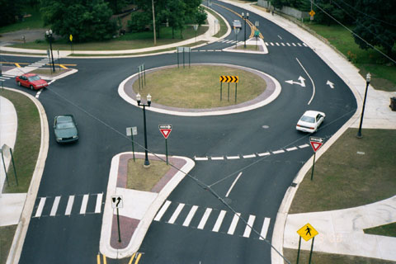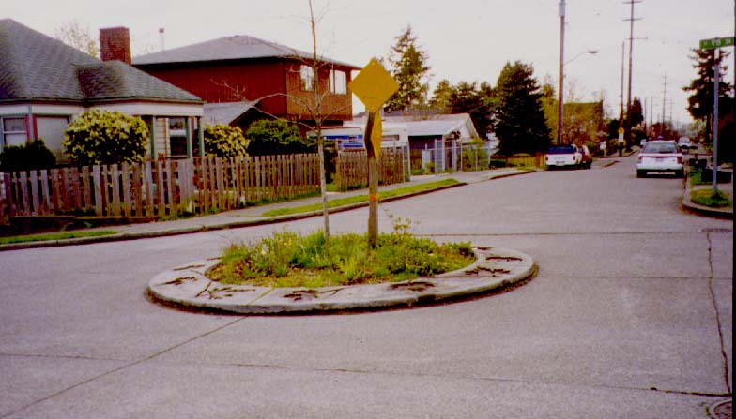
(i) Roundabout in Okemos, Michigan (ii) Neighborhood traffic circle in
Seattle, Washington

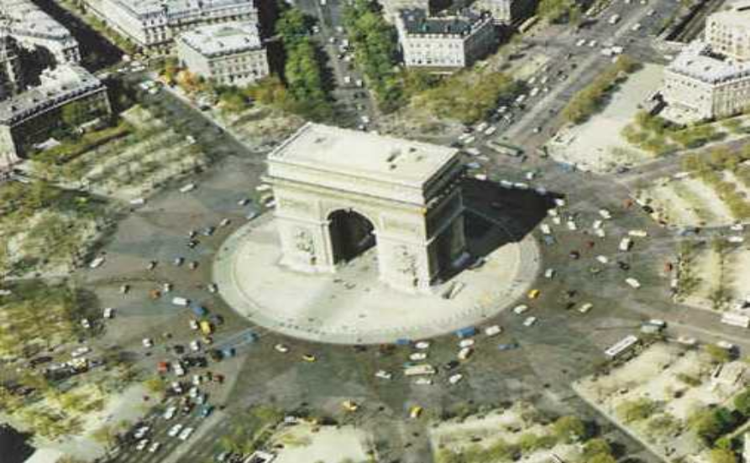
(iii) Big traffic circle or rotary (Arc De Triomphe) in Paris, France
Figure 2.3 Roundabout, neighborhood traffic circle and rotary (Courtesy: Center for transportation research and training, roundabout website, KSU and Office of transportation, portland)

A modern roundabout is a type of intersection control that has a central island (can be circular or elliptical) and restricts the flow of traffic in a counter-clockwise direction (in countries that drive on the right side of the roadway) with entering vehicles yielding at entry to the circulating vehicles. Figure 2.4 shows the geometric elements that constitute a modern roundabout.
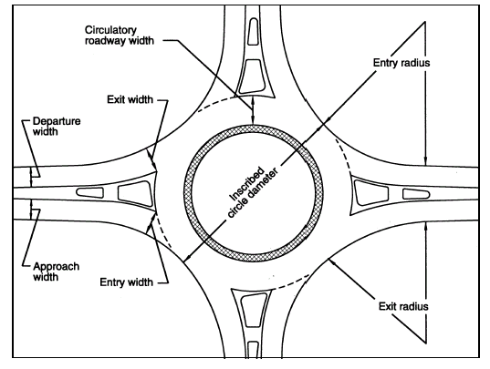
Figure 2.4 Geometric elements of a modern roundabout
(Source: FHWA Guide 2000)

- Circulating road width: The width of the circulating roadway on which the vehicles circulate to reach their preferred exits. It is the width between the outer edge of the roadway and the central island excluding the width of the truck apron.
- Inscribed diameter: The diameter measured between the outer edges of the roadway. This includes, the circulating roadway, truck apron and the central island.
- Entry and exit width: The perpendicular length from the right edge of the entry/exit to the intersection point of the left edge line and the inscribed line.
- Entry and exit radii: The minimum radius of curvature of the outside curb.
- Approach and departure width: The width of the approach/departure lane used by traffic stream to enter/exit the intersection.
This intersection control has superior operational characteristics (i.e. capacity, delay, queue length, proportion stopped, etc.,) and the capability of reducing the frequency of crashes and crash severity makes it safer than other TCDs [FHWA 2000; IIHS 2000; Russell, et al., 2000; Jacquemart 1998; Garder, 1998; Flannery, 2001; Austroads 1993; Garder et al., 2000; Flannery & Datta 1996; Alcelik and Besley 1998; HWS consultant group 2001].
An Insurance Institute of Highway Safety (IIHS) study have shown that total crashes decreased by 39%, injury crashes decreased by 76% and collisions involving loss of life were estimated to reduce 90% [IIHS 2000]. A study done by the Maryland Highway Administration at five of its modern roundabouts revealed a decrease of 63% in total crashes and a decrease of 86% in injury related crashes [Urban Transportation Monitor (UTM) 1999].
A research study conducted by the researchers at KSU for IIHS, studied the before and after performances at three intersections, one each in Kansas, Maryland, and Nevada, which were controlled by two-way stop signs before being converted to modern roundabouts [IIHS 2001]. The study concluded that the modern roundabouts at these three locations perform better than the two-way stop controls (TWSC) they replaced by reducing the average intersection delay by about 20% in each case and reducing the proportion of vehicles having to stop by 14% to 37% at the three sites [IIHS 2001].
Another study done by KSU researchers studied comparable intersection traffic control types (TWSC and AWSC) and found that a modern roundabout in Manhattan, KS performed equal or better than TWSC and AWSC intersection traffic control at low-volume intersections, considering safety and operation [Russell et al., 2000].
Delays at modern roundabouts in the USA are about 75% less than under the previous traffic control methods they replaced [Jacquemart 1998]. While modern roundabouts are now considered viable alternatives to conventional intersection TCD in the USA, many factors should be considered in choosing an appropriate TCD for efficient operation and safety at an intersection. For example, a study conducted at Pennsylvania State University (Penn State) on the safety and geometric design aspects of modern roundabouts determined that some rural modern roundabouts experience loss-of-control crashes due to high approach speeds and possible violation of driver expectancy because of improper approach and/or entry design [Flannery 2001]. This study indicates that the exceptional safety reported at most roundabouts is due to their being well designed such that vehicle speeds are low – a concept strongly supported by the author. The Flannery study also (based on a case study at Summerlin, Nevada modern roundabout) concluded that there is a need for addressing the appropriateness for modern roundabouts at intersections with lower volume to capacity ratios (v/c).
Modern roundabouts have been a great success in the UK, Europe and Australia and found to be a better alternative in many situations than conventional intersection traffic control types such as stop controls and traffic signals at intersections. [Austroads 1993; Brown 1995]. However, their history of circular intersections (gyratories, traffic circles, rotaries, etc.) is similar to the history in the USA. The early gyratories/traffic circles/rotaries were inefficient and could be very confusing, congested and have high crash rates. It is only the modern roundabout (post 1980’s) that has improved operational efficiency and safety. In the past decade, growth of modern roundabouts in Europe has been phenomenal, particularly France which has been building about 1000 modern roundabouts per year, Netherlands built more than 400 between 1986 and 1992, Norway built around 500 between 1980 and 1992 and in Switzerland about 220 were built between 1980 and 1992 [Wallwork and Siegman 1997].

2.4.2 Appropriate and inappropriate sites for modern roundabouts

This section covers some situations at intersections, where modern roundabouts are appropriate and are inappropriate as given in Roundabouts, Part-6, Austroads, 1993. [Austroads 1993]
Modern roundabouts may be appropriate in the following intersections: [Austroads 1993]
- Where the traffic volumes on the intersecting roads are such that “Stop” or “Yield” signs or the “T” junction rule (i.e. turning vehicles, give way to all traffic crossing or coming from the right) results in unacceptable delays for the minor road traffic. In these situations, roundabouts would decrease delays to minor road traffic, but increase delays to the major road traffic.
- Where there is a high proportion of right (left)* turning traffic.
- Where there are more than four legs and/or when conventional intersection controls face difficulty in defining priorities and require large numbers of phases in the case of traffic signals.
- Where there are disproportionately high numbers of crashes.
- At rural cross roads (including those in high speed areas) at which there are crash problems involving right angle collisions.
- At locations where traffic growth is likely to be high and future traffic patterns are likely to be uncertain and changeable.
- Where either of the crossroads needs to be given a priority and,
- Where major roads intersect in “Y” or “T”

Modern roundabouts may be inappropriate in the following intersections: [Austroads 1993]
- Where a satisfactory geometric design cannot be provided due to insufficient land space or unfavorable landscape or unacceptable high cost in construction.
- Large combination vehicles and over-sized vehicles frequently use the intersection and insufficient space is available to provide the necessary geometric layout.
- Where there are highly unbalanced flows resulting in higher delays on one or more approaches.
- Where a minor and a major road intersect and there is unacceptable delay for the major road traffic. Roundabout causes delay and deflection to all the traffic, whereas control by two-way stop or yield or the ‘T’junction rule would result in delays to only the minor road traffic.
- Where it is isolated in a network of progressive traffic signals.
- Where peak period, reversible lanes may be required.
- Where traffic flows leaving the roundabout would be interrupted by a downstream traffic control, which could result in back-ups that influence the operation of the modern roundabout.
These guidelines are a good start but there is a need for further research in the USA to determine more specific guidelines and to develop volume and safety warrants for conditions where modern roundabouts may not be the best TCD.

2.5 Two-way stop control (TWSC)

This type of intersection is controlled by regulatory signs (Stop sign – MUTCD R1-1) installed on the minor road approaches. This type of control allows priority for the major street users and the minor road users wait for an acceptable gap to maneuver through the intersection. The drivers on the controlled approaches (minor street) are required to assess gaps in the major street flow and execute the move based on judgment. If a queue is present on the side street approach, each driver should move-up to the first position in the queue and begin to evaluate gaps in the major street flow.
Thus, the capacity of the controlled approaches are mainly based on three factors: the distribution of gaps in the major street traffic stream, driver judgment in selecting gaps and follow-up time, i.e., the time between the departure of one vehicle from minor street and the departure of the next vehicle using the same gap under a condition of continuous queuing [HCM 2000].
Intuitively, because of the priority given for the major street users, the TWSC causes more delays for the minor street users and little or none for the major street users. Under congested conditions, the right-of-way is sometimes preempted by conflicting movements from the minor streets [HCM 2000] and this can most probably cause a safety concern by increasing the possibility of a right-angle collision at the intersection. Also, the maneuvering from the minor street through the major street depends on subjective judgment of an acceptable gap, which is certainly not the same for all motorists and it creates a safety issue for the traffic entering the intersection.
Some of the other factors that influence the operation and safety of the TWSC intersection are [HCM 2000]:
- Existence of a wide raised median often causes some degree of gap acceptance phenomenon called the two-stage gap acceptance, where the motorists cross the intersection in two stages.
- Geometric elements (i.e. lane configuration) near the stop line on the controlled approach affect capacity. For instance, if the entry of the intersection is flared or if the curb radius is large or if it is tapered or parking is prohibited the intersection may result in higher capacity.
- Existence of a nearby signalized intersection either upstream or downstream of the major and minor approaches can cause vehicles to arrive in platoons or influence the operational performance of the intersection due to queue formation from the downstream or upstream signalized intersection.

2.6 All-way stop control (AWSC)

This type of intersection traffic control (AWSC) has stop signs installed on all the approaches. All vehicles traversing through this intersection are required to stop before entering the intersection. The right-of-way for every vehicle is allocated through the interactions between the traffic streams itself. The capacity of the AWSC intersection is related to the departure headway, defined as the average time in seconds between two successive vehicles departing from the stop line of the same lane [HCM 2000]. The departure headway for a subject vehicle, depends on the presence of the number of vehicles on the conflicting approach the type of subject vehicle and the turning movement of the subject vehicle. For example, the departure headway for a passenger car will be less than for a tractor trailer; the departure headway will be longer for a vehicle making a left-turn than for the same vehicle going straight through the intersection, and the presence of vehicles on all the approaches of an AWSC intersection will result in longer departure headways and longer driver decision times that reduce the capacity of the intersection.

2.7 Traffic signal control (TSC)

It is self-evident that at any intersection of streets or highways there exist conflicting movements that increase safety concerns. The need to safely separate these conflicts is obvious. For minor traffic, stop signs could be suitable control. For heavy traffic, conflicting movements could be separated in space. However, grade separations are not always feasible due to economic constraints and hence these conflicting movements are usually separated in time by providing traffic signals to alternate conflicting flows.
The traffic control devices handbook (1983) defines traffic control signals as:
“power-operated, traffic devices that alternatively direct traffic to stop and to proceed such that the assignment of right-of-way at locations where conflicts exist or where passive devices, such as signs and markings, do not provide necessary flexibility of control to properly move traffic in a safe and an efficient manner”.

Traffic signals assume the prerogative of ordering assignment to traffic streams based on traffic characteristics, driving behavior and pattern, thus making it different from other traffic control devices. The TCD handbook (1983) states:
“the primary function of the traffic signal control is to assign the right-of-way at intersecting streets or highways where, without such control, a continual flow of vehicles on one roadway would cause excessive delay to vehicles and/or pedestrians waiting on the other roadway”.

Installing well-designed TSC at an appropriate intersection may improve the orderly movement of traffic, will allow pedestrians and minor road traffic to cross the heavy major road traffic and will reduce the frequency of certain types of crashes, for instance, right-angle and left-turn crashes [Orcutt and Sullivan, 1992].
While having advantages, TSCs do have some disadvantages. They may increase the delay to heavy traffic movements, will reduce the freedom of drivers to control their own progress and may result in driver disobedience and traffic violations [Orcutt and Sullivan 1992]. By installing TSC at inappropriate intersections, it will most likely increase the frequency of rear end crashes and may cause excessive delay to all movements, and it may result in unnecessary frustration for drivers and diversion of traffic through the neighborhood [MUTCD 2000].

2.7.1 Types of Traffic Signal controller

Given the need for dividing the traffic movements in time and in an efficient manner, the signal timing has to be properly set up. The various components of signal timing that are involved in the design decision of a TSC are: [Kell and Fullerton, 1982 ; Wallace and Courage 1991; MUTCD 2000]
- phase plan,
- phase sequence,
- cycle length,
- interval length,
- phase length,
- change period length or clearance time, and
- offsets.
All the above components of signal timing vary with the traffic volume to be served, capacity parameters such as saturated flow rate, start up-lost time, extension of effective green, sneakers, etc. and other characteristics mentioned in the beginning of this chapter (see sec 2.2). Assigning various movements through the intersection for each approach is accomplished through the phase plan, i.e., assigning them in a sequence called the phase sequence. A phase plan of a signal cycle is defined as the combination of intervals during which the traffic movements are given right-of-way, or otherwise allowed to move An interval is a segment of the cycle during which all signal displays, both traffic and pedestrian remain fixed. The change period length or clearance time is the time allocated for the yellow interval and optional all-red clearance interval. Offset is the time from some system reference point to the beginning point of the cycle at each signal controller in the system. The time taken to complete one full cycle of all the intervals in all the phases is known as the cycle length.
The above-mentioned elements of signal timing are operated by means of a controller. Recent advancements in the electronic control systems and then robust computing power has allowed the development of more sophisticated and complex traffic signal systems that adapt to real time traffic demands and renders service accordingly. The hardware design and working of signal controllers are beyond the scope of this report. However, a brief summary on the common types of signal controllers and their function is presented below.
There are three types of traffic signal control system namely,
- pre-timed or fixed time signal,
- semi-actuated signal and
- fully actuated signal.
Pre-timed or fixed traffic signal controls are those that have a fixed phase plan and a fixed time length for each phase interval in the signal cycle and are operated either mechanically or electronically. There are provisions in the hardware controller for more than one phase setting to set different timings for different periods in a day. The right-of-way for an approach is fixed and limited no matter when the vehicle arrives at the intersection. This type of traffic control is best used at intersections where the traffic pattern and the demand is reasonably predictable and doesn’t vary significantly [TCD Handbook 1983]. Typically it is used when there is a requirement for coordinating traffic signals for progressive traffic movement [TCD Handbook 1983].
Actuated traffic signals do not have a fixed cycle length. The length and the sequence of the phasing depend on the existing vehicle and/or pedestrian demand and might not be the same from cycle to cycle. In other words the system provides right-of-way depending on the existing demand on the approaches and may omit actuation of a particular phase if demand doesn’t exist. The vehicle demand is sensed by using embedded sensors in the pavement (inductor loops) or, with more sophisticated systems, using video cameras or radar.
Controllers operating in the semi-actuated mode are set to function for a guaranteed minimum green time during the non-actuated phase. The non-actuated approach will be serviced as long as there is no demand in the actuated approach. Upon sensing a vehicle in the actuated approach, the vehicle extension interval is reset for the non-actuated approach. The green on the non-actuated approach will terminate when either the extension interval is allowed to time out or the preset maximum green time is reached. If the actuated phase completes its preset maximum time, the controller assumes a ‘trapped’ vehicle on the actuated approach between the detector and the stop bar and a call is placed such that the non-actuated approach functions only for the minimum preset time and returns to the actuated phase. Semi-actuated traffic control is used at intersections where the minor road demand varies [TCD Handbook 1983].
In case of a fully actuated signal system, all the approaches are installed with detectors. In this case the system operates on a continuously varying cycle length. The right-of-way is not returned automatically to a designated phase unless it is recalled. Also, there is no preset minimum green for any approach; rather it varies with the demand and switches depending upon the detector receiving a higher demand call. Fully actuated signal systems are best suited at isolated intersections were the traffic demand varies throughout the day [TCD Handbook 1983].

2.8 Intersection with wider medians

Based on a National Cooperative Highway Research Program (NCHRP) study [Harwood et al., 1995] it was determined that “most types of undesirable driving behavior in the median areas of divided highway intersections are associated with competition for space by vehicles traveling through the median in the same direction”. The median area at an intersection is defined as the area in the center of the divided highway covered by the median width, plus the median opening length, plus the left-turn lanes, if any, at the intersection. Types of undesirable driving behavior include side-by-side queuing, angle stopping, and encroaching on the through lanes of a divided highway. The study further indicated that, [Harwood et al., 1995]
- at rural, unsignalized intersections, the frequency of undesirable driving behavior and crashes were observed to decrease as the median width increases,
- median widths between 3.6 and 9 m (12 and 30 ft) are desirable at intersections,
- median widths more than 18 m (60 ft) are undesirable at signalized intersections,
- median widths 31 m (100 ft) or more may require separate signals on each roadway of the divided highway, and
- the effect of median width on the operation of signalized intersections showed that the performance of the intersection decreases as the median width increases, as more clearance time is required for those vehicles to clear the median width.
The Austroads roundabout guide, Part-6 (1993) states that a modern roundabout may be a suitable form of intersection control if designed properly. Due to the presence of a wider median, the central island of the roundabout will be elliptical and the circulating speeds will be different at different sections of the circulating lane. Right-turning (left)* vehicles from the divided roadway will find the radius of the turning path decreasing. This may affect the performance of the modern roundabout.
It appears from the literature that, as the median width increases, the suitability of TSC based on performance, decreases. This is due to the increase in clearance time for the vehicles making a left-turn from the divided highway. In the case of unsignalized intersections it appears that a 3.6 m to 9 m (12 to 30 ft) median may be acceptable, however, there are chances of the two-stage gap acceptance phenomena (see section 2.5 pp 24-25). While there are some guidelines on median width at intersections, there has been no study that addresses the suitability or appropriateness of various intersection traffic control types at intersection with wider medians based on operational, safety and economical benefits. As modern roundabouts reduce the physical area of the intersection they may be expected to perform better in terms of safety, however, the viability of intersection types will depend on various other factors such as traffic loading, distribution of turning movements, arrival patterns etc.

2.9 Measures of effectiveness (MOE)

The performance of the intersection is assessed by certain measures of effectiveness that relates to:
- operational benefits,
- safety benefits and
- economical benefits.
The HCM (2000) states that for interrupted flow facilities, the control of time for traffic flow is critical to quantify the operational benefit measures such as capacity, level of service, etc. For instance, TSCs cause delay for vehicles that arrive on red and the TWSC stops traffic on the minor road and produces delay for them. AWSCs stop all vehicles on every approach before clearing the intersection thereby causing delay on all approaches. Hence, control delay involves vehicle movements at lower speeds, stops at intersection approaches or vehicle move-up in the queue or slow downs due to the impact of the upstream/downstream intersection performance.
Therefore, the operational performance of a TCD at an intersection is quantified by determining the control delay (i.e. the additional travel time caused due to the presence of the control device at the intersection) and queue length. Based on the control delay, the HCM gives a qualitative measure called the Level Of Service (LOS), which describes the operational condition within a traffic stream at an intersection. Six LOS, ‘A’ through ‘F’ is defined, with ‘A’ representing the best operating condition and ‘F’ representing worst. In addition to delay, the HCM also adopts a measure called as the v/c ratio, also called the degree of saturation, and is defined as the ratio of the flow rate to capacity of the facility, which is used to assess the operational performance of the intersections.
Safety benefits include quantifying the safety history in the study area in terms of crash rate for each level of severity (fatal, injury and property damage), reduction in number or severity of crashes, or reduction in number of conflicts, or ‘near crashes’.
Economic benefits cover the costs involved in crashes, time costs involved due to delay experienced at the intersection, costs involved in fuel consumption, and impacts of air quality and the environment as a result of vehicle exhaust, construction costs, operation costs and maintenance costs.

2.10 Computer software – Analysis tools

Operational analysis calculations involve tedious work. The computations necessary for this research were to be done with the aid of computer software that was reliable and had been validated under field conditions in the USA. Some of the software packages that were user friendly and relevant for this research study were studied. They were: Highway Capacity Software (HCS), ROundabout DELay (RODEL), Signalized and Unsignalized Design and Research Aid (SIDRA), and TRAffic Network StudY Tool –Federal program TRANSYT 7F. The capabilities of the software relevant to this study are summarized below in this document.
The latest millennium version of the Highway Capacity Manual (HCM) and Highway Capacity Software (HCS) has the capability to analyze various intersection types such as unsignalized intersections with stop and yield control, signalized intersections, and it has some options to analyze modern roundabouts. As modern roundabouts are fairly new to the USA it was felt that the HCM and HCS are limited in the abilities as regards to comparing the operational aspects of modern roundabouts to other intersection types [Kanilwa 2000].
ROundabout DELay (RODEL) an interactive computer program developed in the UK is used for evaluation and design of modern roundabouts only. This software developed by the Highway Department of Staffordshire County Council in the UK is based on empirical relationships that relate capacity to detailed geometric parameters of UK modern roundaobuts There are two main modes of operating the software:
Mode 1: Design - the user specifies target parameters for average delay, maximum delay, maximum queue and maximum v/c ratio. The program generates several sets of entry geometry based on the given input for each approach.
Mode 2: Evaluation/Analysis – This allows the user to analyse the performance of the modern roundabout for geometric parameters and traffic characteristic for specific site conditions.
SIDRA has the capability to analyze and design several intersection traffic control types including modern roundabouts. Also, a study done by Elefteriadou et al., (1998) showed that predictions of SIDRA on the performance indices such as intersection delay are reasonable for driving conditions at unsignalized intersections in the USA. Also, the Florida Roundabout design guide [FDOT 1996] and the Maryland roundabout design guide [MDOT 1995] recommended the SIDRA computer package for the study and analysis of modern roundabouts.
A simulation study done to compare the sensitivity of RODEL and SIDRA to changes in dimension of the roundabout geometry concluded that there are variations between the two models and predictions may differ for the same set of geometric parameters [Kanilwa, 2000]. For this study, it was decided to rely on SIDRA, which has had validation in the USA for operational analysis of modern roundabouts [FHWA 2000, FDOT 1996, MDOT 1995, Aty and Hosni 2001].
The design of a TSC directly relates to the design of signal timing, and functionally, signal timings are more likely to be considered an operational responsibility rather than a part of design activity [Kell and Fullerton 1982]. Hence, there is a need for a signal-timing tool. The Transport Research Laboratory, UK, developed the original model (TRANSYT); however, this was “Americanized” for the Federal Highway Administration (FHWA) by the Transportation Research Center (TRC), University of Florida and renamed TRANSYT – 7F [Wallace and Courage 1991]. As it is widely accepted in the USA and accepted by the FHWA, this software was considered reliable and used for signal timing optimization in this study.
Many fields, for instance, medicine, agriculture, natural science and applied sciences such as engineering, etc. employ statistical techniques. It is quite understandable that traffic engineering deals with quite a lot of numerical data such as traffic volume, number of crashes, speed data, performance measures, etc., a need to organize, summarize and draw conclusions from the data exists. In general, statistical methods for analysis provide investigators with a powerful tool to make sense out of the data. Also, the advent of computer programs has made it easy to do the tedious calculations involved in statistics. Minitab, an interactive windows based computer software that has test descriptions and illustrative electronic help windows for data entry and interpreting results, was used in doing all the statistical analysis in this research study [Minitab, user manual, 2000].
In summary, the software packages that were considered for the operational analysis of the intersection types in this study were Signalized and Unsignalized Design and Research Aid (SIDRA) version –1.0.14 developed by Australian Road Research Board (ARRB) and TRAffic Network StudY tool – version 7 Federal (TRANSYT 7F), signal timing optimization software program developed by Transportation Research Center, University of Florida and Minitab (release 13) for performing the statistical analysis. The following sections cover a brief overview of the two operational analysis software packages used in this research study.

2.10.1 SIDRA

SIDRA is user-friendly, Windows-based computer software used for analyzing operational performance of various intersection types including modern roundabouts. For the purpose of analyzing the conventional intersection types, the HCM (methodology) is configured and adopted in this study. By configuring the software in the HCM methodology, SIDRA is set to calculate intersection delay (control delay) as given in the HCM. SIDRA adapts to the right-hand drive (i.e. driving on the right-hand side on the road) rule and allows data entry in customary units (foot-pound-second) followed in the USA.
Delays at intersection are of two types: Geometric and Queuing delay. The delay caused due to the presence of the intersection is called geometric delay. In other words, geometric delay to a vehicle is the difference between the interrupted (due to the presence of the intersection) and uninterrupted (if the intersection were not there) travel times through the intersection [Alcelik and Besley 1998]. Queuing delay is associated with the time taken for the vehicle to decelerate, idle or stop due to the presence of other vehicle(s) in the intersection. It is the delay, other than the geometric delay. The overall delay is the sum of the geometric and the queuing delay. These delay estimates in SIDRA are modeled based on the “path trace – instrumented car” method of measuring delays.
SIDRA relies upon peak flow period and the peak flow factor or the peak hour factor (PHF) and these parameters have a large effect on the overall results when varying them [Alcelik and Besley 1998]. These are user specific and the software gives flexibility to adjust for local conditions. The flow period for this study was fixed at 60 minutes, with a peak flow period rate of 15 minutes and the PHF was calculated for every 6-hour period by the equation 2.1 as defined in HCM 2000.
PHF = Peak hour Volume / (4*Maximum (Peak flow period volume))………..(2.1)

The PHF varied depending on the peak hours and the 15-minute peaks collected over the period. The raw data collected represents the field data but SIDRA will modify those counts based on the PHF from the equation 2.1. The modified volume is given by the equation 2.2 below: [Alcelik and Besley 1998]
Volume _{(SIDRA)} = Volume _{(Field)} / PHF ……………………………………...(2.2)

For analyzing a modern roundabout the software uses the theory of gap acceptance in predicting the performance measures (MOEs). Based on the turning movements and the geometric parameters, SIDRA gives the MOEs to evaluate various intersection types. It predicts nineteen MOEs for all the intersection control type. They are:
- intersection level of service,
- worst movement level of service,
- average intersection delay (s),
- maximum average movement delay (s),
- largest back of queue (ft),
- degree of saturation-highest among the lane group (%),
- practical spare capacity-lowest among the lane group (%),
- total vehicle capacity –all lanes (veh/h),
- total vehicle flow (veh/h),
- total person flow (pers/h),
- total vehicle delay (veh-h/h),
- total person delay (per-h/h),
- total effective vehicle stops (veh/h),
- total effective person stops (pers/h),
- total vehicle travel (veh-mi/h),
- total cost (US$/h),
- total fuel (ga/h),
- total CO₂ (kg/h) and
- total lead emission (kg/h).
As intersection delay is identified as a critical parameter to assess the performance of an intersection [HCM 2000, Russell et al., 2000], MOEs given by SIDRA that are associated with ‘delay’ were chosen for comparison. Capacity was not used but degree of saturation, which gives the relation between the actual traffic load and the demanded traffic, was used. It can be considered a surrogate for capacity. Table 2.1 provides the description of the six MOEs (among the nineteen MOEs that SIDRA provides) used in this study for comparing the performance of the various intersection traffic control types.
In addition to these MOEs, intersection level of service (LOS), based on overall intersection delay, was considered, to give a qualitative measure on the performance of the intersection. Other measures that involve pedestrians, cost and fuel consumption were not taken into consideration due to lack of data and validation in the USA.

Table 2.1 Intersection measures of effectiveness [Russell et al., 2000]

Measure of effectiveness | Description
95th Percentile queue length (ft) | Length of the queue for all the approaches at 95% confidence level (25ft ~ 1 vehicle)
Average Intersection Delay (sec) | Average vehicle delay for all entering vehicles including geometric and queuing delay
Maximum Approach Delay (sec) | Average vehicle delay for the approach with the highest average vehicle delay
Proportion Stopped | Proportion of entering vehicles that are required to stop due to vehicle(s) already in the intersection.
Maximum Proportion Stopped | Proportion of entering vehicles that are required to stop due to vehicles already in the intersection on the approach that has the highest proportioned stopped value.
Degree of Saturation (ratio) | Capacity consumed by the current loading of traffic usually referred as v/c ratio

Apart from these MOEs, SIDRA includes variable flow scale options that allow the user to analyze the effects on the performance measures of the intersection control type for assumed increased or decreased traffic flows and, also, a design life analysis to find the operational design life of the intersection control type. Given a range of traffic flow rates and the incremental steps, SIDRA calculates and provides performance measure outputs for each step. The output includes 95th percentile queue length, degree of saturation and average intersection delay. Assuming a practical degree of saturation of 0.85, the comparison of the MOEs for various intersection traffic control types was performed for an assumed, increased traffic loading. This assumption is recommended because of the following reasons [Alcelik and Besley 1998]:
- In order to avoid unstable conditions near capacity, due to rapid increase in delay, queue length and stops due to non-linear characteristics in intersection performance.
- Provide safety margins allowing for random errors and variations in prediction and performance errors in the model.
The design life analysis is to investigate how much of an increase in flow levels can be accommodated without exceeding the practical degree of saturation. If the growth rate of the entering traffic flows for an intersection is know, the life of the intersection can be obtained.
Compared with conventional stop controls, particularly AWSC, modern roundabouts are found to give appreciably smaller delays and hence higher capacities for a comparable traffic loading [Alcelik and Besley 1998; Russell et al., 2000]. This may not be true in the case of a major street intersected by a stop controlled minor street with low traffic volumes, but it is questionable if a modern roundabout would be viable option in this situation. The main reasons that the modern roundabout performs better are the reduction in conflict levels (for the entering vehicle, there is only on opposing stream to watch) and equal priority is given to all the approaches unless opposed by the circulating traffic [Alcelik and Besley 1998].

2.10.2 TRANSYT - 7F

Descriptions provided in this section are paraphrased from the TRANSYT- 7F Reference manual and the User guide [Wallace and Courage 1991; Wallace et al., 1998] unless otherwise mentioned.
The TRANSYT– 7F is Windows based computer program used mainly for optimizing traffic signals in a network. It has two major functions:
- simulate traffic flow in a network using a macroscopic traffic simulation model, and
- develop optimized traffic signal timing plans using an optimization model.
In signal timing design, number of phases, phase sequence, cycle length, interval and phase length and offsets are the key elements as explained earlier. Among the five key elements, the phase plan and the phase sequence are required inputs to the software, along with a range of cycle lengths. TRANSYT 7F has the capability of evaluating user specific ranges of cycle length and optimizes it for given traffic characteristics. The optimization model proceeds sequentially through all signal timing alternatives, locating an optimal timing. The cycle lengths and the phase lengths (splits) are calculated such that they are optimized based on the degree of saturation on all approaches being less than 100%. It ensures that minimum time is provided for all the approaches based on the vehicle and pedestrian requirements. It also optimizes for unacceptable high delays and queue lengths. This software produces estimates of performance measures (such as degree of saturation, delay, stops and fuel consumption) to allow the analyst to evaluate the quality of the system.
The optimization technique used by TRANSYT - 7F is called the “hill-climbing” technique. The objective of this technique is to locate a timing that has the lowest performance index (PI) (i.e. a value based on combination of stops, delays, fuel consumption, operating cost and other weighing factors). The traffic model simulates an initial signal-timing plan and the initial PI is calculated by equalizing the degrees of saturation on conflicting critical movements. The timing steps are incremented and the PI is calculated again, until the PI starts to decrease. The steps stop incrementing once the PI starts to increase. When no further improvement in the PI can be made, the program stops calculating and continues to the next intersection in the case of a network. Otherwise, it gives the performance measures, optimum interval length, phase length, splits, offsets and the pin settings for the best timing and terminates. The TRANSYT - 7F reference manual recommends that it is essential to examine the performance measures given by the program to completely accept the best cycle length [Wallace et al., 1998]. The output gives the performance measure with respect to all cycle lengths within a user specified range. For this study the cycle length for the minimum intersection delay was taken into account instead relying on the PI.

2.11 Safety

Various studies in the USA and other countries have shown that a properly designed modern roundabout is a safer form of intersection control than other conventional types of intersection control [APWA 1998; UTM 1999; Garder et al., 2001; Garder 1998; Safety Auditors’ Perspective 2000; Wallwork 1996; Russell et al., 2000]. A Swedish study on roundabouts states that, for a single lane roundabout with 10,000 motor vehicles entering per day and 30% secondary road traffic, it may be expected that there will be one reported crash every two years, one injured person every 10 years and one seriously injured person every 50 years and practically never any fatalities [VTI 2000].
This extent of safety is provided by its unique geometry that reduces the speed of a vehicle entering the intersection and thereby provides more time for drivers to make safe maneuvers and thus reduce the chances of a crash, particularly a right angle collision [IIHS 2000; Brown 1995; Austroads 1993 and FHWA 2000]. Also, it has been observed in Australia that in many situations, modern roundabouts provide a capacity similar to traffic signal controls but operate with lower delays and better safety [Austroads 1993]. Troutbeck (1993) reported a 74 percent reduction in the rate of injury crashes after the installation of 73 roundabouts in Victoria, Australia. Another study conducted to study the safety effects of roundabouts conversions in the USA that used an empirical Bayes procedure to analyze crash data, found that for a sample size of 24 intersections that had been converted to roundabout control there was an estimated 40% reduction for all crashes, an 80% reduction for all injury crashes and a 90% reduction in numbers of fatal and incapacitating injury crashes [Garder et al., 2001].
Safety at modern roundabouts is enhanced basically because of the following advantages it has over other conventional intersection traffic control types as given in the FHWA Guide (2000) and the Road Planning Design Manual, Queensland (2000):
- Number of vehicular conflict points
Vehicular conflict points are defined as those points in an intersection where the vehicle path from one approach intercepts the vehicle path(s) from other approach(s). Those points can be said to be points of potential crashes. By installing a modern roundabout in place of other conventional intersection traffic control types, conflict points are reduced from 32 to 8, a 75% reduction in conflict points (see Figure 2.5).
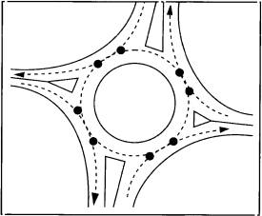
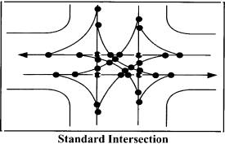
Roundabout

Figure 2.5 Conflicts points at conventional intersection and a roundabout (Source: City of Hutchinson web page)

Of the 8 conflicts points in a modern roundabout there are some common crash patterns observed [Road Planning Design Manual, Queensland, 2001]. They are rear end crash at the entry, side impact (side swipe) by an entry and a circulating vehicle and a rear end crash on an exiting vehicle by the circulating vehicle. However, the most serious type of intersection crash, the right angle (T-bone) crash, is almost impossible at a well-designed modern roundabout, certainly by prudent drivers exercising reasonable care.
The FHWA guide combined crash data from France, Queensland (Australia) and the UK. A total of sixteen crash patterns were identified:
- single vehicle loss of control at the exit,
- exiting vehicle on the entering,
- rear-end in the circulatory roadway,
- rear-end at the exit,
- passing a bicycle at entry,
- passing a bicycle at exit,
- weaving in circulatory roadway,
- wrong direction in circulatory roadway,
- pedestrian on circulatory roadway,
- pedestrian at approach outside crosswalk,
- passing a bicycle at entry,
- passing a bicycle at exit,
- weaving in circulatory roadway,
- wrong direction in circulatory roadway,
- pedestrian on circulatory roadway, and
- pedestrian at approach outside crosswalk (see Figure 2.6).
- The speed differential or relative speeds
Speed differential can be defined as the relative speeds of vehicles on each of the crossroads at an intersection. For a well-designed modern roundabout the relative speeds will be reduced because of the approach curvature and/or the deflection at the entry. The higher the relative speed of vehicles, the higher is the potential of higher vehicle crash rates and greater severity [Road Planning Design Manual, Queensland, 2001].

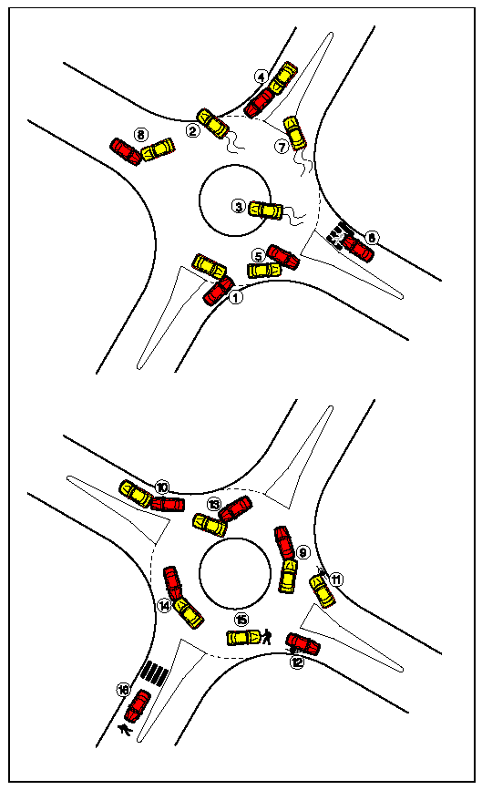
Figure 2.6 Common crash patterns in a singlelane modern roundabout (Source: taken from FHWA Guide 2000)
- Absolute speed
In a well-designed modern roundabout, vehicle speeds are reduced to a manageable level. The geometric features of the modern roundabout cause both entering vehicles entering and circulating vehicles in the modern roundabout to slow down to a safe and a controllable speed. Low absolute speeds allow the driver to have more time to react to potential conflicts and hence the likelihood of a fatal crash becomes rare [FHWA Guide 2000].

2.12 Public opinion about modern roundabouts

This section presents a brief summary of public opinion about the modern roundabouts in the USA and particularly, the public opinion in Hutchinson, Kansas about the modern roundabout at the study location. Public opinion is discussed in this report because opposition to modern roundabouts is prevalent in many areas of the USA and is something that has to be addressed as the use of the modern roundabout for intersection traffic control grows. The United States of America is far behind the rest of the world that uses modern roundabouts for intersection traffic control in appreciating and accepting the benefits of modern roundabouts. Many members of the public perceive that modern roundabouts are the same as most old traffic circles or rotaries that were inefficient, congested and confusing. Also, they dislike and show resistance to change in both driving behavior and their driving environment [Russell et al., 2002]. In many parts of the USA obtaining public acceptance for installing the first modern roundabout as an alternative traffic control treatment in an area is one of today’s biggest challenges [FHWA 2000, Russell et al., 2002].
A study sponsored by the IIHS examined public opinion regarding modern roundabouts in the USA, both before and after construction of a modern roundabout. It was found that the proportion of drivers opposed to modern roundabouts decreased from 55 to 28 percent, the proportion strongly opposed decreased from 41 to 15 percent and the proportion favoring modern roundabouts increased from 31 to 63 percent [Retting et al., 2001].
The City of Hutchinson, KS considered the modern roundabout as an alternative to direct traffic at the intersection of 23rd Avenue and Severance Street in early August 1999. The traffic volume at the intersection was insufficient for Kansas Department of Transportation (KDOT) to approve a federally funded traffic signal system. However, KDOT would provide funding for a modern roundabout; therefore, the City considered a modern roundabout. On the 18th of August 1999, the City Council endorsed constructing a modern roundabout with one opposing vote and applied for federal funds. However, there was considerable opposition for the implementation of a modern roundabout by several Hutchinson citizens.
A group of people calling themselves Citizens Against Roundabouts (CAR) used radio, newspaper advertising, a downtown billboard and a petition drive with approximately 350 signatures in an attempt to convince the council to reverse the decision to install the modern roundabout. By November 1999, many citizens’ concerns were raised. In an attempt to calm citizens’ concerns, a mock roundabout in the Sports Arena parking lot was demonstrated. Police cars, fire trucks and 18-wheelers were tested and no problems were reported. A neighborhood petition against the roundabout idea on December 1999 pushed one more councilman against the roundabout. However, Hutchinson’s plan to construct the city’s first modern roundabout prevailed on a 3-2 vote The modern roundabout about was completed by August 2000 in time for the annual Kansas State Fair in September. After it had been in operation for sometime, the officials who worked towards implementing the modern roundabout at 23rd and Severance, received kudos from the Hutchinson public. It is believed that public acceptance of modern roundabouts will escalate as more drivers experience and adapt to this safer and more efficient form of intersection control.

2.13 Summary

This chapter presented the summary of the literature review conducted for this study. From the literature it appears that modern roundabouts are a unique type of intersection control that is beginning to be accepted as a potential candidate for intersection treatment in the USA. There is some reluctance from the public in accepting modern roundabouts, however, it is believed that once they experience driving through them and getting used to them, their opposition will decrease.
A modern roundabout substantially reduces the points for potential crashes (conflict points) at the intersection resulting in a low probability for crashes to occur. Also, well- designed modern roundabouts can operate better in terms of safety and operational efficiency than compared with other conventional intersection traffic control types.

3 Experimental Design

3.1 General

The study method used for the Hutchinson modern roundabout is similar to the one that was adopted in earlier studies by KSU on different intersection scenarios that used comparable intersection types to make an assessment on the performance of the modern roundabout in Manhattan, KS [Russell et al., 2000] and before & after studies performed by a KSU team at sites in Kansas, Nevada and Maryland where modern roundabout replaced stop signs. [IIHS 2001]

3.2 Data collection

The data required for this study were the hourly traffic volumes going through the intersection, the geometric parameters of the intersection and the intersection approach speeds at the study intersection. The geometric parameters and the approach speeds were collected during a site visit.
The traffic data collection process consists of two phases:
- video data collection, and
- visual data collection from the video tapes.
With the assistance from the Engineering Department, City of Hutchinson, the KSU research team installed a 360° omni-directional video camera at the end of the light arm on the top of an existing light pole (see Figure 3.1).
The scene viewed by the camera was fed into a VCR/TV sheltered in a steel traffic signal cabinet (see Figure 3.2) to be recorded on six-hour standard VHS videotapes. The videotapes
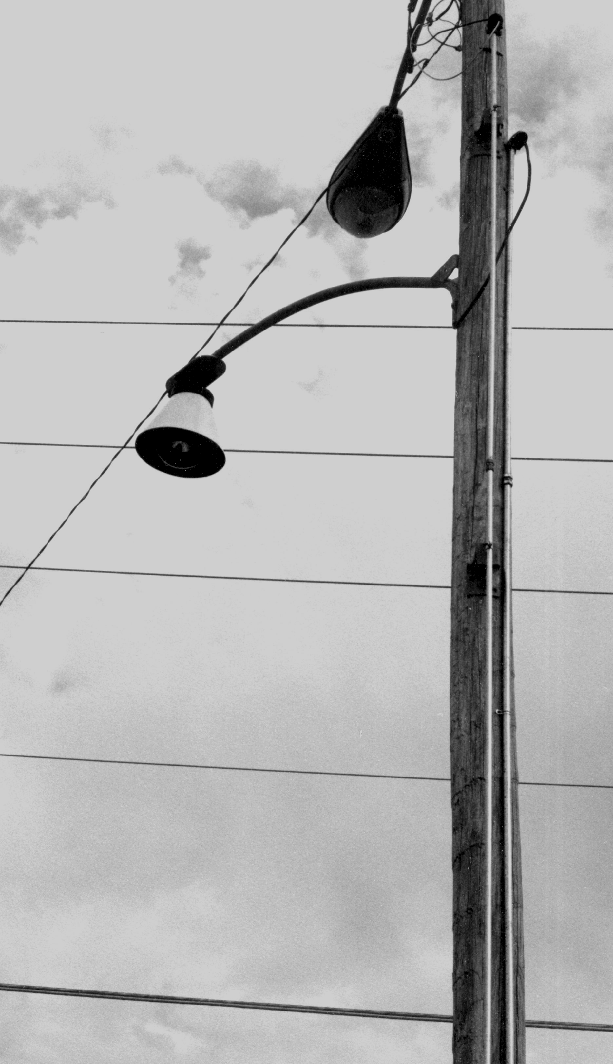

Figure 3.1 Camera mounted on a lamp pole (Source: Russell et al., 2000)

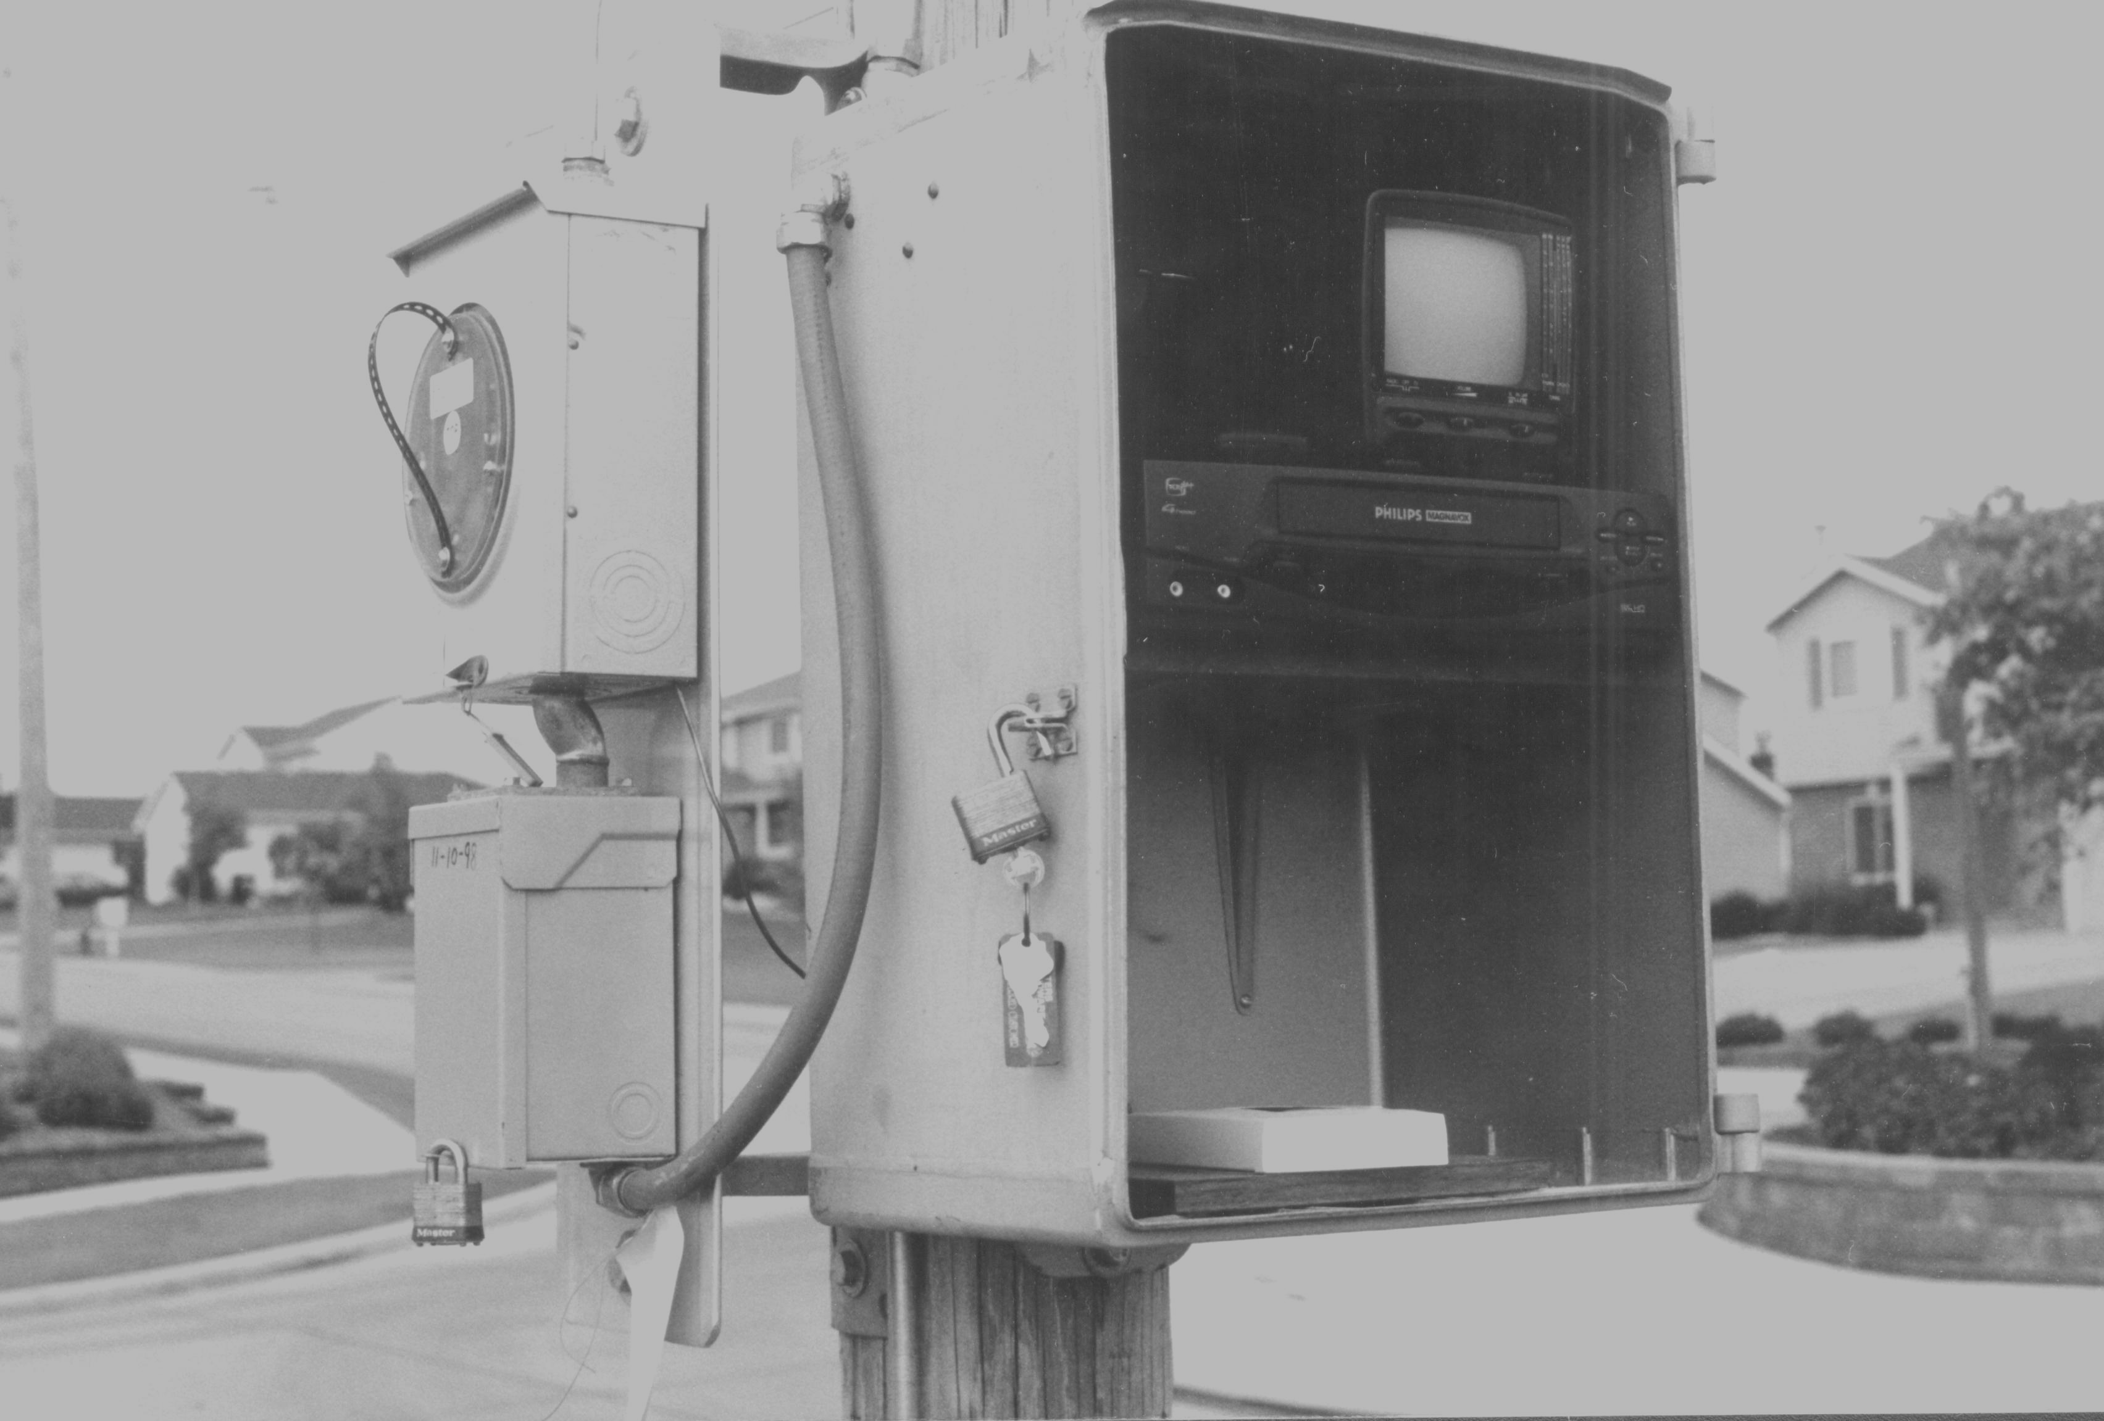
Figure 3.2 VCR/TV signal steel cabinet (Source: Russell et al., 2000)

were changed every six-hours by City of Hutchinson technicians. The pole selected allowed the camera to be strategically placed to get a view of the intersection such that the vehicles coming from all the approaches were captured on standard VHS videotape. The pole is approximately 6 m (20 feet) above the road surface. According to the camera specifications, this mounting height provides a focal plane of approximately 40.5 m by 54.0 m (133 feet by 177 feet) [List and Waldenmaier 1997 cited in Russell et al., 2000]. The focal plane of the camera could be adjusted by altering the height of the placement.
The traffic flows at the intersection were videotaped for the before condition (TWSC) and the after condition (modern roundabout) intersection types. A total of 156 hours of traffic data for the “before” condition (TWSC), 52 hours for “after” condition (modern roundabout) and 150 hours for “after fair” condition (modern roundabout with 2000 State Fair traffic) were videotaped. Subsequently, all the videotapes were studied visually to extract the traffic volumes and turning movements for the analysis. Various student graduate research assistants in the Department of Civil Engineering at KSU did the data extraction from the videotapes. Every vehicle coming from all the approaches for a period of fifteen (15) minutes was recorded on pre-prepared data collection sheets (see Figure 3.3). The right turning movements were marked on the right-hand side box (R), through movements (T) on the middle box and left turning movements (L) on the left-hand side box, respectively, for all the approaches. Subsequently data from these sheets were entered in spreadsheets (MS-Excel) to calculate the hourly volumes and peak hour factors (see Figure 3.4).

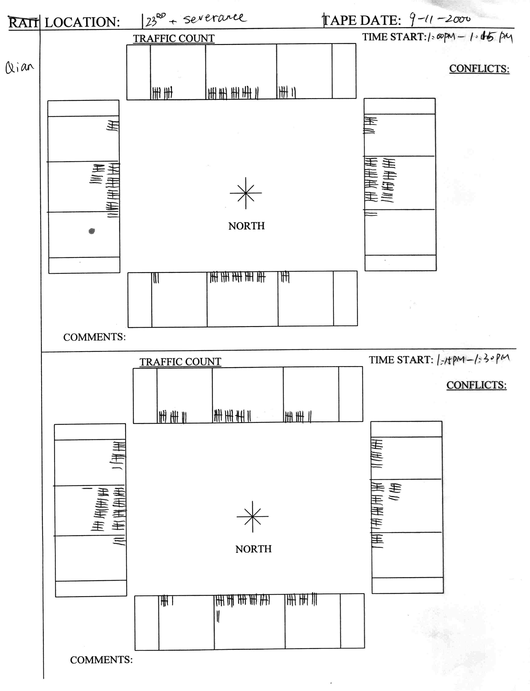
R

T

L

Figure 3.3 Pre-prepared volume counts mark sheet (A copy of an actual sheet)

3.3 Data analysis
The analysis part is divided into three parts
- Data analysis I - Operational analysis: This part of the analysis included the operational analysis done to evaluate and compare the before and after conditions at the study intersection. The evaluation of each intersection traffic control type was made using MOEs from SIDRA and the comparisons of the SIDRA MOEs were made using standard statistical analysis procedures.
- Data analysis II - Safety analysis: The safety evaluation for the study site was compared for the before and the after condition.
- Data analysis III - Theoretical analysis: This part of the analysis assumed various intersection traffic control types at the study intersection and, a comparison of their
Location: |  | HUTCHINSON After |  |  |  |  |  |  |  |  |  |  |  |  |  | Date: | 10/6/2000
Time |  |  | North Approach |  |  |  | East Approach |  |  |  | South Approach |  |  |  | West Approach |  |  | Intersection | Hour
Start: |  | Right | Thru | Left | Total | Right | Thru | Left | Total | Right | Thru | Left | Total | Right | Thru | Left | Total | Total: | Totals:
7:00 AM |  | 1 | 24 | 0 | 25 | 2 | 26 | 4 | 32 | 1 | 8 | 0 | 9 | 9 | 19 | 1 | 29 | 95 | na
7:15 AM |  | 5 | 41 | 3 | 49 | 4 | 34 | 27 | 65 | 3 | 15 | 2 | 20 | 22 | 45 | 3 | 70 | 204 | na
7:30 AM |  | 2 | 51 | 5 | 58 | 11 | 37 | 17 | 65 | 8 | 24 | 7 | 39 | 24 | 73 | 4 | 101 | 263 | na
7:45 AM |  | 3 | 42 | 7 | 52 | 7 | 46 | 8 | 61 | 17 | 31 | 3 | 51 | 9 | 63 | 8 | 80 | 244 | 806
8:00 AM |  | 6 | 16 | 5 | 27 | 4 | 28 | 8 | 40 | 9 | 24 | 1 | 34 | 5 | 33 | 9 | 47 | 148 | 859
8:15 AM |  | 2 | 27 | 8 | 37 | 7 | 25 | 4 | 36 | 3 | 18 | 1 | 22 | 2 | 18 | 2 | 22 | 117 | 772
8:30 AM |  | 7 | 28 | 6 | 41 | 9 | 29 | 10 | 48 | 7 | 18 | 2 | 27 | 4 | 29 | 4 | 37 | 153 | 662
8:45 AM |  | 3 | 30 | 7 | 40 | 5 | 29 | 6 | 40 | 5 | 22 | 4 | 31 | 4 | 31 | 4 | 39 | 150 | 568
9:00 AM |  | 3 | 31 | 5 | 39 | 8 | 22 | 8 | 38 | 6 | 20 | 3 | 29 | 1 | 22 | 4 | 27 | 133 | 553
9:15 AM |  | 4 | 18 | 5 | 27 | 3 | 27 | 5 | 35 | 11 | 22 | 3 | 36 | 1 | 26 | 8 | 35 | 133 | 569
9:30 AM |  | 5 | 21 | 6 | 32 | 5 | 27 | 4 | 36 | 6 | 22 | 6 | 34 | 5 | 32 | 3 | 40 | 142 | 558
9:45 AM |  | 5 | 34 | 10 | 49 | 8 | 25 | 6 | 39 | 8 | 18 | 9 | 35 | 1 | 19 | 3 | 23 | 146 | 554
10:00 AM |  | 4 | 25 | 8 | 37 | 9 | 38 | 6 | 53 | 4 | 28 | 7 | 39 | 4 | 33 | 8 | 45 | 174 | 595
10:15 AM |  | 5 | 22 | 8 | 35 | 11 | 23 | 6 | 40 | 6 | 24 | 5 | 35 | 2 | 31 | 1 | 34 | 144 | 606
10:30 AM |  | 1 | 21 | 10 | 32 | 8 | 31 | 5 | 44 | 11 | 22 | 5 | 38 | 5 | 26 | 4 | 35 | 149 | 613
10:45 AM |  | 4 | 22 | 10 | 36 | 13 | 27 | 6 | 46 | 13 | 35 | 5 | 53 | 4 | 41 | 2 | 47 | 182 | 649
 |  |  |  |  |  |  |  |  |  |  |  |  |  |  |  |  |  |  | 859
 |  |  | North Approach |  |  |  | East Approach |  |  |  | South Approach |  |  |  | West Approach |  |  | Intersection
Study Hour |  | Right | Thru | Left | Total | Right | Thru | Left | Total | Right | Thru | Left | Total | Right | Thru | Left | Total | Total: | PHF:
7:15-8:15 |  | 16 | 150 | 20 | 186 | 26 | 145 | 60 | 231 | 37 | 94 | 13 | 144 | 60 | 214 | 24 | 298 | 859 | 0.82
Turning Movements: |  |  |  |  |  |  | North
Time: | 7:15-8:15 |  |  |  |  | 16 | 150 | 20
 |  |  |  |  |  | <--' | | | '-->
 |  |  |  | 24 | ---^ |  | V |  | ^--- | 26
 |  |  | West | 214 | ---> |  |  |  | <--- | 145 | East
 |  |  |  | 60 | ---v |  | ^ |  | v--- | 60
 |  |  |  |  |  | <--, | | | ,-->
 |  |  |  |  |  | 13 | 94 | 37
 |  |  |  |  |  |  | South

Figure 3.4 Excel spreadsheet: Sample of visual data extracted from videotape
operational performance was made. The evaluation of each intersection traffic control type was made using MOEs from SIDRA and the comparisons of the SIDRA MOEs were made using standard statistical methods.

3.3.1 Statistical analysis overview

This study basically involved comparing independent treatment conditions (i.e. intersection traffic control types operating independently) based on responses (i.e. MOEs). The treatments are considered independent because the samples (traffic hourly volumes) observed for each treatment condition is not influenced by the other treatment(s). In other words, only one intersection traffic control type at a time was observed.
The standard statistical tests that were used in this study were:
- analysis of variance (ANOVA) and
- non-parametric test (Kruskal-Wallis)
ANOVA was used to compare whether the means of the treatment(s) are equal or not equal. This is used only if the data are normally distributed and are of equal variances. ANOVA produces an F-statistic accompanied with a p-value denoting the probability of obtaining an F-value as large as or larger than the calculated value under a users specified confidence interval (95% confidence interval was used in this study). A p-value > 0.05 means that we accept that the treatment means are equal and are comparable at the 95% confidence interval. If, on the other hand, a p-value turns out to be < 0.05, the test rejects the hypotheses that the treatment means are equal and comparable. The next step, (upon a p-value < 0.05) was to find which of the treatments are statistically different. Multiple comparison test methods such as Duncan’s and Turkey’s comparison test was used if the responses were normal and had equal variance. If normal and unequal variances existed, Welch’s test was used to compare the means and the Fisher least significant difference; multiple comparison test was subsequently used, if Welch’s test is rejected. The normality and the equality of variance tests were done using the Shiparo-Wilks test and Levene’s test, respectively. The p-values given by the tests were used for the test inferences as mentioned earlier.
If the data were not normally distributed, then the data were assumed to have an unknown population distribution with the same spreads, and tested as if they belonged to the same population distribution. Such tests are known as non-parametric tests, which are used when the distribution of the data is unknown. In this study, the Kruskal-Wallis (KW) test was used for the non-parametric test, if the data were non-normally distributed. The test gives a p-value and if the p-value is < 0.5 at the 95% confidence interval, the average rank order for the data points of the treatment given by the test are compared. The lower the average rank order of a treatment relative to another, the better the treatment is, compared to the other. If a p-value is > 0.05, the population distribution for the treatments are considered to be the same and they are considered to be not significantly different.
The statistical tests mentioned above were used for the following purposes in this study:

- To test if the traffic volumes collected represented the same population and are comparable, and
- To test the statistical significance of the differences between the measures of effectiveness of the intersection traffic control types.

3.4 Summary

This chapter presented the methodology used for the data collection and data analysis for this study. Traffic data recorded on the videotapes was extracted visually and those volumes were used in a computer program (SIDRA) along with the geometric specifics of various intersection traffic control types to analysis their operation using MOEs obtained from SIDRA. Subsequently, through statistical methods, comparisons of the intersection traffic control types were made based on six MOEs obtained from SIDRA.

4 Data Collection

4.1 General

This chapter covers description of the study site, a summary of the data collected and the traffic volume trends at the study intersection.

4.2 Site description

The study intersection is the junction of two arterials in the center of a multi-functional area in the northeast section of Hutchinson, KS. To the southwest of the study intersection is a parking area for the Kansas State Fair. The northwest corner has a rehabilitation center/nursing home. Behind the center (to the north) are school district athletic fields. Across the street to the east from the rehabilitation center (NE corner) there is a credit union. Beyond the credit union is a residential neighborhood made up of duplexes and single-family homes. The southeast corner and beyond is also residential in nature. Along the north and the south approaches, there is a drainage ditch of about 6 – 6.6 m (20 – 22 feet), which is open on the north approach, then continues underground under the intersection towards the south. Due to the presence of the ditch, the south and the north approaches have a wide median of about 10.5 m (35 feet) (see Figure 4.1). This median led to the design of an oval shaped central island for the modern roundabout (see Figure 4.2).
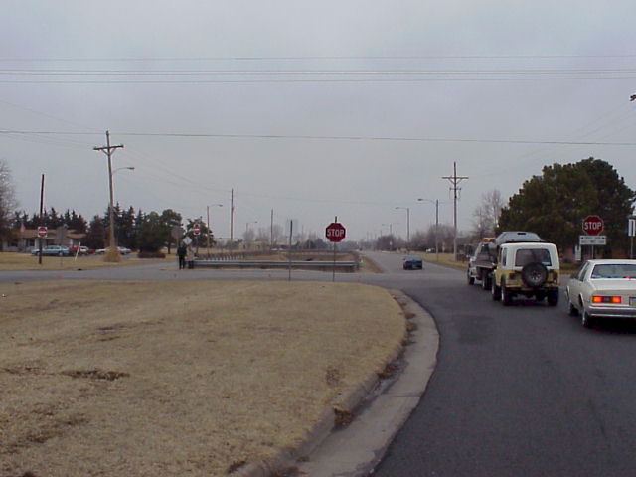

Figure 4.1 Two-way stop control at 23rd Ave and Severance St view from south approach (Photo courtesy: Dr. Russell)

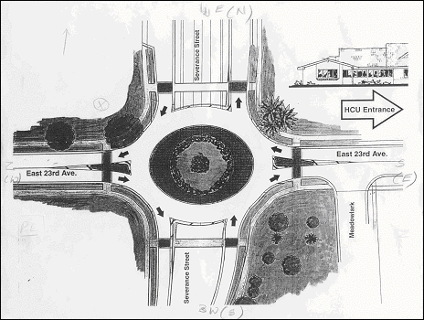
Figure 4.2 Hutchinson Modern roundabout (Not drawn to scale) Courtesy: Engineering department, City of Hutchinson, KS.

4.2 State fair traffic flow

In past years, prior to the construction of the modern roundabout, the study intersection (with the 23rd Avenue being the major street and the Severance Street being the minor street) was significantly affected by traffic generated from the east during the fair. Before the modern roundabout was built, traffic coming from the east came on 17th Avenue to Lorriane Street, then north on Lorriane Street to 23rd Avenue, then west on 23rd Avenue to the parking lot entrances (see Figure 4.3). After the modern roundabout was built, a newly constructed entrance allowed vehicles to enter the parking lot without going through the modern roundabout at 23rd Avenue and Severance Street. As a result, the heavy traffic usually experienced during the fair week at this intersection did not materialize. This fact was not known until the study was underway. This situation led to a decision to theoretically increase the peak hour fair traffic using the ‘flow scale’ options in SIDRA (as explained in Chapter 2) for analyzing intersection traffic control types under high traffic volumes.

4.3 Two-way stop control - Before condition

Prior to the installation of the modern roundabout at this site the intersection was controlled by TWSC, i.e., stops signs on Severance Street (minor street). This type of control allows priority for the major street users and the minor street users wait for an acceptable gap to make the maneuver through the intersection. Intuitively, TWSC causes more delays for the minor street users and little or none for the major street users. Since the maneuvering from the minor street through the major street depends on subjective judgment of an acceptable gap, it creates a safety issue for the traffic entering the intersection.
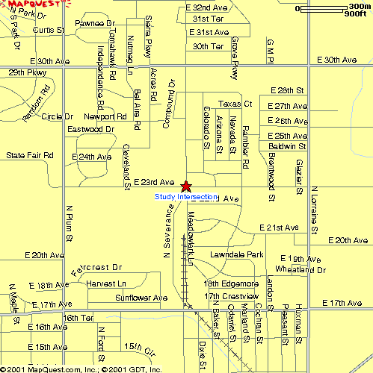
Figure 4.3 Routes for the traffic from east to the fair parking lots
(Downloaded from www.mapquest.com)

4.3.1 Crash History- Before condition

The crash history obtained from the Engineering Department, City of Hutchinson, KS revealed that there had been nineteen right angle collisions within a span of one year and nine months with six injury crashes and thirteen property damage crashes and no fatal crashes (see Figure 4.4).

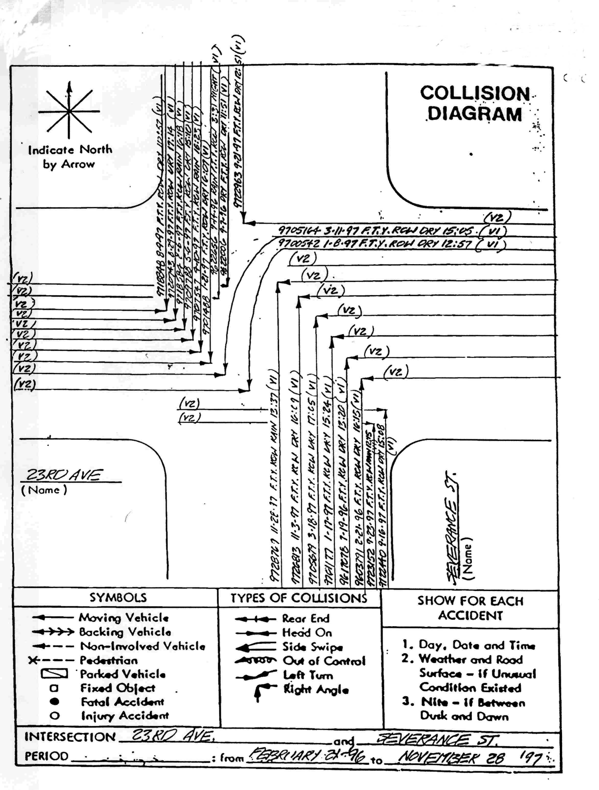
Figure 4.4 Collision diagram-Before condition (not drawn to scale) (Source: Engineering Department, City of Hutchinson, KS)

4.3.2 Geometric parameters - Before condition

Severance Street (N-S) has lane widths of 4.2 m (14 feet) and a 10.5 m (35 feet) median (drainage ditch) on both the approaches (see Figure 4.1). The major street, 23rd Avenue (E-W) has 3.6 m (12 feet) lane widths on the 23rd Avenue (E-W) with no median (see Figure 4.5). All the approaches are single lane. The posted speed limit is 48 km/h (30 mph) an all the approaches. Spot speeds obtained during a site visit indicated that the operating speeds on the approaches was 52 km/h (32 mph) on 23rd Avenue (E-W) and 61 km/h (38 mph) on Severance Street (N-S).

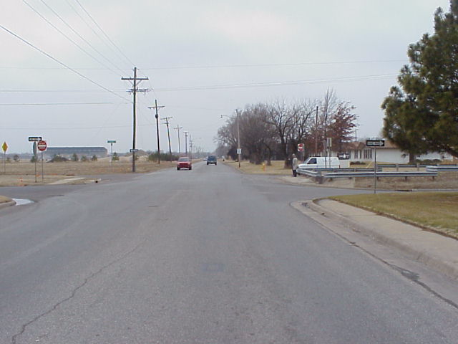
Figure 4.5 Two-way stop control at 23rd Ave and Severance St View from east approach (Photo courtesy: Dr. Russell)

4.4 The Hutchinson Modern roundabout – After Condition

The Hutchinson engineering department, ranked the study intersection 4th in the order of frequency and severity of crashes in 1998 in Hutchinson, KS. The City of Hutchinson decided upon installing its first modern roundabout (see Figure 4.6) at the study intersection mainly to alleviate crash problems and increase safety at this intersection. As stated earlier in Chapter 2 research on modern roundabouts and experiences in the USA [Jacquemart 1998; KDOT 2000; IIHS 2000] indicates that modern roundabouts are a safer form of intersection traffic control than other, conventional intersection controls.

4.4.1 Crash history - After condition

At the time of the Hutchinson data was analyzed, one year and three months after the modern roundabout was opened, there have been only two reported property damage crashes and no injury or fatal crashes. One of the crashes was reported to be a rear end collision due a skid on ice and the other was reported as a failure to yield at the entry for the circulating traffic (see Figure 4.7).

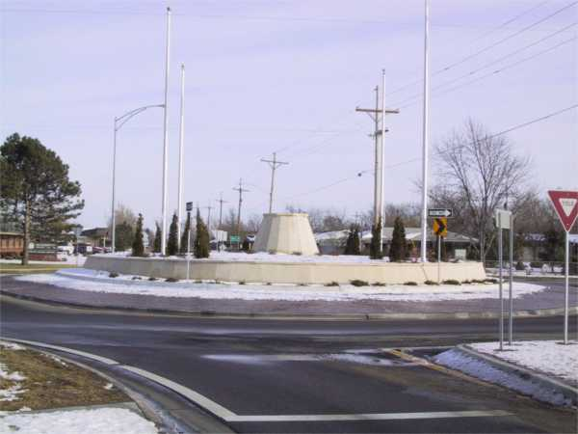
Figure 4.6 Hutchinson modern roundabout at 23rd and Severance: view from the east exit (Photo courtesy: Engineering department, City of Hutchinson, KS)

4.4.2 Geometric parameters- After condition

This first modern roundabout in Hutchinson, KS is a single lane roundabout with an oval central island. The roundabout has a circulating lane width (W_{c}) of 5.7 m (19 feet) on a flat terrain (zero gradient on all the approaches). The approach lane width is 3 m (10 feet) and 2.7 m (9 feet) for the N-S and E-W approaches respectively. The inscribed diameter (D_{i}) was measured to the middle of the stop line of the approach road in order to get the equivalent central island diameter measure for oval roundabouts* [Alcelik and Besley 1998]. The central island diameter was thus calculated as 30 m (100 feet) and used as input into SIDRA. The posted speed limits on the approaches were 48 km/h (30 mph). However, a field study showed that the average spot speeds on the approaches were 51 km/h (32 mph) for the 23rd Avenue (E-W) approaches and 61 km/h (38 mph) for the Severance Street (N-S) approaches.
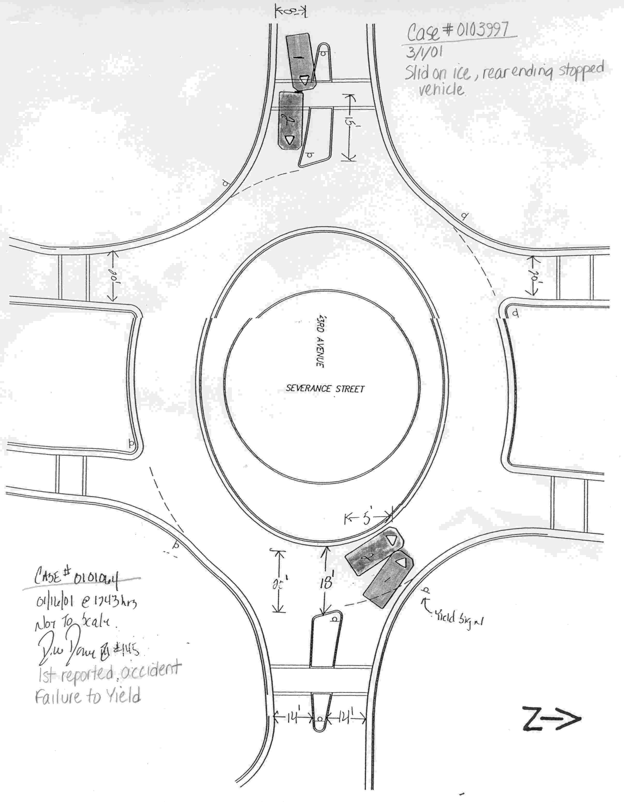
Figure 4.7 Collision diagram - After condition (not draw to scale) (Source: Engineering department, City of Hutchinson, KS)

4.5 Hourly volumes

According to 1998 records (the latest available to the researchers), 23rd Avenue carries an annual average, two-way daily traffic of 8818 vehicles. To obtain videotaped traffic volume data for the busiest 12 hours, the local engineers suggested using a data collection period from 7:00 AM to 7:00 PM for “normal days”. A normal day in this study refers to a day with no adverse environmental/weather or any external factor(s), such as special events in the nearby locality of the study intersection that would impact the flow of traffic through the study intersection. The traffic volumes for the before and the two after conditions, were videotaped on two six hour videotapes. The before condition was with the intersection operating on normal days with TWSC. The after condition was with the intersection operating on normal days after the modern roundabout was in operation. The second after condition was with the intersection operating during the 2000 annual state fair weeks. The traffic data will be referred to hereafter as “before”, “after” and “after fair” in this document.
The southwest side of the study intersection has a parking lot that is used during the state fair. Thus, when the study was planned, it was believed that very heavy traffic would go through the modern roundabout. Therefore, traffic volumes were observed during the 2000 state fair week to assess the performance of the modern roundabout under the expected heavy traffic flows, i.e. the “after fair” data. A total of 156 hours of video data were obtained for the “before” condition (i.e. when TWSC was operating in normal days), 52 hours for the “after” condition (i.e. when modern roundabout was operating in normal days) and 150 hours for “after fair” (i.e. when modern roundabout was operating during the weeks of the annual 2000 Kansas state fair).
Subsequently, by watching the videotapes, 15-minute turning movement counts were obtained and recorded. Periods that had traffic less than 200 vehicles per hour were ignored in the analysis, as it was desired to study their operational performance under higher volumes.
Some portion of the video data on the east approach recorded glare from the sun that rendered it difficult to view the vehicles and be sure of the extract turning movements. As a result of this, some data was unavailable. Therefore, the effective hours of traffic data used for the analysis were 153 hours for the “before” condition, 46 hours for the “after” condition and 143 hours for the “after fair” condition. Table 4.1 gives the statistics for the observed hourly traffic volumes when the intersection was operating under these respective conditions and Figure 4.8 shows the traffic volume variation on a typical day when the intersection was operating under these different conditions.

Table 4.1 Descriptive statistics for the observed hourly traffic volumes
Statistics | Intersection Treatments
 | Before | After | After fair
Min | 244 | 280 | 230
Mean | 785 | 731 | 803
Max | 1206 | 1110 | 1434
Stdev | 212 | 193 | 213
No.of Data points | 153 | 46 | 143

During the process of visual data extraction from the videotapes, it was observed that pedestrian and bicyclists’ traffic was low, then they were ignored in the analysis. Heavy vehicle traffic going through the intersection was also light and therefore, they were not counted separately. Instead, heavy vehicle traffic was assumed to be 3% of the total traffic volumes on each of the approaches. The average headways for a period of 24 hours were obtained on each of the approaches by the Hutchinson engineering department. The north and south approaches had an average headway of 13 and 12 seconds respectively, and the east and west approach had 10 and 11 second average headways, respectively.

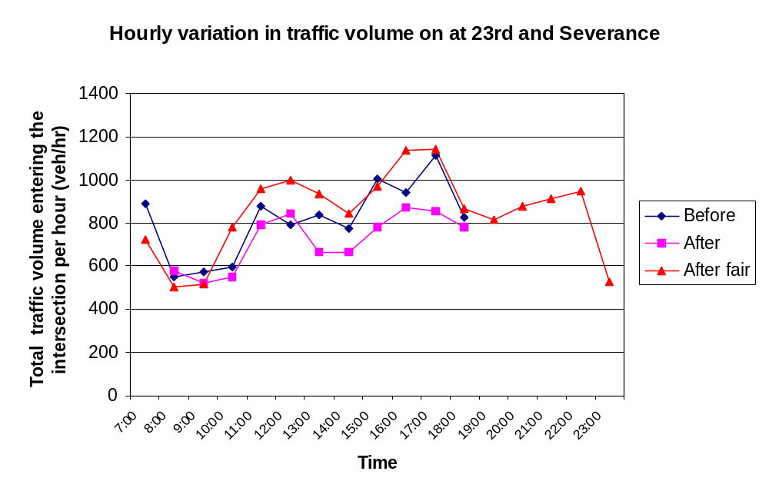

Figure 4.8∗ Traffic volume variations on an average day

5 Data analysis i -operational analysis

5.1 General

Statistical tests were performed to determine if the observed hourly volumes were comparable (see Appendix A for a detailed description of the tests). Through the statistical tests, it was inferred that the “before” hourly volumes are comparable to both the “after” and “after fair” hourly volumes, respectively. It is believed that the reason that “after fair” traffic is similar to the “before” traffic when the intersection was operating with stop signs (TWSC) is due to the fact that most of the fair traffic coming from the east was diverted to another fair parking lot entrance and did not go through the modern roundabout as had been expected. The “after fair” condition proved to be statistically comparable, and had near balanced samples with the “before” condition. Thus the “after fair” traffic was more like the “after” traffic and was used for the comparison purposes with the “before” condition. This chapter describes the comparison on the operational performance for the before condition (TWSC) and after condition (modern roundabout) at the study intersection.
As mentioned previously, SIDRA was used to obtain the six performance measures (MOEs) for the intersection traffic control types studied. SIDRA was set up for right-hand side driving, data entry in USA customary units (foot-pound-seconds scale) and control delay definition as used in the USA, Highway Capacity Manual (HCM). However, SIDRA was configured such that the delay due to the geometry of the intersection was also taken into consideration. A discussion of the analysis and comparison of the MOEs obtained from SIDRA are presented in the following section.

5.2 Operational analysis

This analysis was conducted to objectively analyze the performance of the various treatment conditions discussed previously. In this part of the study, the treatment units are the intersection traffic control types; namely, TWSC and the Hutchinson modern roundabout. The traffic data collected were entered into the computer program and the output (six MOEs) were obtained. Table 5.1 (next page) shows the descriptive statistics of the MOEs. The output indicates that the mean values of the six MOEs are better for the modern roundabout than for the TWSC, based on the six MOEs i.e., the modern roundabout was operating more efficiently. This indicates that the Hutchinson modern roundabout performed well at this site. The comparison analysis is discussed in more detail in the following section.

5.3 Comparison analysis

As all the MOEs were not normally distributed, the non-parametric Kruskal Wallis (KW) test was used to test the comparison, as discussed previously (ref sec 3.3.1 Chapter 3 pp 55-56). Table 5.2 shows the KW test summary obtained from Minitab that compares the 95th percentile queue length for the modern roundabout (RA) and TWSC.

Table 5.2 Minitab output: Kruskal Wallis summary comparing 95th percentile queue length between TWSC and RA
95th Percentile Queue length

Factors N Median Ave Rank Z
RA 143 59.00 106.7 -8.11
TWSC 153 114.00 187.5 8.11
Overall 296 148.5

H = 65.84 DF = 1 P = 0.00
H = 65.85 DF = 1 P = 0.00 (adjusted for ties)

Table 5.1 Descriptive statistics of the moes
 | Minimum |  | Mean |  | Maximum |  | Standard deviation
Measure of effectiveness | TWSC | RA | TWSC | RA | TWSC | RA | TWSC | RA
95th Percentile queue length (ft) | 14 | 17 | 146 | 72 | 499 | 357 | 92 | 48
Average intersection delay (sec) | 4.5 | 10.3 | 13.7 | 12.0 | 36.2 | 20.9 | 5.8 | 1.4
Maximum approach delay (sec) | 10.3 | 11.5 | 27.7 | 14.8 | 89.9 | 63.3 | 14.4 | 5.74
Proportion stopped | 0.24 | 0.20 | 0.53 | 0.46 | 0.90 | 0.81 | 0.10 | 0.09
Maximum proportion stopped | 0.28 | 0.33 | 0.71 | 0.60 | 1.00 | 0.99 | 0.15 | 0.13
Degree of saturation (v/c ratio) | 0.097 | 0.087 | 0.565 | 0.309 | 1.000 | 0.867 | 0.204 | 0.132

TWSC: Two-way stop control (before condition)

RA: Hutchinson modern roundabout (after fair condition)
The p-value of 0.00 < 0.05 rejects the hypotheses that the 95th percentile queue length for TWSC and RA has the same population distribution; therefore, the average rank order obtained from the KW test is compared. The average rank order for RA (106.7) is less than the rank order for TWSC (187.5). Hence, it is inferred that RA performs better than TWSC (i.e. RA>TWSC) based on the 95th percentile queue length. Table 5.3 (next page) presents the summary of the Kruskal Wallis test results as obtained from running the KW test on the MOEs using Minitab.
After performing the analysis it was observed that there was a percentage reduction in all the MOEs for the modern roundabout at the study site, i.e. the modern roundabout performed better on all the six MOEs and the difference on five was statistically significant. There were reductions of 51% in the 95th percentile queue length, 12% in the average intersection delay, 47% in the maximum approach delay, 13% in the proportion stopped, 30% in the maximum proportion stopped and 40% in the degree of saturation. All but average intersection delay were statistically significant at the 95% confidence interval. Table 5.4 shows the results.

Table 5.4 Summary of comparison results (TWSC vs RA)

Measures of Effectiveness | Intersection Types |  | Percentage Reduction | Statistical Significance
 | TWSC | RA | (%) | For α =0.05
95th Percentile Queue Length (ft) | 146 | 72 | 51 | Yes
Average Intersection Delay (sec) | 13.7 | 12.0 | 12 | No
Maximum Approach Delay (sec) | 27.7 | 14.8 | 47 | Yes
Proportion Stopped | 0.53 | 0.46 | 13 | Yes
Maximum Proportion Stopped | 0.71 | 0.60 | 30 | Yes
Degree of Saturation (v/c ratio) | 0.565 | 0.309 | 40 | Yes

Table 5.3 Summary of statistical test to compare TWSC and RA

 |  |  | Kruskal Wallis Test |  | Average Rank Order
Measure of Effectiveness |  |  | p-value | Result | TWSC | RA | Efficient intersection type  Best-→ Worst
95th Percentile Queue Length (ft) |  |  | 0.00 | Reject Ho: | 187.5 | 106.7 | RA>TWSC
Average intersection delay (sec) |  |  | 0.36 | Failed to reject Ho: | n/a | n/a | n/a
Maximum approach delay (sec) |  |  | 0.00 | Reject Ho: | 201.7 | 91.6 | RA>TWSC
Proportion stopped |  |  | 0.00 | Reject Ho: | 173.8 | 121.5 | RA>TWSC
Maximum proportion stopped |  |  | 0.00 | Reject Ho: | 179.3 | 115.5 | RA>TWSC
Degree of saturation (v/c ratio) |  |  | 0.00 | Reject Ho: | 199.9 | 93.6 | RA>TWSC

n/a : Not applicable
TWSC: Two-way stop control (before condition)

RA: Hutchinson modern roundabout (after fair condition)
Reject Ho: The population distribution of the specific measure of effectiveness for the factors does not have same population distribution

5.4 Approach performance

The N-S approach is the minor street (Severance street) and the E-W approach is the major street (23rd Avenue). The proportion of the total vehicles entering the intersection having to stop because of vehicle(s) already in the intersection (in the one-hour period analyzed) is the proportion stopped and is expressed as a percentage. The approach that has the highest value of the proportion stopped is the maximum proportion stopped (MPS) approach. The percentage values in figures 5.1 and 5.2 denote the proportion of the study period that a given approach, for a given intersection type, had the maximum proportion stopped value.
The analysis for the “before” condition (see Figure 5.1), which had an average MPS value of 0.71 showed that the north approach was the MPS approach for 75% of the study period, followed by the south approach for 18% of the study period, then the east and west approaches with 4% and 3%, respectively. When the modern roundabout was in operation, the west approach had an MPS value for 38% of the study period, the east approach for 23%, the south approach for 31% and the north approach for 8%, with an average MPS value of 0.50 (see Figure 5.2). The MPS value for an approach that is the maximum stopped approach for a specific hourly volume might not be the same across different intersection traffic control types. Hence, no direct comparisons between intersection traffic control types should be made from the results of the performance of the approaches. However, since the average MPS value for the Hutchinson modern roundabout is less than the MPS value of the TWSC, it can be inferred that the Hutchinson modern roundabout reduced the number of vehicles having to stop and also improved the operation of the approaches based on a greater MPS value when the TWSC was operating.
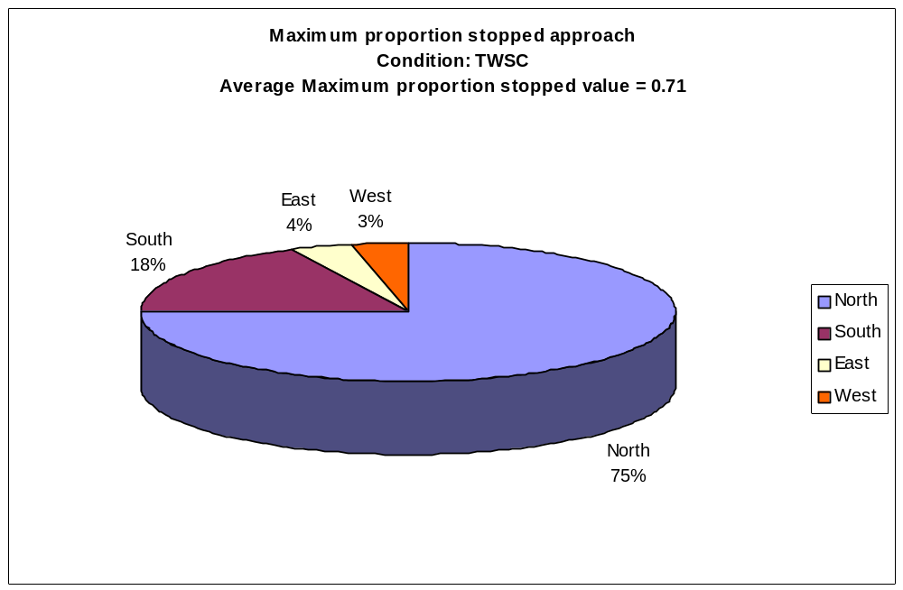
Figure 5.1 Maximum proportion stopped approach (TWSC)

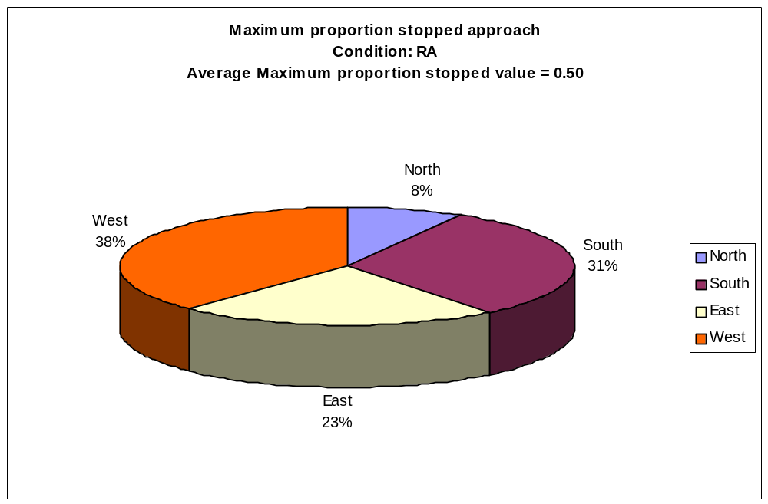

Figure 5.2 Maximum proportion stopped approach (RA)

5.5 Level of service (LOS)

As mentioned earlier, SIDRA calculates Level of Service (LOS), a qualitative measure based on overall, average intersection delay. The TWSC was operating in LOS ‘A’ for 39% of the study period, LOS ‘B’ for 28% and LOS ‘C’ for 29% (see Figure 5.3). The breakpoints for LOS with respect to total hourly volume entering the intersection are shown in Table 5.5. The modern roundabout at the study intersection operated in LOS ‘B’ for the entire study period with hourly volume ranging from 230 – 1434 vehicle per hour).

Table 5.5 Summary of intersection performance with respect to hourly entering volume & los - twsc

Entering volume range (TWSC)  Veh/hr | Intersection LOS
244 – 865 | A
582 – 916 | B
639 – 1250 | C
1035 – 1206 | D
> 1171 | E

Note: The reason for the hourly volume ranges in the above table overlap may be due to different proportions in the turning movements (not shown in the table) for each hourly entering volume.

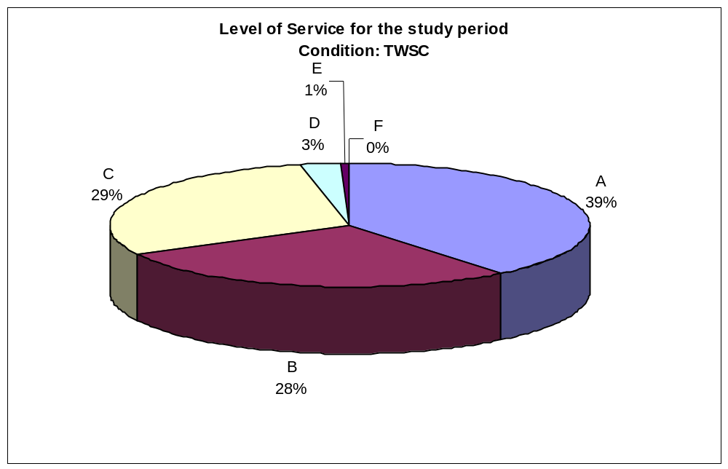
Figure 5.3 Level of service (TWSC)

The following chapter evaluates the safety of the intersection before and after the modern roundabout was built at the study intersection.

5.6 Summary

This chapter presented the results of the operational analysis and a summary of the results of statistical tests conducted for the intersection traffic control types. Reduction in all the six MOEs, with five of the reductions being statistically significant, shows that the Hutchinson modern roundabout performs better than the TWSC at the study intersection.

6 Data analysis ii –safety analysis

6.1 General

One of the prime reasons the city engineering staff wanted to replace the TWSC at 23rd Avenue and Severance Street with a modern roundabout at this study site was to improve safety. This chapter provides safety evaluation done for the before and after condition for the study site.

6.2 Safety evaluation for the study site

The before and the after crash records as of December 2001 for the 23rd and Severance intersection were presented in Chapter 4. The before crash history shows that all the crashes (nineteen of them) were right angle collisions increasing the potential for an injury or fatal crash. There were six injury crashes and no fatal crashes at the study intersection in the before analysis period. The after analysis period at the study intersection had two property damage crashes, and no injury or fatal crashes.
The literature provides clear evidence that modern roundabouts are safer than other conventional types of intersection traffic control. In addition, the crash history for the before and the after conditions for the study intersection at Hutchinson, KS indicates that there has been a considerable reduction in the number of crashes and severity of crashes over the period between the installation of the modern roundabout and the end of 2001. For similar before and after periods (one year and three months), there was an 88% reduction in the number of crashes and 100% reduction in the number of injury crashes after the installation of the modern roundabout at the study intersection. It can be concluded that the intersection is operating safer than it was before with the TWSC.
It can be seen that frequency of crashes and severity of crashes are significantly reduced since the modern roundabout was installed. It can be concluded that the intersection is operating safer than it was before with the TWSC.

6.3 Summary

The performance for the before and the after conditions in terms of operational benefits and safety benefits were documented and it is seen that the Hutchinson modern roundabout performed better in terms of operational and safety benefits at the study intersection.

7 Data analysis iii – Theoretical analysis

7.1 General

The operational analysis covered in Chapter 5 was to compare the performance of the study intersection before and after the implementation of a modern roundabout in place of the TWSC. As the traffic counts obtained when the TWSC was in operation were statistically similar to the fair traffic obtained when the modern roundabout was in operation, the fair traffic, referred to as “after fair”, was used in the comparison, as explained previously.
The primary objective of this part of the study was to determine how TWSC, AWSC and TSC at the study intersection would perform when compared to the Hutchinson modern roundabout for the fair traffic, if they had been installed. The secondary objective was to compare the performance of these intersection traffic control types under theoretically increased traffic loading, while assuming the distribution and turning movements of the assumed traffic in the same proportion as the existed peak hour fair traffic. The third objective was to estimate a design life for the intersection types studied, based on the degree of saturation. This chapter describes the analysis and the results obtained.

7.2 Comparability of the intersection types

This study deals with comparing various intersection traffic control types at 23rd and Severance, which was originally operated with TWSC and currently with a modern roundabout. The AWSC and TSC are assumed, and the TSC designed to have optimal parameters to accommodate the traffic at the study intersection. SIDRA was used to obtain the operational performance results. The AWSC assumed stop signs were installed on all the approaches of the study intersection and that the same lane configuration existed as when the TWSC was in place.
For the traffic signal condition, an appropriate traffic signal was designed. The objective of the design was to design an optimized TSC that could have been a viable alternative at the study intersection for the “before” traffic. A pre-timed traffic signal was assumed and the signal timing was optimized using TRANSYT-7F for the 50% projected, peak hour “before” traffic. The projection of the peak hour was used to compensate for any future fluctuations in the traffic. A simple 3-phase signal design was assumed to be appropriate.
All the approaches had a 22.5 m (75 ft) length and 3 m (10 ft) wide exclusive turn bay for the left turns and 3.6 m (12 ft) wide shared through and right turn lane. As TRANSYT 7F doesn’t model the right-turn-on- red (RTOR) for shared through and right turns, RTOR was ignored.
The projected peak hour used in the design of the signal timing was used as input into SIDRA to calculate the capacity of the designed signalized intersection and the Hutchinson modern roundabout. At LOS ‘C’ (based on the average intersection delay) and practical degree of saturation 0.85, the capacity for the designed TSC and for the Hutchinson modern roundabout came to be 3140 vehicles/hour and 3170 vehicles/hour respectively. Hence, the designed traffic signal was considered optimal to accommodate the traffic flow through the study intersection similar to the Hutchinson modern roundabout at or below the practical degree of saturation (0.85). See Appendix B for details of the traffic signal design.

7.3 Data and Analysis

The traffic distribution and turning movements used in this analysis were assumed to be the same for all intersection traffic control types studied. Thus, comparisons made on the performance results i.e. the six MOEs obtained from SIDRA, of the four traffic control types studied were made for the same traffic loading, based on a total of 143 effective hours of traffic volume data collected during the 2000 state fair. This traffic flow data was input into SIDRA, which was used to obtain the performance measures (MOEs) of TWSC, AWSC, TSC and modern roundabout. Subsequently, statistical tests were carried out in a manner similar to the before and after study previously presented in Chapter 5.
The MOEs were not normally distributed and Kruskal Wallis (KW) test was carried out on the MOEs, as was done previously (ref sec 5.3) to determine if the intersection traffic control types had the same population distribution. For all MOEs it was observed that the Hutchinson modern roundabout (RA) performed better than the TWSC, AWSC and the TSC.
The TWSC performed better based on all the MOEs, except the 95th percentile queue length when compared to the AWSC and better than the TSC based on all the MOEs, except the degree of saturation. The TSC performed better than the TWSC and the AWSC for the degree of saturation. The AWSC performed better than the TWSC and TSC for the 95th percentile queue length. The results are shown in Table 7.1.
The operational analysis for the TWSC compared to the Hutchinson modern roundabout, under the assumed traffic loading, showed that the performance of the modern roundabout contributed a 69% reduction in the 95th percentile queue, a 35% reduction in average

Table 7.1 Summary of statistical test to compare RA, TWSC, AWSC and TSC

 |  |  | Kruskal Wallis Test |  | Average Rank Order
Measure of Effectiveness |  |  | p-value | Results | RA | TWSC | AWSC | TSC | Efficient Intersection Type
 |  |  |  |  |  |  |  |  | Best → Worst
95th Percentile Queue Length (ft) |  |  | 0.00 | Reject Ho: | 139.6 | 370.2 | 254.8 | 381.3 | RA>AWSC> TWSC>TSC
Average intersection delay (sec) |  |  | 0.00 | Reject Ho: | 113.1 | 242.4 | 410.6 | 380.0 | RA>TWSC>TSC>AWSC
Maximum approach delay (sec) |  |  | 0.00 | Reject Ho: | 88.6 | 310.5 | 312.0 | 434.8 | RA>TWSC>AWSC>TSC
Proportion stopped |  |  | 0.00 | Reject Ho: | 125.7 | 167.2 | 489.3 | 363.8 | RA>TWSC>TSC>AWSC
Maximum proportion stopped |  |  | 0.00 | Reject Ho: | 121.5 | 219.0 | 478.3 | 327.1 | RA>TWSC>TSC>AWSC
Degree of saturation |  |  | 0.00 | Reject Ho: | 119.0 | 356.8 | 388.0 | 282.1 | RA>TSC>TWSC>AWSC

TWSC: two-way stop control using fair traffic.
AWSC: all-way stop control using fair traffic.
RA: Hutchinson modern roundabout using fair traffic.
TSC: traffic signal control using fair traffic.
Reject Ho: The population distribution of the specific measure of effectiveness for the factors does not have same population distribution.
intersection delay, a 61% reduction in maximum approach delay and 10%, 17% and 51% reductions in proportion stopped, maximum proportion stopped and degree of saturation respectively (see Table 7.2).

Table 7.2 Summary of results (TWSC and RA)
Measure of Effectiveness | Intersection Types |  | Percentage Reduction | Statistical Significance
Measure of Effectiveness | TWSC | RA | (%) | For α=0.05
95th Percentile Queue Length (ft) | 234 | 72 | 69 | Yes
Average Intersection Delay (sec) | 18.4 | 12.0 | 35 | Yes
Maximum Approach Delay (sec) | 37.8 | 14.8 | 61 | Yes
Proportion Stopped | 0.51 | 0.46 | 10 | Yes
Maximum Proportion Stopped | 0.72 | 0.60 | 17 | Yes
Degree of Saturation | 0.636 | 0.309 | 51 | Yes
The performance of the Hutchinson modern roundabout, when compared to the AWSC, yielded a 48% reduction in the 95th percentile queue length, a 55% reduction in the average intersection delay, a 73% reduction in the maximum approach delay, a 50% reduction in the proportion stopped, a 38% reduction in the maximum proportion stopped and a 56% reduction in the degree of saturation (see Table 7.3).

Table 7.3 Summary of results (AWSC and RA)

Measure of Effectiveness | Intersection Types |  | Percentage Reduction | Statistical Significance
 | AWSC | RA | (%) | For α =0.05
95th Percentile Queue Length (ft) | 138 | 72 | 48 | Yes
Average Intersection Delay (sec) | 26.4 | 12.0 | 55 | Yes
Maximum Approach Delay (sec) | 54.0 | 14.8 | 73 | Yes
Proportion Stopped | 0.92 | 0.46 | 50 | Yes
Maximum Proportion Stopped | 0.96 | 0.60 | 38 | Yes
Degree of Saturation | 0.708 | 0.309 | 56 | Yes

The performance of the Hutchinson modern roundabout, when compared to the TSC, yielded a 62% reduction in the 95th percentile queue length, a 43% reduction in the average intersection delay, a 70% reduction in the maximum approach delay, a 43% reduction in the proportion stopped, a 31% reduction in the maximum proportion stopped and a 41% reduction in the degree of saturation (see Table 7.4).
The reductions in the MOEs on all comparisons mentioned above were found to be statistically different at the 95% confidence interval as indicated in Tables 7.1, 7.2 and 7.4.

Table 7.4 Summary of results (TSC and RA)

7.3.1 Approach performance
Measure of Effectiveness | Intersection Types |  | Percentage Reduction | Statistical Significance
Measure of Effectiveness | TSC | RA | (%) | For α=0.05
95th Percentile Queue Length (ft) | 188 | 72 | 62 | Yes
Average Intersection Delay (sec) | 21.2 | 12.0 | 43 | Yes
Maximum Approach Delay (sec) | 49.4 | 14.8 | 70 | Yes
Proportion Stopped | 0.81 | 0.46 | 43 | Yes
Maximum Proportion Stopped | 0.87 | 0.60 | 31 | Yes
Degree of Saturation | 0.528 | 0.309 | 41 | Yes

The approach that had the maximum proportion stopped (MPS) value for the specific intersection traffic control types studied are shown in Figures 7.1 to 7.4. From these figures the quality or efficiency of each intersection control type can be determined as though it had been in place for the 2000 state fair traffic. The percentage values in the figures denote the proportion of the study time period that the specific approach for an intersection type had the MPS value. As the average MPS value for the Hutchinson modern roundabout was less than the MPS values of other intersection types, it can be inferred that based on the MPS, the modern roundabout is capable of improving traffic operation on the approaches when compared with the other traffic control types studied. When comparing intersection traffic control types, based on the MPS values on the approaches, the best to the worst are: RA>TWSC>TSC>AWSC.
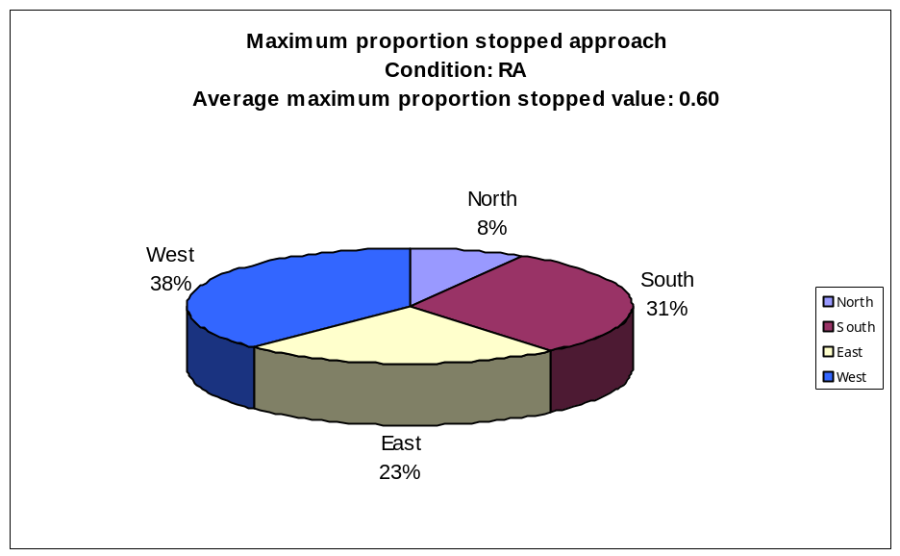
Figure 7.1 Maximum proportion stopped approach (RA)

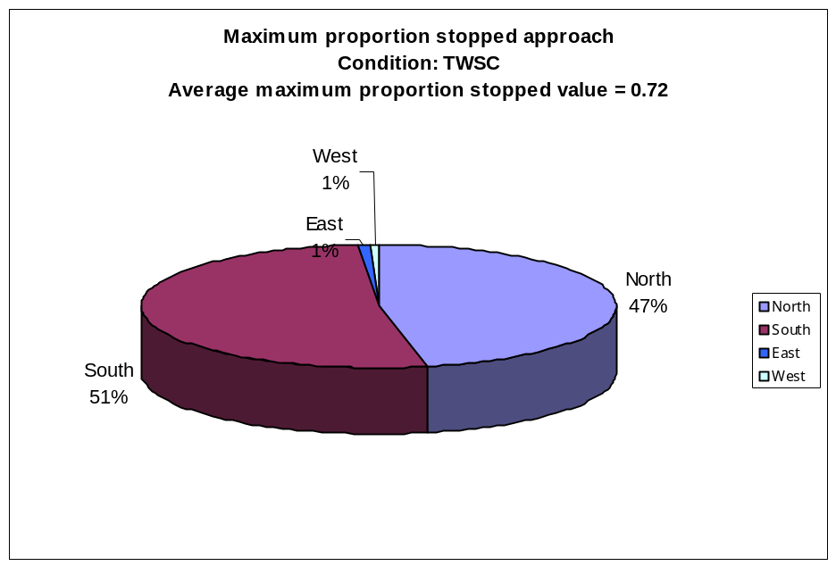

Figure 7.2 Maximum proportion stopped approach (TWSC)

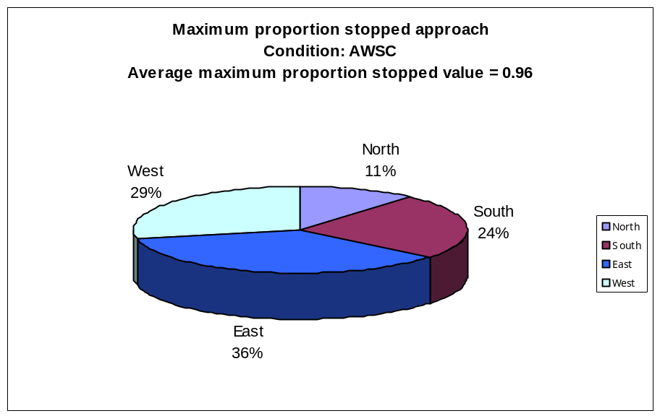

Figure 7.3 Maximum proportion stopped approach (AWSC)

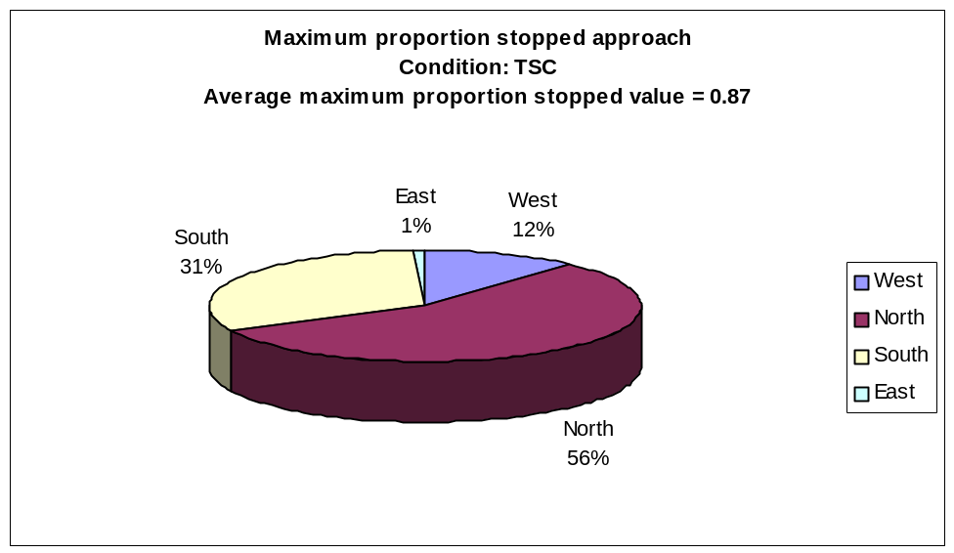

Figure 7.4 Maximum proportion stopped approach (TSC)

7.3.2 Level of service

It was determined that the TWSC was operating in LOS ‘C’ for 42% of the study period and LOS ‘B’ for 38% of the study period (see Figure 7.5). The AWSC was operating in LOS ‘C’ for 71% of the study period (see Figure 7.6). The Hutchinson modern roundabout performed in LOS ‘B’ for the entire range of the hourly volume observed (230-1434 veh/hr). The traffic signal performed in LOS ‘B’ for 41% of the study period and in LOS ‘C’ for 58% of the study period (see Figure 7.7) Breakpoints for the total hourly entering volume with respect to the LOS, based on the overall average intersection delay as obtained from SIDRA for TWSC, AWSC and TSC conditions, are given in Tables 7.5, 7.6 and 7.7.

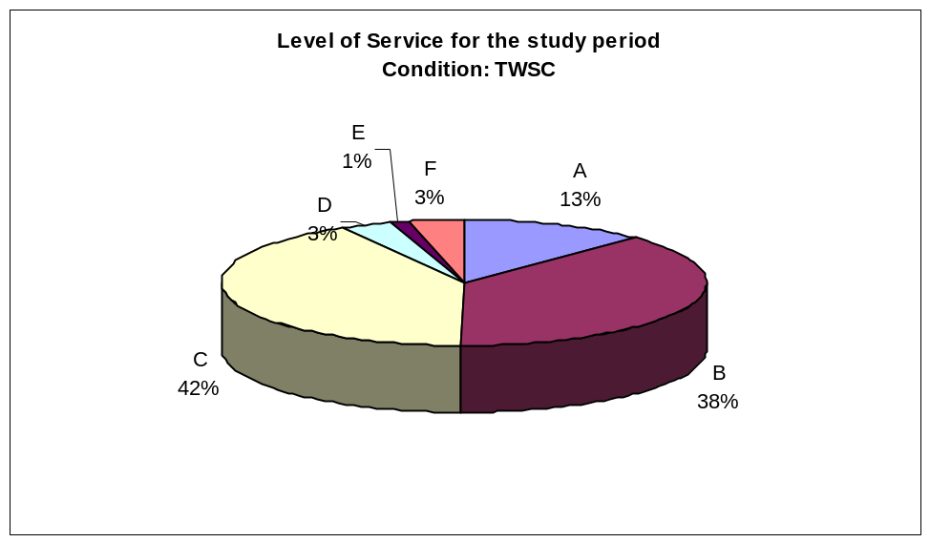
Figure 7.5 Level of service (TWSC)

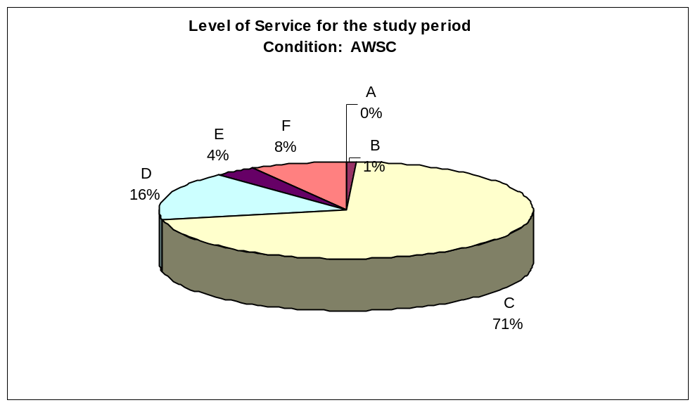
Figure 7.6 Level of service (AWSC)

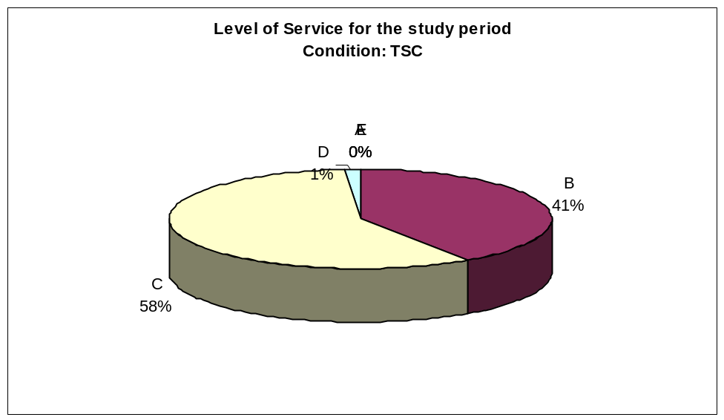

Figure 7.7 Level of service (TSC)

Table 7.5 Summary of intersection performance with respect to hourly entering volume (twsc)

Entering volume range (TWSC)  Veh/hr | Intersection LOS
230-785 | A
360-988 | B
534-1169 | C
1051-1230 | D
1012-1434 | E

Table 7.6 Summary of intersection performance with respect to hourly entering volume (awsc)

Entering volume range (AWSC) Veh/hr | Intersection LOS
- | A
- | B
230-1230 | C
446-1144 | D
785-1044 | E
706-1434 | F

Table 7.7 Summary of intersection performance with respect to hourly entering volume (TSC)

Entering volume range (TSC)  Veh/hr | Intersection LOS
- | A
230-1014 | B
528-1434 | C
873-1037 | D
- | E

Note: The reason for the hourly volume ranges in the above table overlap may be due to different proportions in the turning movements (not shown in the table) for each hourly entering volume.

The results obtained so far in this analysis show that the operational performance of the Hutchinson roundabout functioned better than the TWSC, AWSC and TSC would have functioned at the study intersection if they had been in place during the 2000 state fair. Also, since the traffic data collected during the 2000 state fair was statistically comparable to the “before” condition (traffic volumes collected during normal days), it could be concluded that, based on the six MOEs used, the Hutchinson modern roundabout is performing better than the AWSC and TSC would perform on normal day traffic conditions at the study intersection. The following section covers the performance of all intersection traffic control types studied (TWSC, AWSC, TSC and RA) under theoretically increased traffic loading.

7.4 Data analysis – theoretically increased traffic loading

In order to determine the performance of the intersection traffic control types (TWSC, AWSC, TSC and RA) at the study intersection, under assumed traffic growth, traffic volumes were theoretically increased using the flow scale options provided in SIDRA and the MOEs (95th percentile queue length, average intersection delay, degree of saturation and LOS) were evaluated. It was arbitrarily decided to obtain the results of different intersection control types with a maximum of 4000 vehicles passing through the study intersection during the peak hour.
The objective of the comparison in this phase of the study was to find the operating performance under very high volumes but below the practical degree of saturation (i.e. v/c ratio = 0.85). Typical traffic distribution and turning movements were determined by using actual data that had been obtained from a typical hour of the actual traffic observed. However, it was determined that none of the intersection traffic control types performed well for 4000 veh/hr at the study intersection. Therefore, the flow scale was decremented and the performance measures were compared.

7.4.1 95th Percentile queue length

The 95th percentile queue length was obtained for varying hourly flows rates for the traffic control types studied: TWSC, AWSC, TSC and Hutchinson modern roundabout (RA) (see Figure 7.8). It can be seen from the figure that the Hutchinson modern roundabout performed better (shorter queue length) than all the other intersection traffic control types. In case of the TWSC, the queue length was less at lower volumes, but as the volume increases, the 95th queue length for the intersection increases. This may be due to increased traffic on the major street (23rd Avenue) causing the minor street (Severance Street) traffic to back-up. In the case of AWSC, the queue length appears to be the same as the Hutchinson modern roundabout until flow equals about 600 veh/hr then, it begins to increase but less (actual value) than TWSC and TSC.
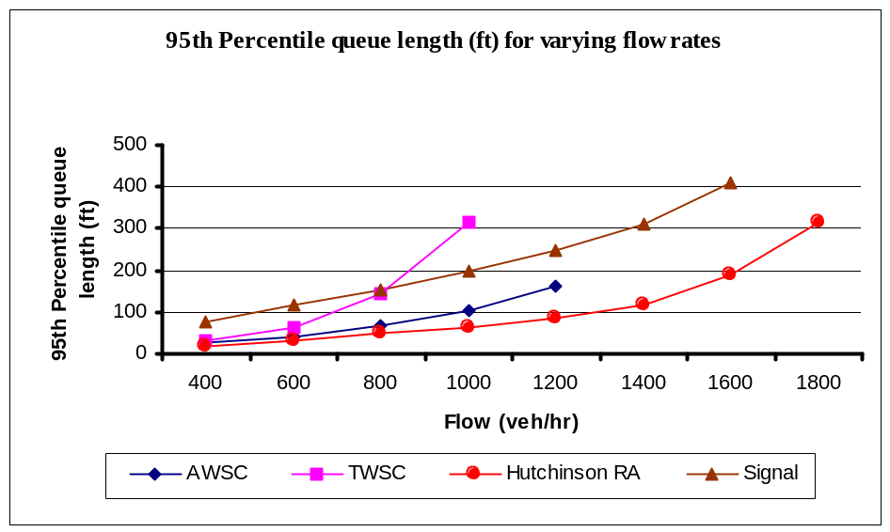
Figure 7.8 95th Percentile queue lengths for varying flow scales for various intersection types

For the TSC, there seems to be a constant increase in the 95th percentile queue length to a flow of 1400 veh/hr, and then there is a slightly steeper increase beyond a flow of 1400 veh/hr as it reaches the practical degree of saturation (1560 veh/hr). All the curves terminate when the respective intersection traffic control types reach their practical degree of saturation i.e. 0.85.

7.4.2 Average intersection delay

Figure 7.9 shows the change in average intersection delay for all the intersection traffic control types as the traffic flow entering the intersection increases. At lower volumes it appears that TWSC operates better than all the other intersection types. As the volume increases beyond 800 veh/hr, the roundabout performs better than all the other intersection types. At a flow rate of 1000 veh/hr, the TWSC is operating at par with both the TSC and the AWSC.

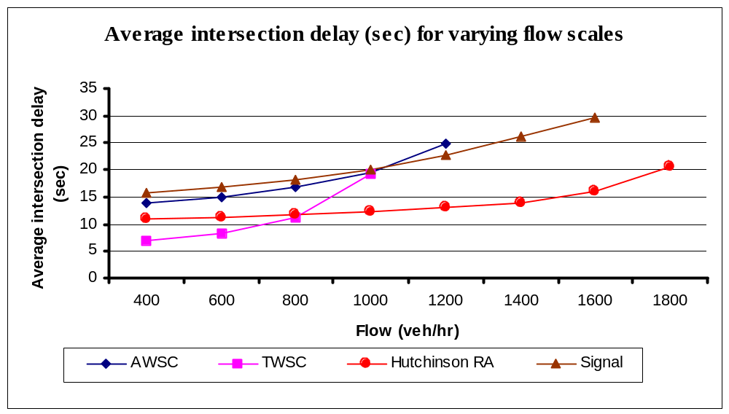

Figure 7.9Average intersection delay (sec) for varying flow scales for various intersection types

Beyond 1000 veh/hr the TWSC reaches its practical degree of saturation and the traffic signal performs better than the TWSC and the AWSC, however, not as good as the Hutchinson modern roundabout.

7.4.3 Level of service (LOS)

The LOS, based on the average intersection delay for the various intersection traffic control types under study, was obtained below the practical degree of saturation. Comparisons were made for the flow rate of 1000 veh/hr at which all the intersection traffic control types were under or equal to the practical degree of saturation (0.85). At 1000 veh/hr all the other intersection traffic control types operated in LOS ‘C’, while the RA operated in LOS ‘B’. This shows that the Hutchinson modern roundabout is capable of performing better than TWSC, AWSC and TSC studied, based on having a higher LOS at flows below the practical degree of saturation.

7.5 Design life analysis

Using the options provided in SIDRA the design life for the intersection was studied. It was observed that the degree of saturation for the Hutchinson modern roundabout reached the practical degree of saturation (0.85) (indicated with the dotted line, see Figure 7.10), when the flow rate was 1910 veh/hr, followed by the TSC when the flow rate was 1560 veh/hr, then by the AWSC when the flow rate was 1200 veh/hr and the TWSC when flow rate was 1000 veh/hr. This means that the Hutchinson modern roundabout would handle 1910 veh/hr before being congested while the traffic signal would handle 1560 veh/hr, the AWSC would handle 1200 veh/hr and the TWSC would handle 1000 veh/hr. If a two percent growth rate per year in traffic volume is assumed, then the RA has a design life of 23.8 years, the TSC has a design life of 19.5 years, the AWSC has a design life of 15 years, and followed by the TWSC with a design life of 12.5 years.
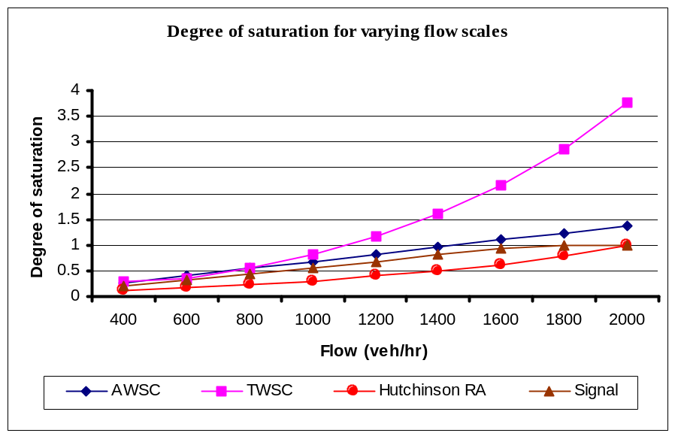
Figure 7.10 Degree of saturation for varying flow scales for various intersection type

7.6 Summary

This chapter explained the analysis performed to compare the performance of the TWSC, the AWSC and the TSC to the Hutchinson modern roundabout (RA) for the 2000 state fair traffic and also for theoretically increased traffic loadings, and presented the results. The RA performed better than all the intersection traffic control types studied at volumes near the practical degree of saturation, based on average intersection delay, 95th percentile queue length and degree of saturation. However, based on average intersection delay, at lower volumes (< 800 veh/hr) the TWSC performed better than the other intersection traffic control types studied. From the design life analysis it can be seen that the RA has a longer design life than the other intersection traffic control types studied followed by the TSC, the AWSC and the TWSC.

8 Summary and Conclusions

8.1 Summary

This study was conducted primarily to evaluate the performance of the intersection at 23rd Avenue and Severance Street, Hutchinson, Kansas, before and after the construction of a modern roundabout. The operational analysis was carried out using SIDRA and the statistical analysis in this study was performed using Minitab (release 13). As the MOEs were not normally distributed, the comparisons were made using non-parametric tests. The proportion of vehicles having to stop on the N-S approaches could have resulted in back-ups and comparatively more delays if a TWSC had been there during the annual 2000 Kansas State Fair. Safety at the study site was evaluated using before and after crash history.
By using the 2000 Kansas State Fair traffic, comparisons of the RA, TWSC, AWSC and TSC, were made using SIDRA. This comparison revealed that the Hutchinson modern roundabout performed better than the TWSC, AWSC and the TSC would have if they were the traffic control type in place at the study intersection under this traffic loading. The results obtained in this study are quite consistent with the results obtained in a similar study that compared a modern roundabout to other unsignalized intersection traffic control options [Russell et al., 2000].
Also, the performance of the traffic control types at the study intersection was studied under increased traffic loading conditions. The breakpoints of the LOS and the design life period were obtained using the flow scale options provided in SIDRA.

Following are the results obtained in this study:
- There was a 12% reduction in average intersection delay after the modern roundabout was built at the study intersection, replacing TWSC, though it was not statistically significant. There were 30 to 51% reductions in the other five MOEs, when compared with the “before” condition (TWSC). These reductions were statistically significant.
- There was a considerable reduction in crash frequency and severity of crashes after the implementation of the modern roundabout at the study intersection. There was an 88% reduction in the number of total crashes and a 100% reduction in the number of injury crashes for a comparable before and after periods of one year and three months. There were no fatalities in the before and after, safety evaluation periods.
- The worst approach for the “before” condition (TWSC) was the north approach which was the maximum proportion stopped approach for 75% of the study period and had an average maximum proportion stopped value of 0.71.
- The worst approach when the RA was operating during the fair was the west approach, which was the maximum proportion stopped approach with 38% of the study period and had an average maximum proportion stopped value of 0.60.
- It was determined from the SIDRA analysis with assumed traffic loading at the study intersection, that all six MOEs were higher than those for the RA i.e. the RA was operating better for all six MOEs. All the MOE reductions were statistically significant in all the cases.
When compared to the TWSC, the RA had a 35% reduction in the average intersection delay, a 69% reduction in the 95th percentile queue length, a 61% reduction in the maximum approach delay, a 10% reduction in the proportion stopped, a 17% reduction in maximum proportion stopped and a 51% reduction in the degree of saturation.
When compared to the AWSC, the RA had a 55% reduction in the average intersection delay, a 48% reduction in the 95th percentile queue length, a 73% reduction in the maximum approach delay, a 50% reduction in the proportion stopped, a 38% in the maximum proportion stopped and a 56% reduction in the degree of saturation.
When compared to the TSC, the RA had a 43% reduction in the average intersection delay, a 62% reduction in the 95th percentile queue length, a 70% reduction in the maximum approach delay, a 43% reduction in the proportion stopped, a 31% in the maximum proportion stopped and a 41% reduction in the degree of saturation.
- The RA reached a v/c ratio of 0.85 at flow 1910 veh/hr, the TWSC reached a v/c ratio of 0.85 at flow 1000 veh/hr, the TSC reached a v/c ratio of 0.85 at flow 1560 veh/hr and the AWSC reached a v/c ratio of 0.85 at flow 1200 veh/hr.
- At flow rate 1000 veh/hr, below the practical degree of saturation, all the intersection traffic control types studied operated in LOS ‘C’ while the RA operated in LOS ‘B’.
- Based on the degree of saturation and a 2% growth rate applied to the peak hour state fair traffic, the RA has an estimated design life of 23.8 years, followed by the TSC with 19.5 years, the AWSC with 15 years and the TWSC with 12.5 years.

8.2 Conclusions

This study adds more evidence to previous studies that concluded that modern roundabouts are safer and performs more efficiently than other conventional intersection traffic control types under a wide range of conditions. This research report also provides a study methodology for evaluating operational benefits and making comparisons of conventional intersection traffic control types.
Following are the specific conclusions made from this study:
- The modern roundabout at 23rd and Severance, Hutchinson, KS (after condition) operated more efficiently than the TWSC (before condition).
- The wide raised median approaches on Severance Street and the resulting oval shape central island, did not have any adverse effects on the operation of the modern roundabout.
- In concurrence with the literature, this study adds support to previous study conclusions that modern roundabouts are capable of enhancing safety and reducing the frequency of crashes and severity of crashes by eliminating right angle collisions.
- Based on the six measures of effectiveness obtained from SIDRA, the Hutchinson modern roundabout at 23rd Avenue and Severance Street, performed more efficiently during the 2000 state fair than the previous TWSC and more efficiently than an assumed AWSC and an assumed TSC would have.
- The modern roundabout at 23rd and Severance, Hutchinson, KS reached the practical degree of saturation (0.85) at a flow of 1910 veh/hr followed by the TSC at a flow of 1560 veh/hr, the AWSC at a flow of 1200 veh/hr and the TWSC at a flow of 1000 veh/hr. This showed that the modern roundabout at the study intersection can handle more traffic and has higher capacity than the other intersection traffic control types studied.
- The LOS for the Hutchinson modern roundabout, based on average intersection delay, is better than the LOS of the TSC, the TWSC and the AWSC at flow rates below their practical degree of saturation.

8.3 Area of further research

AASHTO states that for signalized intersections, a median width more than 18 m (60 ft) is undesirable and widths more than 31 m (100 ft) require separate traffic signals on the divided roadway. For TWSC, the HCM implies a two-stage gap acceptance phenomena if the intersection have wide medians. The intersection studied in this report had a 10.5 m (35 ft) raised median on the Severance Street, which did not appear to affect the operational performance of the modern roundabout. The operational performance measures for the modern roundabout at the study intersection in this research was good, compared to the other conventional intersection traffic control types studied. This shows that modern roundabouts could be an appropriate alternative at intersections where wide medians exist. However, the relationship with median width and the performance of various intersection types and the appropriateness of a roundabout at such sites should be studied further. Also, this study motivates the development of suitable volume, safety and appropriate site location warrants for modern roundabouts.

References

American Association of State Highway and Transportation Officials, A Policy on Geometric Design of Highways and Streets, Washington, D.C. 2001. [AASHTO 2001]

Akcelik and Besley, SIDRA 5.11 & 5.2b User Guide and Manual, Akcelik & Associates, ARRB Transport Research Ltd, Australia, 1998. [Akcelik and Besley 1998]

AUSTROADS Guide to Traffic Engineering Practice – Part 6: Roundabouts, Australia, 1993. [Austroads 1993]

American Public Works Association Reporter, Traffic roundabouts provide less costly, safer intersections, Kansas City, MO, Volume 65, Issue 7, 1998. [APWA 1998]

Florida Department of Transportation, Florida Roundabout Guide, 1996 [FDOT 1996]

Federal Highway Administration, Roundabouts: An Informational Guide, Report RD-00-067, June 2000. [FHWA Guide 2000]

Federal Highway Administration, Safety facts 1999, http://safety.fhwa.dot.gov/fourthlevel/09/jbonneson.htm downloaded on 27th Feb 2002. [FHWA 1999]

HWS Consulting group, Technical Memorandum City of Manhattan, KS, Kimball Avenue Corridor Project- Analysis of Intersection treatment Alternatives at Kimball and Manhattan Avenue, 2001. [HWS 2001]

Insurance Institute of Highway Safety, Roundabouts Status Report Vol.35, No.5. May 13, 2000. [IIHS May 2000]

Insurance Institute of Highway Safety, Stop, Status Report Vol.36, No.7. July 28, 2001. [IIHS July 2001]

MINITAB Statistical Software, Statistical Analysis Made Easy, MINITAB User's Guide 1: Data, Graphics, and Macros, 2000. [Minitab user manual 2000]

National Research Council, Transportation Research Board, Highway Capacity Manual, Washington, DC., 2000. [HCM 2000]

Road Planning and Design Manual, Roundabouts, Queensland, Initial Release, May 2000 downloaded from www.transtec.dmr.qld.gov.au/rpdm/chapt14.pdf on 11/2/2001. [Road Planning and Design Manual, Queensland 2000]

Swedish National and Transport Research Institute (VTI) What Roundabout Design Provides the Highest Possible Safety?, NORDIC Road & Transport Research No.2, 2000. [VTI 2000]

State of Maryland, Department of Transportation, State Highway Administration, Roundabout Design Guidelines, Maryland, 1995. [MDOT 1995]

Transfund & Traffic Design Group, Safety Auditors’ Perspective The Inns and Outs of Roundabouts, New Zealand, April 2000 [Safety Auditors’ Perspective 2000]

Technology Transfer Digest, Kansas Department of Transportation What’s the Deal About Roundabouts?, Volume XVI, No II, , Summer 2000. [KDOT 2000]

The Urban Transportation Monitor, Modern Roundabouts Relieve Congested Intersections in Colorado, March 1996. [UTM 1996]

The Urban Transportation Monitor, Roundabouts significantly reduce crashes in Maryland, Vol 13 No.8 April 30 1999. [UTM 1999]

US Department of Transportation, Federal Highway Administration, Manual for Uniform Traffic Control Device –Millennium edition, 2000. [MUTCD 2000]

US Department of Transportation, Federal Highway Administration, Traffic Control Devices Handbook, 1983. [TCD Handbook 1983]

Akcelik, R., Lane-by-lane modeling of unequal lane use and flares at roundabouts and signalized intersections: The SIDRA solution, Traffic Engrg & Control, London, 38(7/8), 1997. [Akcelik 1997]

Briglia M. Peter., Jr, An Evaluation of 4-Way Stop Control, Journal of Institute of Transportation Engineers, 1982. [Briglia 1982]

Douglas W. Harwood, Martin T. Pietrucha, Mark D. Wooldridge, Robert E. Brydia and Kay Fitzpatrick Median Intersection Design, National Cooperative Highway Research Program, Report 375, Transportation Research Board, Washington DC, 1995. [Harwood et al., 1995]

Flannery A and Datta T K Modern Roundabouts and Traffic Crash Experience in United States, TRR 1553, Transportation Research Board, National Research Council, Washington DC, 1996. [Flannery and Datta 1996]

Flannery A, Elefteriadou L, Koza P and McFadden, J Safety, Delay and Capacity of Single lane Roundabout in the United States, TRR 1646, Transportation Research Board, National Research Council, Washington DC, 1998. [Elefteriadou et al., 1998]

Flannery A, Geometric Design and Safety Aspects of Roundabouts, TRR 1751, Transportation Research Board, National Research Council, Washington DC, 2001. [Flannery 2001]

Fred L. Orcutt, Jr. and Darcy Sullivan, Traffic Signal Philosophy and Practice – A Management Overview, Roadtalk, Tennessee Transportation Assistance Program, 1992. [Orcutt and Sullivan 1992]

Garder E Per, Lord D, Persaud B N, Retting RA Crash and Injury Reduction Following Installation of Modern Roundabouts in the United States, American Journal of Public Health Vol 91 Issue 4 April 2001. [Garder et al., 2001]

Garder E. Per, Bhagwant N.Persaud, Richard A.Retting, Dominique Lord, Crash Reductions Following Installation of Roundabouts in United States, Insurance Institute of Highway Safety, March 2000. [Garder et al., 2000]

Garder E. Per Little Falls, Gorham-A Modern Roundabout Technical Report 96-2B Maine Department of Transportation, Bureau of Planning, Research & Community Services, Transportation Research Division, September 1998. [Garder 1998]

Jacquemart Georges National Cooperative Highway Research Program Synthesis of Highway Practice No. 264 Modern Roundabout Practice in the United States National Research Council, Transportation Research Board, Washington, DC 1998. [Jacquemart 1998]

James H. Kell and Iris J. Fullerton Manual of Traffic Signal Design, Institute of Transportation Engineers, Prentice-Hall Inc., 1982. [Kell and Fullerton 1982]

James L. Pline, Traffic Engineering Handbook, Institute of Transportation Engineers, Prentice-Hall Inc., 1992. [Pline 1992]

James A. Bonneson and Michael D. Fontaine, Evaluating Intersection Improvements: An Engineering Study Guide National Cooperative Highway Research Program 457, Transportation Research Board, National Research Council, Washington, DC. 2001. [Bonneson and Fontaine 2001]

Kanilwa R, Comparison of the Sensitivity of SIDRA and RODEL to Changes in the Dimensions of Roundabout Geometric Parameters, MS-Thesis, Kansas State University, 2001. [Kanilwa 2001]

List, GF and Waldenmaier, EW, Omnidirectional Video Instrumentation for Unsignalized Intersections and Roundabouts, Third International Symposium on Intersections Without Traffic Signals, Portland, Oregon, 1997. [List and Waldenmaier 1997]

Mike Brown The State- Of-The-Art Review - The Design of Roundabouts, Transport Research Laboratory, Department of transport, 1995. [Brown 2001]

Mohamed Aty A., Yasser Hosni State-Of-The-Art Report On- Roundabouts Design, Modeling And Simulation, Center for Advanced Transportation Systems Simulation, Florida March 2001. [Aty and Hosni 2001]

Richard A.Retting, Russell Eugene and Greg Luttrell, Public Opinion and Traffic Flow Impacts of Newly Installed Modern Roundabouts in the United States, Insurance Institute of Highway Safety, August 2001. [Retting et al., 2001]

Russell Eugene, Margaret Rys and Greg Luttrell, Modeling Traffic Flows and Conflicts at Roundabouts, MBTC FR-1099, Mac-Blackwell National Rural Transportation Study Center, University of Arkansas 2000. [Russell et al., 2000]

Russell Eugene, Margaret Rys and Greg Luttrell, Kansas Roundabout Reluctance, offered for presentation at the 81st Annual Meeting of the Transportation Research Board, National Research Council, Washington, D.C. and publication in TRB, 2002. [Russell et al., 2002]

Ray Moe, Eric Bracke and Barry Crown Mulberry Avenue (SH 14) and Lemay Avenue Intersection Alternative Analysis, City of Fort Collins, Colorado, March 2000. [Moe et al., 2000]

Stephen R. Kuciemba and Julie Anna Cirillo Safety Effectiveness of Highway Design Features-Intersections, Volume 5, FHWA-RD-91-048, US Department of Transportation, Federal Highway Administration, 1992. [Kuciemba and Cirillo 1992]

Sisiopiku P. Virginia and Heung-Un Oh Evaluation of Roundabout Performance Using SIDRA, Journal of Transportation Engineering, March/April 2001. [Sisiopiku and Heung-Un Oh 2001]

Todd. K, A History of Roundabouts in United States and France Transportation Quarterly Vol 42. No. 4 Jan 1988. [Todd 1988]

Troutbeck, R.J. Capacity and Design of Traffic Circles in Australia, TRR 1398, Transportation Research Board, National Research Council, Washington DC, 1993. [Troutbeck 1993]

Wallace C.E, Courage K.G, Hadi M.A, and Gan, A.C, Transyt-7F User Guide, Volume 4 in a Series: Methodology for Optimizing Signal Timing (M|O|S|T), Transportation Research Center, University of Florida, Gainesville, 1998. [Wallace et al., 1998]

Wallace C.E, Courage K.G, Transyt-7F Reference Manual, Volume 1 in a Series: Methodology for Optimizing Signal Timing (M|O|S|T), Transportation Research Center, University of Florida, Gainesville, 1991. [Wallace and Courage 1991]

Wallwork, MJ, Roundabouts Workshop, Genesis group, Inc Florida April 1996. [Wallwork 1996]

Wallwork, MJ and Patrick Siegman Modern Roundabouts, Technology Transfer for Local Transportation Agencies, Institute of Transportation Studies, University of California, Berkely, Summer 1997. [Wallwork and Siegman 1997]

Appendix A-Initial statistical analysis

A.1 General

This appendix describes the statistical analysis done to determine if the sample means of the traffic volumes collected under different treatment conditions were comparable. This analysis is to check the assumptions of the F-Test (Test I and II – see Table A.1) and subsequently, depending upon the results, follows with the appropriate statistical tests described in Table A.1. Minitab – release 13 was used to perform all statistical tests performed in this study.

A.2 Summary of statistical test to check for the assumptions of F-Test

The assumptions of the F-Test are as follows:

- The hourly traffic volume counts are independent between intersection conditions and independent within each intersection condition,
- The population values in each group have a normal distribution, and
- All conditions have the same parametric (population) variance.
As this is a “before and after” study, the conditions are performed separately and it is assumed that there is no correlation between the hourly volumes within a treatment condition. In other words, the analysis assumes that an individual treatment performance is independent within each data point (hourly volume). Next, the traffic volumes were checked to determine if they were normally distributed. The Interquartile /Standard Deviation (IQR/Stdev) for all the conditions came to be > 1.3. However, a formal statistical test for normality (Shapiro-Wilk test) was conducted to find if the data were normally distributed. The normal probability distribution plot for various conditions is shown in Figures A.1, A.2 and A.3.

Table A.1 Overview of statistical test [Modified from Russell et al., 2000]

Statistical Test Comments
I. Normality
IQR/S ~ 1.3 | Interquartile range divided by standard deviation
Shapiro-Wilks Test | Ho: Have a normal distribution α = 0.05
If P-value is less than 0.05 it rejects Ho then test II, else it fails to reject Ho, test IIIC.
II. Equality of Variances
Levene's Test | Ho: σ²_{before}=σ²_{after} and σ²_{before} = σ²_{after fair}
If P-value is less than 0.05 it rejects Ho, has unequal variances, else it exhibits equal variances
III.A Normal w/ Equal variances
Analysis of variance F-Test | Ho: X _{before} = X _{after} and X _{before} = X _{after fair}, at α = 0.05
If P-value is less than 0.05, it rejects Ho; Sample means are considered unequal, perform
multiple comparison tests Turkey's and Duncan
If P-value is greater than 0.05, it fails to reject Ho; Sample means considered equal; Analysis stops
III.B Normal w/ Unequal variances
Welch's test | Ho: X _{before} = X _{after} and X _{before} = X _{after fair}, at α = 0.05
Failed to reject; Sample means are considered equal; Analysis stops
Reject; Perform multiple comparisons Fisher Least Significant Differences test
III.C Non Normal
Kruskal-Wallis test | Ho: Population distribution are the same, at α= 0.05
If p-value is less than 0.05 it rejects Ho; determine average rank order; Analysis stops
If p-value greater than 0.05, it fails to reject Ho; distribution considered equal; Analysis stops

The plots indicate that the traffic volumes were normally distributed. This is reinforced by a p- value > 0.05 obtained from the Shapiro-Wilk’s test for all the conditions at the 95% confidence interval, except for the before condition, which was determined to be normal at the 90% confidence interval (p-value = 0.0185). The “before” (TWSC) condition had 153 data points, the “after” (Modern Roundabout) had 46 data points and the “after fair” (Roundabout with 2000 State Fair traffic) condition had 143 data points. The average hourly volumes were 785, 731 and 803 vehicles for the “before”, “after” and “after fair” conditions respectively.
The third assumption was verified using Levene’s test. Figure A.4 shows the output for the test conducted at the 95% confidence interval and the box plots for the factor levels. The F-Test statistic in the figure is to be considered if the P-value is <0.05. A p-value of 0.345 indicates that the test failed to reject the null hypotheses that the population variance for the treatment under consideration (“before” and “after”) is equal, at the 95% confidence interval.

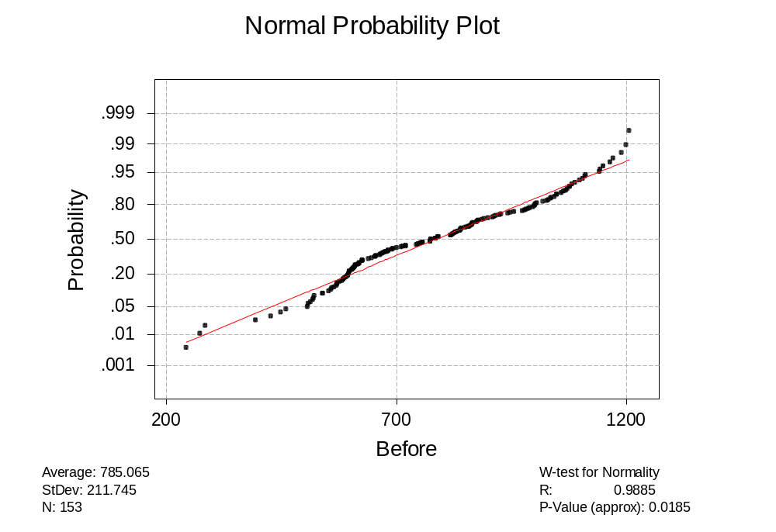
Figure A.1 Shapiro-Wilk Normality Test for Before condition
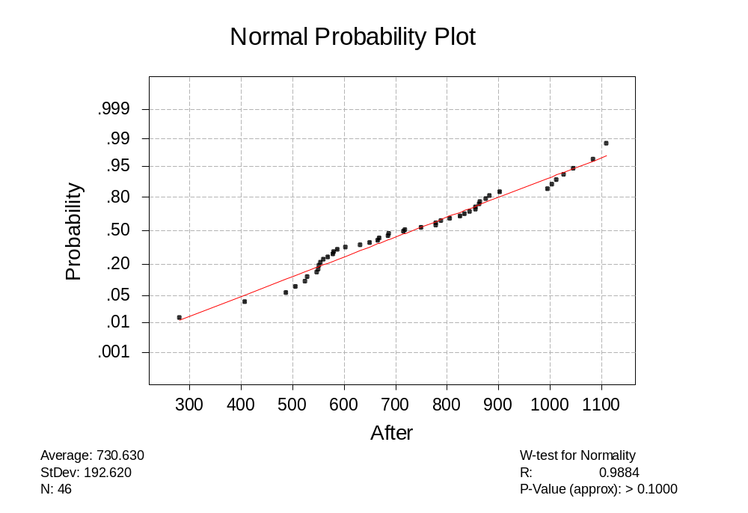

Figure A.2 Shapiro-Wilk Normality Test for After condition

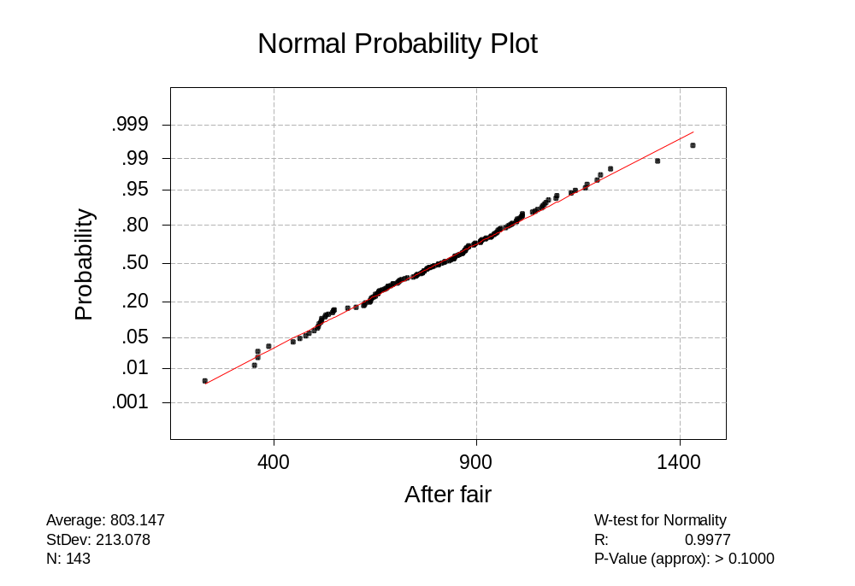

Figure A.3 Shapiro-Wilk Normality Test for After fair condition

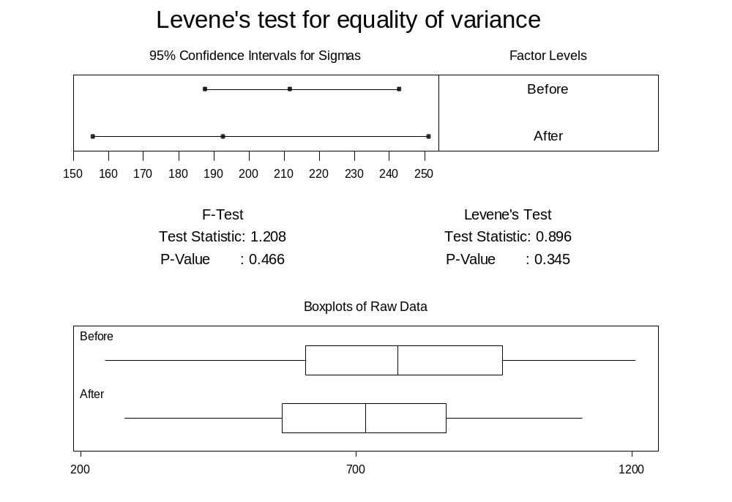
Figure A.4 Levene equality of variance test (Before and After)

Also a p-value of 0.594 > 0.05 for “before” and “after Fair” treatment conditions (see Figure A.5) indicates that the equality of variance condition is satisfied. Following the Levene’s test, the hourly volumes were tested to determine if they were comparable. The data collected were normal and had equal variances and satisfied the assumptions required to conduct the one-way analysis of variance (ANOVA). Therefore, one-way ANOVA was performed and a p-value of 0.12 was obtained. This p-value, 0.12 > 0.05, indicates that the hourly volumes under the treatments (before and after) are comparable and have the same sample means within the 95% confidence interval (see summary of the one-way ANOVA Table B.2). Also, a p-value of 0.465 > 0.05 (see Table B.3) for the treatment levels “before” and “after fair” indicates that both are comparable.

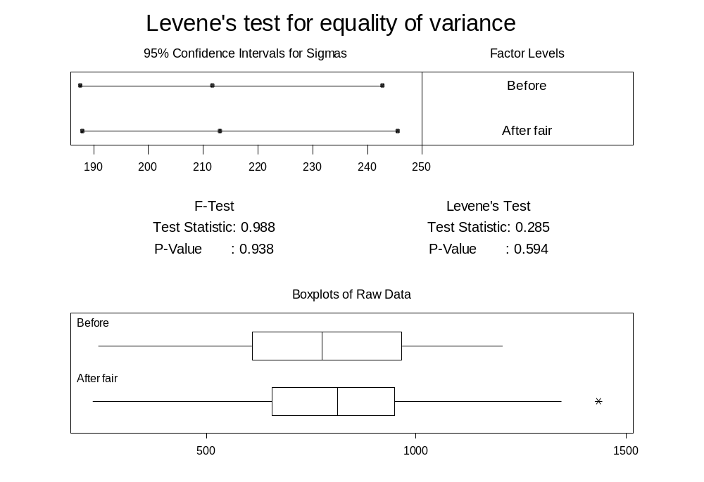
Figure A.5 Levene equality of variance test (Before and After fair)

Table A.2 Summary of anova (before vs after)
Summary of One-way ANOVA: Before, After

Analysis of Variance
Source DF SS MS F P
Factor 1 104798 104798 2.43 0.120
Error 197 8484670 43069
Total 198 8589468
Individual 95% CIs For Mean
Based on Pooled StDev
Level N Mean StDev ---+---------+---------+---------+---
Before 153 785.1 211.7 (-------*--------)
After 46 730.6 192.6 (--------------*--------------)
---+---------+---------+---------+---
Pooled StDev = 207.5 680 720 760 800

Table A.3 Summary of anova (before vs after fair)
Summary of One-way ANOVA: Before, After fair
Analysis of Variance
Source DF SS MS F P
Factor 1 24166 24166 0.54 0.465
Error 294 13262191 45109
Total 295 13286357
Individual 95% CIs For Mean
Based on Pooled StDev
Level N Mean StDev ----------+---------+---------+------
Before 153 785.1 211.7 (------------*-------------)
After fair143 803.1 213.1 (-------------*-------------)
----------+---------+---------+------
Pooled StDev = 212.4 775 800 825

A.3 Summary

The statistical analysis presented in this appendix was performed to determine if the sample means of the observed hourly volumes were comparable for the treatment conditions studied. The statistical analysis showed that the hourly volumes are comparable and hence the performance MOEs can be compared. However, similar initial statistical tests were performed for all the MOEs obtained from SIDRA and, based on the results, comparisons were made using an appropriate statistical test. Based on the results of the statistical analysis it was determined that the “after fair” condition is comparable with the “before” condition. The two samples also are of nearly equal size. Therefore, the “before” and “after fair” conditions were used for comparison purposes.

Appendix B - Traffic Signal Design

B.1 General

The objective of the traffic signal design was to have a traffic signal system to compare the performance with other intersections traffic control types at the study intersection. The main objective in the design of the traffic signal system was to design a traffic signal that would have optimal parameters for the traffic flows at the study intersection. TRANSYT 7F was used to optimize the signal timing. This appendix covers a summary of the procedure adopted for designing an appropriate traffic signal to be used in comparison at the study intersection.

B.2 Summary of data and assumptions

Following were the data used in the design:

- Peak hour turning movements when TWSC was in operation,
- Crash history (Before), and
- Average headway – when the roundabout was operating (obtained from the Engineering Department, City of Hutchinson, KS.
Following were the assumptions made for the design and evaluation of the traffic signal:
- design vehicle – Passenger car,
- design speed on the approaches 30 mph,
- saturation flow rate 1900 pc/h/ln,
- lane width 3.6 m (12 ft),
- left turn lane bay: 22.5 m (75 ft) length and 3 m (10 ft) width,
- clearance time 2 – 3 sec,
- all-red time 1 sec,
- right-turn-on-red (RTOR) is ignored (TRANSYT does not model RTOR for shared through and right turn movements),
- pedestrian flows are ignored,
- heavy vehicle flow 3% of the entering volume,
- economic benefits are ignored
- construction feasibility at the study intersection are not considered, and
- sight distance assumed adequate for the assumed design speed.

B.2 Design hourly volume

The peak hour traffic obtained from the “before” data was arbitrarily increased by 50% in order to account for any fluctuations/projection in the traffic demand through the study intersection and the turning movement distribution was kept the same (see Table B.1 and B.2). The increased peak hour traffic movements were used in TRANSYT 7F to optimize the signal timing.

B.3 Type of signal operation

The study intersection was checked to determine if it was an isolated intersection. The approximate distance of the closest downstream and upstream intersection was about 750 m (2500 ft). The road segment volumes (total on both the directions) on the major and minor approaches were 788 and 1035 veh/hr. From Figure B.1 developed by Bonneson and Fontaine;

Table B.1 Typical peak hour turning movement counts at 23rd Avenue and Severance street Condition: TWSC

Approach | Left (L) | Through (T) | Right (R ) | Total (T+R) | Total (L+T+R) | Percentage of total entering volume | Left turn percentage of approach volume
North | 50 | 164 | 53 | 217 | 267 | 40 | 19
South | 30 | 169 | 53 | 222 | 252 | 40 | 12
East | 59 | 339 | 58 | 397 | 456 | 60 | 13
West | 41 | 247 | 33 | 280 | 321 | 60 | 13
 |  |  |  |  | 1296

Table B.2 Design turning movement counts (50% increased) used for optimizing the cycle length at 23rd Ave and Severance St

Approach | Left (L) | Through (T) | Right (R ) | Total (T+R) | Total (L+T+R)
North | 75 | 246 | 80 | 326 | 401
South | 45 | 254 | 80 | 333 | 378
East | 89 | 509 | 87 | 596 | 684
West | 62 | 371 | 50 | 420 | 482
 |  |  |  |  | 1944

Orcutt, Hook and Albers [cited in Bonneson and Fontaine 2001] the lines intercept near the small platoons zone. Hence, an isolated intersection was assumed for the study.

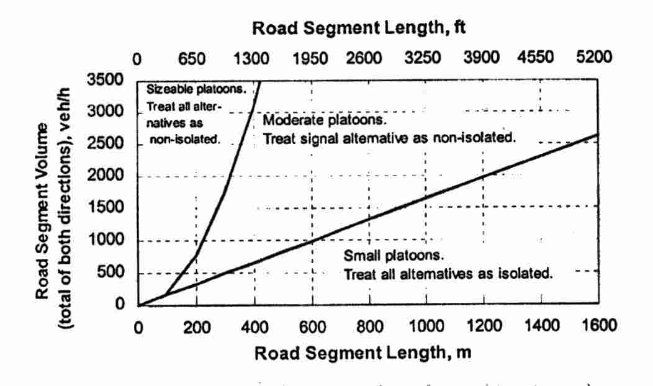

Figure B.1 Volume and segment length combinations that define isolated and non-isolated operation (Source: Bonneson and Fontaine 2001)

Extensive turning movement counts were collected for this study. Figure B.2 shows the cross traffic demand observed during the study period. The x-axis denotes the number of observations and the y-axis denotes the ratio of the major approach traffic (both directions) to the total entering traffic demand per hour. The average cross traffic demand per hour observed at the study intersection had a 53 - 47% split for the major road (23rd Ave) and minor road (Severance St) respectively. The peak hour distribution had about a 60 - 40% split (see Table B.1). The Hutchinson Engineering Department, used NU-METRICS (a computerized traffic volume counter) that reports the average headway as one of the outputs. For a 24-hour period on a normal day, the average headway was 13 seconds on the north approach, 12 seconds on the south approach, 11 seconds on the west approach and 10 seconds on the east approach. This means that on average, there is a time gap of 11 seconds between two successive vehicles passing the same point on all the approaches. This shows that the demand on all the approaches is quite comparable and therefore, it was decided to assume a pretimed traffic signal system.

B.5 Left-turn movements

The next step was to consider the left-turn movements. All the approaches of the intersection are single lane approaches. The left turn phase criteria as recommended by the TCD Handbook (1983) was satisfied only when considering the crash history for the study intersection. Based on the crash history it was decided to have a protected left turn phase for the major approaches (23 Avenue) and a permitted left turn phase for the minor approaches (Severance Street). It was assumed that 10 feet wide left turn bay lane with 75 feet in length on all the approaches would be adequate.

B.5 Phase plan

Based on the decision made in the previous section, it was decided to have a minimum number of phases that would separate the identified conflicting movements. A three-phase signal system was assumed (see Figure B.3).
The numbers in figure B.3 represents the link numbers, the dotted lines represent permitted movements and the solid line represents protected movements. As TRANSYT 7F does not model right-turn-on-red (RTOR) for shared through and right turning movements, RTOR was not considered and the right turn volumes were added to the through volume.

Phase 1 Phase 2 Phase 3
3 4

7 8

5 6

2 1

Figure B.3 Phase diagram

B.6 Timings

The phase plan, volume, movements, lane configuration and a cycle length range (min – max) were input into the computer program TRANSYT 7F to optimize the timing (i.e. cycle length, splits, interval etc) for minimum delay. The program checks for each and every possible combinations of signal timing and produces extensive outputs showing results for each run. Table B.3 shows the results for the best optimum signal timing along with the splits. As this is an isolated signal system, the offset timing was ignored.

Table B.3 Transyt-7F output: traffic signal timing table

System Best Cycle Length = 49 Seconds
No master offset reference controller specified
All offsets are referenced to an arbitrary time base.
Key to Interval Types:
F : Fixed green.
V : Variable green.
Y : Yellow.
R : All-red.
An 'M' by an interval length means this is the minimum time available.
INTERSECTION CONTROLLER SETTINGS
------------------------------------------------
Intersection 1 Pretimed - Splits are fixed
------------------------------------------------
Interval Number : 1 2 3 4 5 6 7 8 9

Intvl Length(sec): 13.0 3.0 1.0 21.0 2.0 1.0 5.0 2.0 1.0

Intvl Length (%): 27 6 2 43 4 2 10 4 2

Pin Settings (%): 100/0 27 33 35 78 82 84 94 98

Phase Start (No.): 1 2 3

Interval Type : V Y R V Y R V Y R

Splits (sec): 17 24 8

Splits (%): 35 49 16

Links Moving : 1 5 6
-2 7 8
3
-4

Offset = 3.0 sec 6 %.

B.7 Summary

The performance of the Hutchinson modern roundabout and the designed signal system was evaluated using the design hourly volume as input to SIDRA. The capacity for the roundabout was 3170 veh/hr and the capacity for the optimized signal system was 3140 veh/hr, at LOS ‘C’ and below the practical degree of saturation 0.85. Hence, the designed traffic signal was considered optimal to accommodate the traffic flow through the study intersection similar to the Hutchinson modern roundabout.

* These design elements presented subsequently in this section are generally considered for any highway facility. As this study deals with intersections, ‘highway facility’ is replaced by ‘intersection’.
* The parenthetical notation added by author to apply to right hand driving circumstances
* The parenthetical notation added by author to apply to right hand driving circumstances
* D_{c} = D_{i} – 2*W_{c} = 42 – 2*5.7 = 29.4 m (~100 feet)
 Lines in the figure are provided for the reading convenience. No conclusions should be made that the lines indicate a statistical distribution

