EVALUATION OF THE ROAD DIET CONCEPT AND COMPARISON TO THE OPERATIONAL PERFORMANCE OF A SINGLE-LANE MODERN ROUNDABOUT AND A TRAFFIC SIGNAL

By

SRINIVAS MANDAVILLI
B.Tech. (Distinction), Nagarjuna University, India, 2000

A THESIS

submitted in partial fulfillment of the requirements for the degree

MASTER OF SCIENCE

Department Of Civil Engineering

College Of Engineering

KANSAS STATE UNIVERSITY
Manhattan, Kansas
2002
Approved by

--------------------------------
Dr. Eugene R. Russell
Major Professor

ABSTRACT
Safety is a prime concern of transportation engineers and safety specialists in the United States. Traffic volumes have increased tremendously over the past years. Accommodating the increased demand, while improving traffic safety, has led transportation officials to utilize various lane configurations and intersection controls to operate the transportation system more efficiently and safely. The primary focus of this research is to evaluate the benefits of the Road Diet concept and the operational performance of alternative intersection controls at a site in University Place, Washington. The term “Road Diet” is a new term used to mean a reduction in the number of travel lanes. The intersection studied in this project is the intersection of 44th Avenue and 67th Avenue, in University Place, Washington. The alternative intersection controls studied are two-way stop control, a roundabout and traffic signals. The operation of the roadways at the intersection was videotaped and the traffic flow data collected was extracted from these tapes and analyzed using SIDRA (Signalized and Un-signalized Intersection Design and Research Aid) software. The version used is a.a. SIDRA 1.0. The software produces many Measures Of Effectiveness (MOEs) of which six were chosen in this project for evaluating the performance of the roadways and the intersection controls. All the MOEs were statistically compared to determine which roadway configuration and intersection control performed better. After observing all the MOEs and the conflict rates for the before and after traffic volumes, it was found that the three-lane roadway configuration reduced the conflict rate and performed better than or equal to the four-lane roadway configuration. For the evaluation of the operational performance of the intersection controls studied, the actual traffic volumes were incremented by 25% and 50% and the
MOEs from the SIDRA output for the three intersection controls (Two Way Stop Control, a Modern Roundabout and Traffic Signals). Each control type was tested for the original and the incremented volumes. It is concluded that three-lane roadway configurations can be used, as a viable alternative for problematic four-lane roadway configurations and a single-lane modern roundabout would have been the best form of intersection control at the intersection studied.

Table Of Contents

List Of Tables iii
List Of Figures v
Acknowledgements vi
Chapter 1: Introduction and Objectives 1
1.1 Introduction 1
1.2 Objectives 2
Chapter 2: Literature Review 4
2.1 Conversion of Four-lane to Three-lane configurations 4
2.1.1 Bicycle and Pedestrian Safety Issues 5
2.2 Overview of Intersection Controls compared in this study 6
2.2.1 Two Way Stop Signs as Intersection Control 6
2.2.2 Signals as Intersection Control 7
2.2.3 Roundabout as Intersection Control 8
Chapter 3: Data Collection 12
3.1 Phase 1: Video Data Collection 12
3.2 Phase 2: Visual Data Collection 13
Chapter 4: Software Selection 14
4.1 SIDRA Software 14
Chapter 5: Data Analysis 18
5.1 Traffic Volumes 18
5.2 Conflict Analysis 22
5.3 Statistical Analysis 25
5.4 Statistical Analysis Of SIDRA Input (Hourly Traffic Volumes): 28
Chapter 6: Results of Statistical Analysis-Road Diet Concept 30
6.1 Results 30
Chapter 7: Discussion of Results- Road Diet Concept 32
7.1 Observations from the Final Results for the AM period: 32
7.2 Observations from the Final Results for the PM period: 34
Chapter 8: Comparison of operational performance of Road Diet Concept, Modern Roundabout and Traffic Signal 37
8.1 Introduction 37
8.2 Roundabout Design 37
8.3 Traffic Signal Design 39
Chapter 9: Results of Statistical Analysis-Comparison of operational performance of Road Diet Concept, Modern Roundabout and Traffic Signal 40
9.1 Results 40
Chapter 10: Discussion of Results- Comparison of operational performance of Road Diet Concept, Modern Roundabout and Traffic Signal 45
10.1 Observations from the results for AM period 45
10.2 Observations from the results for PM period 46
Chapter 11: Conclusion 48
11.1 Conclusions from the research for the Road Diet Concept 48
11.2 Conclusions from the comparisons of Road Diet Concept, Modern Roundabout and Traffic Signals 49
11.3 Overall Conclusion 50
Chapter 12: References 51
Appendices 54
Appendix A: Conflict Diagrams 55
Appendix B: SIDRA Output and Turning Movements 61

List Of Tables

Table 2.1: Safety Performance Data for 8 intersections converted to roundabouts in the U.S 9
Table 5.1: Original Data points from before and after data sets for AM and PM conditions 20
Table 5.2: Filtered data points from before and after data sets after manual adjustment of hourly counts used in the SIDRA Analysis 21
Table 5.3: Conflict Rate for Intersection 23
Table 5.4: Conflict Rates by Approach 24
Table 5.5: Summary Of Statistical Tests 26
Table 5.6: Statistical Analysis of AM Hourly Volumes 28
Table 5.7: Statistical Analysis of PM Hourly Volumes 29
Table 6.1: Final Results-Road Diet Concept 31
Table B1: AM Final Results 62
Table B2: Comparison of AM Hourly Counts and Measures Of Effectiveness 63
Table B3: PM Final Results 64
Table B4: Comparison of PM Hourly Counts and Measures Of Effectiveness 65
Table B5: AM Original Volume-Measures Of Effectiveness Comparison 66
Table B6: PM Original Volume-Measures Of Effectiveness Comparison 67
Table B7: AM 25% Incremented Volume-Measures Of Effectiveness Comparison 68
Table B8: PM 25% Incremented Volume-Measures Of Effectiveness Comparison 69
Table B9: AM 50% Incremented Volume-Measures Of Effectiveness Comparison 70
Table B10: PM 50% Incremented Volume-Measures Of Effectiveness Comparison 71
Table B-11: Turning Movements AM Original Volume 72
Table B-12: Turning Movements AM 25% Incremented Volume 72
Table B-13: Turning Movements AM 50% Incremented Volume 73
Table B14: Turning Movements PM Original Volume 74
Table B15: Turning Movements PM 25% Incremented Volume 75
Table B16: Turning Movements PM 50% Incremented Volume 76

List Of Figures

Figure 1.1: Figure showing the intersection in the four-lane condition 3
Figure 1.2: Figure showing the intersection in the three-lane condition 3
Figure 3.1: Camera and TV/VCR units used in data collection 12
Figure 5.1: Reduced conflict points in a 3-Lane Roadway 22
Figure 9.1: Graphical representation of results 43
Figure 9.2: Graphical representation of results contd.. 44

Acknowledgements

I would like to take this opportunity to express my sincere appreciation to Dr. Russell, and Dr. Rys for their guidance, patience and encouragement throughout the period of my research work and the completion of this thesis. I would also like to thank Professor Landman and all other members in the Civil Engineering Department for their assistance in my research work and the completion of my of study at Kansas State University.
At this point I would like to dedicate this thesis to my parents, Mandavilli Radhamani and Mandavilli Satyanarayana Murthy for their continued support and encouragement throughout my studies.
I extend my gratitude to my roommates, Kamesh, Bhaskar and Vijay for their constant help and support and in making my stay at Manhattan a very wonderful and memorable one. I wish them all the very best for their future.

Chapter 1: Introduction and Objectives

1.1 Introduction
Roadway safety is a prime concern of transportation engineers and safety specialists in the United States. Traffic volumes have increased tremendously over the past years. Accommodating the increased demand while improving traffic safety, has led transportation officials to utilize various traffic control practices. The main point of using different lane configurations and intersection controls is to operate the transportation system more efficiently and safely.
There are numerous four-lane, undivided roadways in the urban areas of the United States and some of these roadways are operating “at unacceptable levels of service and safety due to changes in volumes, traffic flow characteristics, and/or the corridor environment.” [1]. Transportation engineers and safety specialists are now facing an increased challenge of improving the safety of these four-lane, undivided roadways.
Earlier “improvements to the cross-section of an urban, four-lane undivided roadway are often limited to alternatives that increase its existing curb-to-curb width”, but recently many traffic engineers believe that the “Road Diet” concept, or conversion of four-lane, undivided roadways to a three-lane cross-section (one travel lane in each direction with a Two Way Left Turn Lane (TWLTL) in the center, can be considered a viable mitigation measure to enhance the safety and operation of these roadways. It is believed that the Road Diet concept would “have lower overall impacts than a widening option, and produce acceptable operational and improved safety results” [1].
The term “Road Diet” is a new term used to mean a reduction in the number of travel lanes, usually from four to three.

1.2 Objectives
As mentioned earlier, since there is a problem with some of the four-lane undivided configurations, by adopting the three-lane configuration these problems can be alleviated partially or completely. Also no comparison has been made between the lane reduction concept, a roundabout and traffic signals as to which alternative would be best. This leads to the objective of this research. The two objectives of this research are:
- To evaluate the benefits or disbenefits of the Road Diet concept at an intersection site in University Place, Washington.
- To see if a roundabout or a signal would have been better than the “Road Diet” concept at the intersection studied.

The research site studied is the intersection of 67th Avenue and 44th Avenue in University Place, Washington, where a four-lane, undivided roadway was physically converted to a three-lane roadway with a center TWLTL plus bike lanes on either side of the roadway. The initial lane width was 11Feet for the two through lanes in each direction. After conversion there is one 11-foot through lane in either direction, a center 12-foot TWLTL and 5-foot bike lanes on either side of the roadway, as shown in figures 1.1, and 1.2.

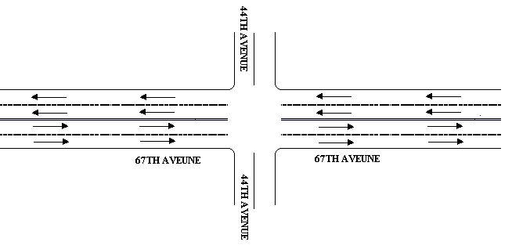
Represents a Stop Sign
Figure 1.1: Figure showing the intersection in the four-lane condition

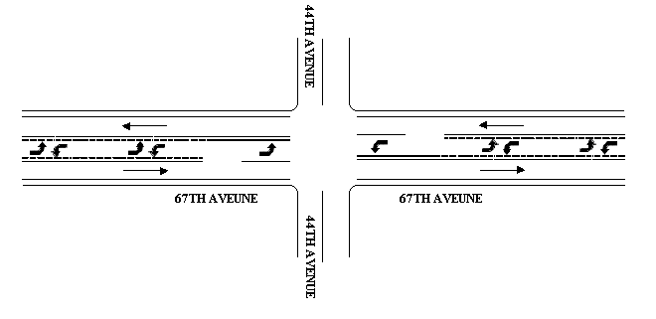

Represents a Stop Sign
Figure 1.2: Figure showing the intersection in the three-lane condition

Chapter 2: Literature Review

2.1 Conversion of Four-lane to Three-lane configurations

There has been very little research done on the conversion of four-lane, undivided roadways to three-lane roadways with a center Two-Way Left Turn Lane (TWLTL) plus bike lanes on either side. Much of the research has been on the operational effects and benefits of TWLTLs. In a paper by Knapp and Welch, [1] they presented the benefits of conversion of a four-lane, undivided roadway to a three-lane roadway with a center TWLTL and presented examples of locations where successful conversions took place. These are summarized as follows [1]:
Successful conversions have taken place in Montana, Minnesota, Iowa, California and Washington. From these conversions many benefits were achieved. In Minnesota, the conversion indicated no significant increase in delay and also a significant decrease in vehicle collisions. The conversion resulted in a general reduction of congestion and vehicle speed, and improvement of safety. In Iowa the traffic flow and safety were increased. In California there was a 17% reduction of collisions due to conversions. In Washington, the total collision rate decreased by approximately 34%.
Knapp and Welch (1999) documented examples where successful conversions have taken place on roadways with Average Daily Traffic (ADT) ranges of 20,000 to 24,000 vehicles [1]. In a study conducted by Walton and Randy, [3] they suggested that conversions to three-lane roadway configurations work well for an ADT range of 5,000 to 12,000 vehicles.
In a study conducted by Nemeth (1970), he concluded that conversion of a four-lane roadway to a three-lane roadway improved the access function of the roadway at the expense of vehicular movement because the lane reduction increased delay. He also observed that the running speeds and conflicts did not change drastically but found that vehicle braking and weaving reduced significantly after the conversion [4].
Harwood suggested that “[i]n some situations, with high, left turn volumes and relatively low through volumes, restriping of a four-lane undivided (4U) facility as a [three-lane] facility may promote safety without sacrificing operational efficiency” [5].
Dan Burden and Peter Lagerway in their report “Road Diet- Fixing the Big Roads” have documented various examples where four-lane configurations have been converted to three lane configurations and are operating successfully [10].
Hummer and Lewis of North Carolina State University produced a report that made safety comparisons of three-lane and four-lane undivided roadways. Safety data from their report indicates that the three-lane undivided roadway configurations had lower crash rates than four-lane undivided roadway configurations in the medium and high-density residential and commercial land use areas. In addition they found that, unlike the two-lane and four-lane undivided roadways, the crash rates of the three-lane roadways did not seem to increase with development density [2].

2.1.1 Bicycle and Pedestrian Safety Issues
Four-lane roadways often tend to generate excessive speeds. As stated by Dan Burden [10]:
“These roadways also erode the ability for transit, walking and bicycling to succeed. Pedestrians have rugged times finding gaps across four lanes. Crash rates and severity of conflicts with autos result in almost certain death (83% of pedestrians hit at 40 mph die). Many bicyclists find four-lane roads too narrow to ride comfortably”

The motorists traversing on the four-lane roadway configurations have an extra lane in their direction of travel and tend to change lanes, overtake other vehicles and travel faster than they should.
With the increased speeds the risk of conflicts also increases during the peak hours. If there are many access points on either side of the roadways, then during rush hours the through vehicles may crash into the vehicles which have slowed down to make left turns and exit the roadway. With the inclusion of separate lanes for the bicyclists, there would be greater safety for the bicyclists in the three-lane configuration with bike lanes on either side than in the four-lane configuration. [10]
In regard to pedestrian safety, the three-lane facility can occasionally provide pedestrian refuge allowing crossing pedestrians to focus on one lane of traffic at a time. In four-lane undivided roadways pedestrians need to focus on two lanes of traffic at a time, which is difficult. Though the center TWLTL is an active traffic lane, it would have a lower volume of traffic and slower vehicle speeds. Often this lane would be unoccupied by vehicles. Hence the three-lane configuration would be beneficial to bicyclists and pedestrians.

2.2 Overview of Intersection Controls compared in this study
Intersection controls are intended to establish which vehicles have the right-of-way through an intersection, improve traffic flow, and reduce intersection delays.

2.2.1 Two Way Stop Signs as Intersection Control
The majority of intersections in US operating under Two-Way Stop Controls (TWSC), operate with minimal delay. As stated by the Federal Highway Administration’s roundabout design guide, “the common problems associated with TWSC are congestion on the minor street caused by a demand that exceeds capacity, and queues that form on the major street because of inadequate capacity for left turning vehicles yielding to opposing traffic” [19]

2.2.2 Signals as Intersection Control
Traffic Signals offer a great degree of control at intersections. They control the movement of traffic at intersections, “by permitting conflicting streams of traffic to share the same intersection by means of time separation. By alternately assigning right-of-way to various traffic movements, signals provide for the orderly movement of conflicting flows.” [14]
The Manual Of Uniform Traffic Control Devices (MUTCD) gives a set of warrants for the installation of signals. When the signal warrants are met, signal installation should be considered at intersections.
Signal timing is very important in the efficient and safe movement of traffic. If justified and properly timed, signals increase the traffic handling capacity of an intersection, and when installed under certain conditions, reduce certain type of accidents, interrupt extremely heavy flows to permit the crossing of minor movements that could not otherwise move safely through an intersection and improve the safety and efficiency of both pedestrian and vehicular traffic. If signal timing and installation is not justified they increase the overall travel times, queuing and delays by adding stops to the through traffic. This may divert the traffic to the nearby residential streets, which would be unsafe. [14]
In regard to collisions, traffic signals can reduce the risk and severity of angle collisions at an intersection while increasing the risk of rear-end collisions. If signals are not justified they can increase accident frequency and cause excessive queuing and delays. As stated in the Arizona Department Of Transportation Traffic Group Home Page:
“A modern signal can cost between $80,000 and $100,000 to install - depending on the complexity of the intersection and the characteristics of the traffic using it. On top of this, there is the cost of the electrical power consumed in operating a signalized intersection 24 hours a day, which averages to about $1,400 per year.” [14]

2.2.3 Roundabout as Intersection Control
Roundabouts may be an unfamiliar type of intersection in the United States, but they're becoming more familiar as evidence of their benefits grows. Many studies have found that one of the benefits of roundabout installation is an improvement in overall safety performance. Several studies in the U.S., Europe, and Australia have found that roundabouts perform better in terms of safety than other intersection forms [11]. Roundabouts are being implemented throughout the United States in a variety of situations. Many states are considering roundabouts as a viable alternative to two-way stop controlled intersections, and, in some cases, signals and complex freeway interchanges [15].
In particular, single-lane roundabouts may perform better than two-way stop-controlled (TWSC) intersections in the U.S. under some conditions [12]. Although the frequency of reported crashes is not always lower at roundabouts, reduced injury rates are usually reported. Safety is better at small and medium capacity roundabouts than at large or multilane roundabouts. While overall crash frequencies have been reduced, the crash reductions are most pronounced for motor vehicles, less pronounced for pedestrians, and equivocal for bicyclists, de-pending on the study and bicycle design treatments [11].
To understand the safety performance of the roundabouts a preliminary comparison of before and after accident rates was performed for eight sites in U.S. These sites have been operational for two years or more and had accident data available for the before period (when there was no roundabout at that location). From this study it was found that the safety performance of intersections studied has improved in terms of reduced accident frequency, accident rates, and injury rates after installation of roundabouts. See Table 2.1 for results [15].
Table 2.1: Safety Performance Data for 8 intersections converted to roundabouts in the U.S

Study site | Per.  Period | Accident Frequency/year  Before/After | Accident Rate  Before/After | Injury Accident Rate  Before/After
Palm Beach County, FL | 2 yrs | 1.5/1.5 | 0.54/0.54 | 0.5/0.0
Lisbon, MD | 2 yrs | 7.5/2.5 | 2.42/0.81 | 1.5/0.5
Tallahassee, FL | 2 yrs | 4.5/1.5 | 0.69/0.23 | 0.0/0.0
Fort Walton Beach, FL | 2 yrs | 8.0/2.0 | 1.83/0.45 | 2.0/0.0
Lothian, MD | 2 yrs | 13.0/4.0 | 2.37/0.73 | 4.5/1.5
Washington County, MD | 2 yrs | 4.5/0.0 | 1.76/0.0 | 1.0/0.0
Cecil County, MD | 2 yrs | 3.0/0.0 | 1.37/0.0 | 1.0/0.0
Carroll County, MD | 2 yrs | 5.3/0.0 | 1.81/0.24 | 2.25/0.75

Source: Flannery. A. “Geometric Design and Safety aspects of Roundabouts.” Transportation Research Record 1751, Transportation Research Board, National Research Council, Washington, DC, 2001.

In an another study conducted by Persaud, Retting, Garder and Lord, they evaluated the changes in motor vehicle crashes following conversion of 23 intersections from stop sign and traffic signal control to modern roundabouts. They conducted a before and after study using empirical Bayes procedure, and estimated highly significant reductions of 40 percent for all crash severities combined and 80 percent for all injury crashes. The reduction in number of fatal and incapacitating injury crashes were estimated to be 90 percent [16].

The reasons for the increased safety level at roundabouts are: [11]
- Roundabouts have fewer conflict points in comparison to conventional intersections. They completely eliminate right angle crashes and left turn head on crashes.
- Roundabouts with single-lane approaches have fewer potential conflicts between vehicles and pedestrians due to short crossing distances thereby producing greater safety benefits than roundabouts with multilane approaches.
- Since the approach speeds and circulating speeds in roundabouts are low they give drivers more time to react to potential conflicts, thus helping to improve the safety performance of roundabouts.
- Due to low relative speeds, crash severity can be reduced compared to some traditionally controlled intersections.
- Pedestrians need to concentrate only on one direction of traffic at a time, at each approach as they traverse roundabouts, when compared to un-signalized intersections. Conflict points between vehicles and pedestrians are generally not affected by the presence of a roundabout.
Roundabouts are becoming popular in the United States for more than just safety reasons. As stated in an article by the Insurance Institute for Highway Safety [San Diego Earth Times, May 2001] “They're less expensive than intersections controlled by traffic signals, saving up to $5,000 per year per intersection in electricity and maintenance” [13]. They reduce fuel consumption and vehicular emissions by reducing stops at intersections. They also reduce noise levels by making the traffic flow orderly. Roundabouts enhance the aesthetics of the place and create visual gateways to communities or neighborhoods. In commercial areas they can improve access to adjacent properties. [13]

Chapter 3: Data Collection

The data collection consisted of two phases. The first phase was video taped data collection and the second phase was the visual data collection from the videotapes.

3.1 Phase 1: Video Data Collection
The benefit of using this method for data collection is that all the data is recorded on videotapes and can be accessed and retrieved at a later time. In this method, all the information recorded on the tapes can be accessed for evaluation at any time and serves as a permanent record for re- verification of results. Two specially designed 360°- omni directional, video cameras and videocassette recorders were used for data collection. The camera was designed by Intelligent Highway systems, Inc., (White Plains, NY). The camera was designed to provide a full 360° view when mounted above the intersection.
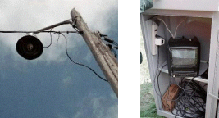
Figure 3.1: Camera and TV/VCR units used in data collection

One camera was placed near the intersection and the other on one of the approaches. This was done to see the traffic flow coming toward and leaving the intersection. The cameras were installed on existing poles and mounted perpendicular to the ground. The perpendicular mounting allowed the video image to be relatively distortion free to the horizon in all directions. The camera was mounted approximately 6 meters (20 feet) above the ground. This mounting height provides a focal plane of approximately 40.5 meters by 54.0 meters (133 feet by 177 feet). The camera feed went in to a TV/VCR unit placed in a recycled traffic signal controller cabinet. All the equipment was mounted on a single pole. The video images were recorded on standard VHS videotapes. [9]
Data from the intersection was collected before the roadway was re-striped and after re-striping the roadway. The traffic counts from the intersection were video taped for two six-hour sessions from 7:00AM-1:00PM and from 1:00PM-7:00PM. The traffic was videotaped for five days in the before (four-lane) condition and for five days in after (three-lane) condition.

3.2 Phase 2: Visual Data Collection
In this phase the data was visually collected from the videotapes. Traffic counts; traffic conflicts, and queuing at the intersection were recorded. The counts were recorded for fifteen-minute intervals. Hourly counts were used as input data for analysis using the computer program aaSIDRA (Signalized and Un-signalized Intersection Design and Research Aid). The tapes were also watched for conflicts and queuing separately for each fifteen-minute interval.
For this research purpose traffic conflicts are defined as:
“a traffic event involving two or more road users, in which one user performs some atypical or unusual action, such as a change in direction or speed, that places another user in jeopardy of a collision unless an evasive maneuver is undertaken.” [6].

Chapter 4: Software Selection

4.1 SIDRA Software
The software used for data analysis is a.a.SIDRA, Version 1.0. The Australian Road Research Board (ARRB), Transport Research Ltd., developed the SIDRA package as an aid for design and evaluation of intersections such as signalized intersections; roundabouts, two-way stop control, and yield-sign control intersections.
In a roundabout performance evaluation study conducted by Sisiopiku and Un-Oh using SIDRA they found that:
“In evaluating and computing the performance of intersection controls there are some advantages that the SIDRA model has over any other software model. The SIDRA method emphasizes the consistency of capacity and performance analysis methods for roundabouts, sign-controlled, and signalized intersections through the use of an integrated modeling framework. This software provides reliable estimates of geometric delays and related slowdown effects for the various intersection types. Another strength of SIDRA is that it is based on the US Highway Capacity Manual (HCM) as well as Australian Road Research Board (ARRB) research results. Therefore SIDRA provides the same level of service (LOS) criteria for roundabouts and traffic signals under the assumption that the performance of roundabouts is expected to be close to that of traffic signals for a wide range of flow conditions.” [17].

The input to the software includes the road geometry, traffic counts, turning movements, and speed of the vehicles. The SIDRA software analyzes the data and the output provides measures of effectiveness from which the performance of the roadway can be determined. There are 19 measures of effectiveness (MOEs) given by SIDRA output but only six of them were considered relevant to the project.
Based on the Level Of Service (LOS) concept, the measures of effectiveness should include degree of saturation (v/c) ratio and delay. The U.S HCM recommends using delay for all intersection alternatives. For signalized intersection control, it recommends analyzing the delay and capacity simultaneously to evaluate the overall operation. Hence the Average Intersection Delay, Maximum Approach Delay and Degree of Saturation were MOEs chosen [17]. According to McShane and Roess “Length of queue at any given time is a useful measure and is critical in determining when a given intersection will begin to impede the discharge from an adjacent upstream intersection” [18]. Hence the Average Queue Length was chosen as another MOE. The proportion of vehicles stopping at an intersection, are related to the queues forming and delays occurring at the intersection. Hence the Proportion Of Vehicles Stopped, and Maximum Proportion Of Vehicles Stopped were also chosen as MOEs. Only these six measures of effectiveness were chosen because they directly relate to the operational effects of the roadway. The other SIDRA measures are more related to environmental effects.
To summarize, the six measures of effectiveness used in this study to evaluate performance are: [7]
- Average Queue Length,
- Degree Of Saturation,
- Average Intersection Delay,
- Maximum approach Delay,
- Proportion Of Vehicles Stopped, and
- Maximum Proportion Of Vehicles Stopped.
These are defined below.
Average Queue Length: SIDRA gives a percentile queue length in the output. This is defined as: “A percentile queue length is a value below which the specified percentage of the average queue values observed for individual cycles fall.” [7] The SIDRA software uses the 95th percentile value as a default value for queues and initially the analysis was performed using this 95th percentile value. The queue length values for the major approach were found to be zero for both the before and after condition when the 95th percentile was used. From the queuing data observed on the tapes, it was observed that the queues were less in the three-lane roadway configuration than the four-lane roadway configuration. In order to quantify the change in average queue length for the two types of configurations, the average queue length was used. The average queue length represents the value below which 50 per cent of all observed cycle queue lengths fall. By using this value the change in queue length for the two roadway configurations could be clearly shown.
Degree Of Saturation: This measure gives us a measure of the congestion on the roadway that is being used by the traffic. It is the ratio of volume to capacity. Here the volume of the vehicles is input and the capacity is calculated by SIDRA. As stated by the
a.a SIDRA manual:
“Delay to a vehicle is the difference between interrupted and uninterrupted travel times through the intersection. SIDRA delay estimates are based on the path-trace method of measuring delays. This includes all delays experienced by vehicles arriving during the demand flow period even if some of those vehicles depart after the analysis period. Both interrupted and uninterrupted travel times measured by an instrumented car include the intersection geometric delay, hence the delay measured by this method is the stop-line delay (equal to the queuing delay + major stop-start delay)” [7].

- Average Intersection Delay: This measure gives the average vehicle delay for all the vehicles entering the intersection.
- Maximum approach Delay: This measure gives the average vehicle delay for the approach with the highest average delay.
Proportion Of Vehicles Stopped: This measure gives the proportion of vehicles that are approaching the intersection and are required to stop due to the vehicles already present in the intersection.
Maximum Proportion Of Vehicles Stopped: This measure gives the highest proportion of vehicles that are stopped on one approach due to the vehicles already present in the intersection.
The Level Of Service (LOS) is not used, per se, but LOS is based on the Average Intersection Delay and this factor is being used in the comparison of the two roadway configurations.

Chapter 5: Data Analysis

The data collected from videotapes for the AM and PM periods was recorded manually in 15-minute periods, and hourly data was then input to the SIDRA software for analysis.
All the Measures of Effectiveness (MOEs) were statistically compared using the standard statistical procedures as described below in this report. The data analysis was done separately for the AM and PM hourly volumes but the procedure followed was the same for both sets of data. This was done to see whether the results differed due to the differences in before and after traffic volumes for the AM and PM traffic counts, as there was more traffic during the PM period than during the AM period.

5.1 Traffic Volumes
When the traffic volumes were collected from the tapes, it was found that the before and after traffic volumes differed significantly for the AM periods. The reason for this difference was that it was necessary to collect the before data during the summer when nearby schools were closed but the after data was collected after the schools reopened. There was no way that the research team could avoid this situation. The school traffic increased traffic in the North-South direction, (67thAvenue). When the traffic volumes were first compared, the AM period volumes were found to be statistically different. To make the before and after counts statistically similar for the AM condition, hourly traffic counts were viewed and subjectively eliminated from the higher set until the two sets tested “statistically similar”. This procedure was adopted so that the roadway conditions being compared would not be biased due to the effect of increased traffic volumes. In the elimination process, one high and one low count were eliminated. See Tables 5.1 and 5.2. The traffic volumes of the PM period were statistically similar, so no adjustments were made.
Statistical “similarity” was tested using the methods described in the Statistical Analysis section of this report. This was done to ensure that similar conditions of traffic volume would be compared. The hourly count data was then input into SIDRA for analysis. After the process of obtaining statistically similar sets, there were 13 data points (hourly volumes) for both the four-lane (before) and three-lane (after) conditions for the AM period. There were 24 four-lane (before) and 25 three-lane (after) data points for the PM period. Since the before and after counts were statistically similar for the PM condition, the data sets were used directly for SIDRA analysis. The statistical techniques used are discussed in detail below in the Statistical Analysis section of this report. Table 5.1 gives the hourly traffic volumes for the AM and the PM conditions before eliminating counts. Each observation in Tables 5.1 and 5.2 represents the total vehicles approaching the intersection from all approaches in one hour, i.e., an hourly volume.
Table 5.1 shows the original traffic counts for the AM and PM periods.
In the elimination process described earlier, the ones that are highlighted (i.e. Observation No.5 in AM 4-Lane period and Observation No.3 in AM 3-Lane period) were eliminated, thus leaving statistically similar data sets for further analysis.
Table 5.2 represents the data points that were used as input into SIDRA after the elimination process. For the PM period no revisions were made.
Table 5.1: Original Data points from before and after data sets for AM and PM conditions
(See note below for correct interpretation)
AM Hourly Traffic (Vehicles) |  |  |  |  | PM Hourly Traffic (Vehicles)
Obs.No | 4-Lane |  | 3-Lane |  | Obs.No | 4-Lane |  | 3-Lane
1 | 930 |  | 1,307 |  | 1 | 1,334 |  | 970
2 | 851 |  | 1,024 |  | 2 | 1,465 |  | 1,343
3 | 797 |  | 1350 |  | 3 | 917 |  | 1,254
4 | 821 |  | 828 |  | 4 | 875 |  | 1,593
5 | 675 |  | 1,242 |  | 5 | 838 |  | 1,219
6 | 874 |  | 907 |  | 6 | 1,052 |  | 775
7 | 801 |  | 1,286 |  | 7 | 1,261 |  | 884
8 | 906 |  | 913 |  | 8 | 1,362 |  | 1,155
9 | 869 |  | 1,255 |  | 9 | 966 |  | 1,335
10 | 912 |  | 888 |  | 10 | 1,077 |  | 1,341
11 | 784 |  | 722 |  | 11 | 1,133 |  | 892
12 | 826 |  | 696 |  | 12 | 1,501 |  | 1,014
13 | 934 |  | 851 |  | 13 | 1,033 |  | 1,307
14 | 979 |  | 792 |  | 14 | 604 |  | 1,466
 |  |  |  |  | 15 | 954 |  | 1,613
 |  |  |  |  | 16 | 1,264 |  | 1,419
 |  |  |  |  | 17 | 1,487 |  | 962
 |  |  |  |  | 18 | 1,197 |  | 1,306
 |  |  |  |  | 19 | 921 |  | 1,090
 |  |  |  |  | 20 | 663 |  | 1,527
 |  |  |  |  | 21 | 835 |  | 931
 |  |  |  |  | 22 | 1,015 |  | 1,101
 |  |  |  |  | 23 | 1,218 |  | 1,320
 |  |  |  |  | 24 | 1,423 |  | 1,446
 |  |  |  |  | 25 |  |  | 1,134

Note: The hourly volumes (Obs.No.) in Table 5.1.for the 4-Lane and the 3-Lane conditions do not necessarily correspond to the same clock hour but, have been tabulated just to show the unfiltered data points, which were originally obtained. The Observation Numbers that are highlighted have been eliminated to make the before and after data sets statistically similar. (This step is more fully discussed in the text of this report). Each hourly volume (Obs.No.) tabulated represents the total vehicles approaching the intersection from all approaches in one hour. The AM hourly volumes are collected between 7:00AM –1:00PM and the PM hourly volumes are collected between 1:00PM –7:00PM, for both roadway conditions.
Table 5.2: Filtered data points from before and after data sets after manual adjustment of hourly counts used in the SIDRA Analysis
(See note below for correct interpretation)
AM Hourly Traffic (Vehicles) |  |  |  |  | PM Hourly Traffic (Vehicles)
Obs.No. | 4-Lane |  | 3-Lane |  | Obs.No. | 4-Lane |  | 3-Lane
1 | 930 |  | 1,307 |  | 1 | 1,334 |  | 970
2 | 851 |  | 1,024 |  | 2 | 1,465 |  | 1,343
3 | 797 |  | 828 |  | 3 | 917 |  | 1,254
4 | 821 |  | 1,242 |  | 4 | 875 |  | 1,593
5 | 874 |  | 907 |  | 5 | 838 |  | 1,219
6 | 801 |  | 1,286 |  | 6 | 1,052 |  | 775
7 | 906 |  | 913 |  | 7 | 1,261 |  | 884
8 | 869 |  | 1,255 |  | 8 | 1,362 |  | 1,155
9 | 912 |  | 888 |  | 9 | 966 |  | 1,335
10 | 784 |  | 722 |  | 10 | 1,077 |  | 1,341
11 | 826 |  | 696 |  | 11 | 1,133 |  | 892
12 | 934 |  | 851 |  | 12 | 1,501 |  | 1,014
13 | 979 |  | 792 |  | 13 | 1,033 |  | 1,307
 |  |  |  |  | 14 | 604 |  | 1,466
 |  |  |  |  | 15 | 954 |  | 1,613
 |  |  |  |  | 16 | 1,264 |  | 1,419
 |  |  |  |  | 17 | 1,487 |  | 962
 |  |  |  |  | 18 | 1,197 |  | 1,306
 |  |  |  |  | 19 | 921 |  | 1,090
 |  |  |  |  | 20 | 663 |  | 1,527
 |  |  |  |  | 21 | 835 |  | 931
 |  |  |  |  | 22 | 1,015 |  | 1,101
 |  |  |  |  | 23 | 1,218 |  | 1,320
 |  |  |  |  | 24 | 1,423 |  | 1,446
 |  |  |  |  | 25 |  |  | 1,134

Note: The hourly volumes (Obs.No.) in Table 5.2 for the 4-Lane and the 3-Lane conditions do not necessarily correspond to the same clock hour but, have been tabulated just to show data points, which were used in the SIDRA Analysis. Observations were selected manually and tested to ensure statistically similar before and after data sets (This step is more fully discussed in the text of this report). Each hourly volume (Obs.No.) tabulated represents the total vehicles approaching the intersection from all approaches in one hour. The AM hourly volumes are collected between 7:00AM –1:00PM and the PM hourly volumes are collected between 1:00PM –7:00PM, for both roadway conditions.

5.2 Conflict Analysis
Crashes are statistically rare events and in order to make valid conclusions several years of data should be used. In the absence of sufficient crash data, conflict analysis techniques can be used as a surrogate to evaluate the safety of the roadway. The first step is to observe the number of conflict points for the roadway condition. From Figure 5.1, it can be seen that there are fewer conflict points in the case of a three-lane roadway configuration. Since the number of conflict points has decreased, the roadway should be operating with less risk in that condition. The three-lane configuration basically reduces the risk of rear end collisions and sideswipe collisions [1]. The types of conflicts that might not decrease, and could possibly increase, are those between the through vehicles and the right turning vehicles.
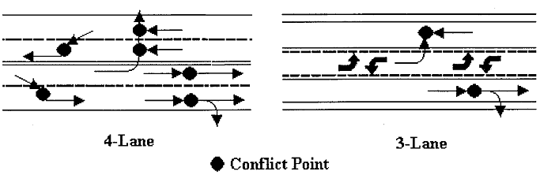
Figure 5.1: Reduced conflict points in a 3-Lane Roadway

The conflicts data was visually collected from watching the tapes. The types of conflicts observed are shown in Appendix A. Very few conflicts occurred in the AM period. Almost all the conflicts occurred in the PM period. The conflicts were observed for every 15-minute interval for the AM and PM periods and the Northbound and Southbound vehicles were tabulated separately. Dividing the total number of observed conflicts with the respective approach volumes and then multiplying the obtained values by 100,000 gives a standard conflict rate. The multiplication by 100,000 results in convenient numbers [8]. Table 5.3 below gives the total conflict rate for the intersection for the before and after condition. The Table 5.4 below gives the conflict rate for the North and South approaches for the before and after condition.
Table 5.3: Conflict Rate for Intersection

Conflict Rate for Intersection
4-Lane Condition |  | 3-Lane Condition
No. Of Conflicts | 11 | No. Of Conflicts | 7
Total App.Vehicles | 34,169 | Total App.Vehicles | 39,253
Conflict Rate | (11/34,169)*100,000  = 32.19 | Conflict Rate | (7/39,253)*100,000  = 17.83
Decrease in Conflict Rate = 44.61%

From Table 5.3 it can be seen that in the four-lane condition the conflict rate is 32.19 conflicts per 100,000 vehicles and for the three-lane condition the rate is 17.83 conflicts per 100,000 vehicles. Hence there is a decrease of 44.61% in conflict rate for the intersection.
Statistical tests were not run to compare the statistical significance of the conflicts for the before and after condition as the number of conflicts observed was very few and a meaningful statistical inference is not possible from the small sample.

Table 5.4: Conflict Rates by Approach

Northbound Vehicles
4-Lane Condition |  | 3-Lane Condition
No. Of Conflicts | 7 | No. Of Conflicts | 3
Total App.Vehicles | 17,149 | Total App.Vehicles | 19,741
Conflict Rate | (7/17,149)*100,000  = 40.81 | Conflict Rate | (3/19,741)*100,000  = 15.19
Decrease in Conflict Rate = 62.77%

Southbound Vehicles
4-Lane Condition |  | 3-Lane Condition
No. Of Conflicts | 4 | No. Of Conflicts | 4
Total App.Vehicles | 17,020 | Total App.Vehicles | 19,512
Conflict Rate | (4/17,020)*100,000  = 23.50 | Conflict Rate | (4/19,512)*100,000  = 20.50
Decrease in Conflict Rate = 12.76%

From Table 5.4 it can be seen that for the northbound vehicles, in the four-lane condition, the conflict rate is 40.81 conflicts per 100,000 vehicles and for the three-lane condition the rate is 15.19 conflicts per 100,000 vehicles. Hence there is a decrease of 62.77% in the conflict rate. For the southbound vehicles, in the four-lane condition the conflict rate is 23.50 conflicts per 100,000 vehicles and for the three-lane condition the rate is 20.50 conflicts per 100,000 vehicles. Hence there is a decrease of 12.76% in conflict rate.
An increase in safety can be logically inferred from the conversion from four-lane to a three-lane configuration. This inferrence is based on reduced conflict points, the literature cited previously and the reduced conflict rates calculated from the videotape observations.
See Appendix-A for the conflict diagrams.

5.3 Statistical Analysis

Statistical analysis techniques were used to test whether the adjusted traffic volumes for the four-lane and the three-lane conditions were statistically similar. Since a comparison is being made between two different roadway conditions, it is essential that the traffic conditions are similar for both conditions; else the comparison made may not be a valid comparison. So before going to the SIDRA analysis a statistical comparison was made of the before (four-lane) and after (three-lane) data sets.
The statistical tests were performed using Statistical Analysis Software (SAS version 6.0 on K-State UNIX System for the evaluation of the Road Diet Concept and for comparison of performance of Road Diet concept, roundabout and traffic signals. First the base assumptions of Normality and Equal Variances were tested for the data sets in order to determine the specific type of statistical test to be used in evaluating the intersection operation using the MOEs described previously. The Table 5.5 presents a summary of the statistical tests.
The first test is the Normality test. The normality of the data set is determined based on the inter quartile range/standard deviation (IQR/S) value and Shapiro Wilk test. The inter quartile range (IQR) is the difference between the first and the third quartile
(i.e 25th and the 75th percentile values) of the data set and is calculated with SAS software. “S” is the standard deviation of the data set, which is also calculated using SAS software. In the first test (IQR/S value) a normal distribution was indicated if the ratio of these two values was near 1.3. For the purpose of this study, this normality indicator was satisfied if the IQR/S was within +/- 55% of the desired value of 1.3. The second test for Normality, the Shapiro-Wilk test, is a sensitive test for smaller data sets and hence an alpha value of 0.01 was chosen to lessen the possibility of false rejection. The test was rejected if the p value was less than the value of alpha (0.01). [9]
The second test is the Equality of Variances test. The equality of variances is tested using Levene’s test. This test is sensitive to normality assumptions and hence an alpha value of 0.01 was chosen for the test. If the p value was found to be less than the alpha value, the test was rejected.
Table 5.5: Summary Of Statistical Tests

Source: “Russell.E.R., Rys M.J., and Luttrell.G., Modeling Traffic Flows and Conflicts at Roundabouts, Mac-Blackwell Report.”
Statistical Test | Inference
NORMALITY TEST
a. – IQR/S ≈ 1.3. | Sample is normally distributed if ≈ 1.3.
b. – Shapiro Wilk P-Value | H_{o}: “Sample is normally distributed”, α=0.01
EQUAL VARIANCES
Levene’s Test | H_{o}: σ²_{4-Lane}= σ²_{3-Lane}, α=0.01
NORMAL W/EQUAL VARIANCES
Analysis Of Variance (ANOVA) F-Test | H_{o}: μ _{4-Lane}= μ _{3-Lane}, α=0.05
 | -Fail to reject H_{o}, Analysis Stops.
-Reject H_{o}, Perform Multiple Comparisons
(Tukey’s and Duncan’s Tests)
NORMAL W/UNEQUAL VARIANCES
Welch’s Test | H_{o}: μ _{4-Lane}= μ _{3-Lane}, α=0.05
 | -Fail to reject H_{o}, Analysis Stops.
-Reject H_{o}, Perform Multiple Comparisons
(Fisher Least Difference Test)
NOT NORMAL
Kruskal-Wallis Test | H_{o}: Population distributions are same, α=0.05
 | -Fail to reject H_{o}, Analysis Stops.
 | -Reject H_{o}, Observe data plots to determine rank order.
IQR: Inter Quartile Range, S: Standard Deviation.

Based on the results of the Normality and the Equality of Variances tests, further tests were conducted. If the sample was found to be Normal and satisfied Equality of Variances, then the equality of the means was tested using the analysis of variance (ANOVA), F-Test. An alpha value of 0.05 was used for this test. If the p value was found to be less than alpha value then the statistical process ended. Failure to reject the null hypothesis meant that the means were considered to be statistically equal. If a rejection of the null hypothesis was made then the means were considered to be unequal. If a rejection was made then the Tukey’s and Duncan’s tests would be used to make a multiple comparison and find out which of the means were different. [9]
If the data was found to be Normally distributed but had Unequal Variances, the equality of the means was tested using the Welch’s test. An alpha value of 0.05 was used for the test. Failure to reject the null hypothesis was rejected meant that the means were considered to be statistically equal. If a rejection was made then, the Fischer Least Difference Test was used to determine which means were statistically different. [9]
If the data was not normally distributed, the Kruskal-Wallis test was used to test whether the data populations were same or not. An alpha value of 0.05 was used for this test. Failure to reject the null hypothesis meant that the means were considered to be statistically equal and the statistical process ends. [9]

5.4 Statistical Analysis Of SIDRA Input (Hourly Traffic Volumes):

The traffic volumes were analyzed in order to check whether the traffic conditions were similar or not for the before and after conditions. The AM and the PM hourly volumes were analyzed separately but the procedures used for evaluation were the same. The results of the analysis are tabulated below in Table’s 5.6 and 5.7.
Table 5.6: Statistical Analysis of AM Hourly Volumes

Statistical Test | Roadway Condition
Normality | 4-Lane | 3-Lane
a. – IQR/S ≈ 1.3. | 1.5 | 1.9
b. – Shapiro Wilk P-Value | 0.662 | 0.071
Normal? | Yes | Yes

Equal Variances
Levene’s Test | P value =0.0001 < α=0.01, Reject.

Normal w/Unequal Variances
Welch’s Test | H_{o}: μ _{4-Lane}= μ _{3-Lane}, α=0.05
 | P value= 0.106 > α=0.05, Fail to Reject.

The AM hourly volumes were normally distributed, but failed the equality of variances using Levene’s test. Since the data is normally distributed with unequal variances, the equality of variances was tested using Welch’s test. The p value was found to be greater than the value of alpha (0.05) and hence we fail to reject the null hypothesis stating that the variances for the four-lane and three-lane roadway conditions (AM period) are equal. Hence the manually revised traffic volume sets for the four-lane and three-lane roadway conditions (AM period) can be considered to be statistically similar.

Table 5.7: Statistical Analysis of PM Hourly Volumes

Statistical Test | Roadway Condition
Normality | 4-Lane | 3-Lane
a. – IQR/S ≈ 1.3. | 1.4 | 1.4
b. – Shapiro Wilk P-Value | 0.575 | 0.574
Normal? | Yes | Yes

Equal Variances
Levene’s Test | P value =0.6833 > α=0.01, Fail to Reject.

Normal w/Equal Variances
Analysis Of Variance (ANOVA) F-Test | H_{o}: μ _{4-Lane}= μ _{3-Lane}, α=0.05
 | P value= 0.103 > α=0.05, Fail to Reject.

The PM hourly volumes were normally distributed and satisfied the equality of variances condition. Since the data is normally distributed with equal variances, the equality of means was tested using analysis of variance (ANOVA), F-Test. The p value was found to be greater than the value of alpha (0.05) and hence we fail to reject the null hypothesis stating that the means for the four-lane and three-lane roadway conditions (PM period) are equal. Hence the manually revised traffic volume sets for the four-lane and three-lane roadway conditions (PM period) can be considered to be statistically similar.
In the next chapters the output from SIDRA are analyzed using the statistical methods described in this chapter. All the six MOEs are evaluated using the same statistical tests. This evaluation will give a clear-cut comparison of the Road Diet concept and whether it is useful to adopt the Road Diet concept, use a modern roundabout or a traffic signal based on the results of comparisons among these three alternatives.

Chapter 6: Results of Statistical Analysis-Road Diet Concept

6.1 Results
The statistical analysis of the MOEs helps determine if and how the four-lane and three-lane roadway conditions differed in operation. The analysis provides information to assess characteristics of the three-lane roadway configuration and the four-lane roadway configuration. The statistical testing was done separately for the AM and PM periods in order to evaluate the operation of the roadway during these separate periods. The overall results of statistical testing and conflict analysis are given in Table 6.1. The discussion of the final results is given in the next chapter.
The results for the AM and PM conditions are also tabulated separately. Refer to Appendix- B for the tabulated results.

Table 6.1: Final Results-Road Diet Concept

Final Results Table
University Place, Washington: 44th and 67th Avenue.
Measures Of Effectiveness |  | AM Period |  |  |  |  |  | PM Period
 |  | 4-Lane |  | 3-Lane |  | St.Diff. |  | 4-Lane |  | 3-Lane |  | St.Diff.
Avg. Intersection Delay (Sec/Veh) |  | 5.2 |  | 6.5 |  | No |  | 7.3 |  | 7.3 |  | No
Max App. Delay -44th Ave. (Sec/Veh) |  | 36.9 |  | 59.4 |  | Yes |  | 70.2 |  | 88.0 |  | No
Avg. Queue Length-44th Ave. (Feet) |  | 19 |  | 33 |  | No |  | 30 |  | 41 |  | No
Avg. Queue Length -67th Ave. (Feet) |  | 11 |  | 1 |  | Yes |  | 18 |  | 2 |  | Yes
Deg. Of Saturation -Intersection (v/c) |  | 0.33 |  | 0.45 |  | No |  | 0.44 |  | 0.55 |  | Yes
Proportion Stopped-Intersection (%) |  | 31 |  | 11 |  | Yes |  | 33 |  | 10 |  | Yes
Max Prop Stopped-44th Avenue (%) |  | 84 |  | 86 |  | No |  | 88 |  | 94 |  | Yes

Conflict Analysis Results
 | Intersection |  |  |  | Northbound Veh. |  |  |  | Southbound Veh.
 | 4-Lane |  | 3-Lane |  | 4-Lane |  | 3-Lane |  | 4-Lane |  | 3-Lane
Number Of Conflicts | 11 |  | 7 |  | 7 |  | 3 |  | 4 |  | 4
Total No. Of Approach Veh. | 6859 |  | 8035 |  | 3316 |  | 4209 |  | 3273 |  | 3826
Conflict Rate | 16.03 |  | 8.71 |  | 21.1 |  | 7.1 |  | 12.2 |  | 10.4
Percentage Change | 45.66 Decrease |  |  |  | 66.35 Decrease |  |  |  | 14.75 Decrease

4 Lane Condition: Two vehicle travel lanes in North and South directions.
3-Lane Condition: One vehicle travel lane North and South, with center two-way left turn lane and, outside bike lanes

Chapter 7: Discussion of Results- Road Diet Concept

7.1 Observations from the Final Results for the AM period:
- The Average Intersection Delay (Seconds/Vehicle) increased by 25% for the three-lane condition. The increase in the delay was anticipated because the three-lane condition had only one through lane for the through vehicles and the right turning vehicles. However, statistical tests showed that the increased delay is not statistically different from the delay that occurred in the four-lane condition.
- The Maximum Approach Delay (Seconds/Vehicle) on the 44th Avenue was 61% higher in the three-lane condition. The Maximum Approach Delay (Seconds/Vehicle) is due to the unavailability of sufficient gaps for the vehicles that are approaching the intersection from the minor approach (44th Avenue). The major approach (67th Avenue) had one through lane dropped in each direction in the three-lane condition and it would be difficult to find more vehicular gaps in this condition than in the four-lane condition. Hence, there was an increase in Maximum Approach Delay (Seconds/Vehicle). Statistical tests showed that this increase is significantly higher than the delay that occurred in the four-lane condition.
- There was a 77% increase in the Average Queue Length (ft) on the minor approach (44th Avenue) in the three-lane condition. This increase on the minor approach (44th Avenue) is likely due to the unavailability of sufficient gaps for the vehicles approaching the intersection from this minor approach (44th Avenue). Statistical tests showed that this increase is significantly higher from the average queuing that occurred in the four-lane condition.
- There was a 91% decrease in the Average Queue Length (ft) on the major approach (67th Avenue) in the three-lane condition. This decrease on the major approach (67th Avenue) is likely due to the separation of the left-turning vehicles from the through and right-turning vehicles. Statistical tests have shown that this decrease is significantly lower than the average queuing that occurred in the four-lane condition.
- There was a 37% increase in the Degree Of Saturation (v/c) in the three-lane condition. This measure gives us the amount of capacity that is consumed by the existing traffic loading, and thus, is a measure of congestion. This factor is very important as it is a measure of whether the three-lane condition is handling the traffic as well as the four-lane condition or not. Statistical tests show that this increase is not significantly different from the Degree Of Saturation (v/c) in the four-lane condition. Hence the three-lane condition is handling the traffic as well as the four-lane condition.
- There was a 66% decrease in Proportion Of Vehicles Stopped (%) in the three-lane condition. Statistical tests showed that this decrease is significantly higher from the Proportion Of Vehicles Stopped (%) in the four-lane condition.
- There was a 2% increase in Maximum Proportion Of Vehicles Stopped (%) in the three-lane condition. The increase in Maximum Proportion Of Vehicles Stopped (%) at the intersection is likely due to the insufficient gaps and increased queuing on the minor approach (44th Avenue). The reasons for insufficient gaps have been explained earlier. Statistical tests showed that this increase is not significantly different from the Maximum Proportion Of Vehicles Stopped (%) in the four-lane condition.

7.2 Observations from the Final Results for the PM period:
- There was no significant change in Average Intersection Delay (Seconds/Vehicle) in the three-lane condition.
- The Maximum Approach Delay (Seconds/Vehicle) on the 44th Avenue increased by 25% in the three-lane condition. The Maximum Approach Delay (Seconds/Vehicle) is likely due to the unavailability of sufficient gaps for the vehicles that are approaching the intersection from the minor approach (44th Avenue). The major approach (67th Avenue) had one through lane dropped in each direction in the three-lane condition and it would be difficult to find more vehicular gaps to in this condition than in the four-lane condition, thus there is an increase in Maximum Approach Delay (Seconds/Vehicle). Statistical tests showed that this increase is not significantly different from the delay that occurred in the four-lane condition.
- There was a 36% increase in the Average Queue Length (ft) on the minor approach (44th Avenue) in the three-lane condition. This increase on the minor approach (44th Avenue) is likely due to the unavailability of sufficient gaps for the vehicles approaching the intersection from this minor approach (44th Avenue). Statistical tests showed that this increase is significantly higher than the average queuing that occurred in the four-lane condition.
- There was a 91% decrease in the Average Queue Length (ft) on the major approach (67th Avenue) in the three-lane condition. This decrease on the major approach (67th Avenue) is likely due the separation of the left-turning vehicles from the through and right-turning vehicles. Statistical tests have shown that this decrease is significantly lower than the average queuing that occurred in the four-lane condition.
- There was a 26% increase in the Degree Of Saturation (v/c) in the three-lane condition. This measure gives us the amount of capacity that is consumed by the existing traffic loading, and thus, is a measure of congestion. This factor is very important as we can decide whether the three-lane condition is handling the traffic as well as the four-lane condition or not. Statistical tests have shown that this increase is not significantly different from the Degree Of Saturation (v/c) in the four-lane condition. Hence the three-lane condition is handling the traffic as well as the four-lane condition.
- There was a 71% decrease in Proportion Of Vehicles Stopped (%) in the three-lane condition. Statistical tests showed that this decrease is significantly lower from the Proportion Of Vehicles Stopped (%) in the four-lane condition.
- There was a 6% increase in Maximum Proportion Of Vehicles Stopped (%) in the three-lane condition. The increase in Maximum Proportion Of Vehicles Stopped (%) at the intersection is likely due to the insufficient gaps and increased queuing on the minor approach (44th Avenue). The reasons for insufficient gaps have been explained earlier. Statistical tests showed that this increase is not significantly different from the Maximum Proportion Of Vehicles Stopped (%) in the four-lane condition.

Chapter 8: Comparison of operational performance of Road Diet Concept, Modern Roundabout and Traffic Signal

8.1 Introduction
The second objective of this research is to see if a modern roundabout or a traffic signal would have been better than the “Road Diet” concept that was implemented at the intersection studied. The intersection of 67th Avenue and 44th street has Two Way Stop Signs as intersection traffic control. In order to test the second objective, the traffic volumes obtained in the after condition were used. The traffic volumes were incremented by 25% and 50% and the operational performance of the intersection traffic controls was evaluated. This was done to observe the performance of Road Diet concept, modern roundabout and traffic signal for various levels of traffic volumes. The traffic signals were compared only with the incremented volume data sets. This was done because the original volume set does not meet the signal warrants and hence traffic signals were not used in comparison for this volume set.

8.2 Roundabout Design
A single-lane roundabout was designed based on the Federal Highway Administration’s roundabout design guide [19], for the existing intersection geometry and traffic conditions. The selected design has the following properties:
- A Single-Lane Roundabout,
- The Inscribed Circle Diameter is 115 feet,
- The Circulating Width is 16 feet (This value is taken because SIDRA has fixed upper and lower limits for circulating lane widths and 16 is the lower limit),
- The truck apron is 9 feet (This was based on the design vehicle requirements a WB-50, which requires a minimum of 25 feet for maneuvering the roundabout. Since the circulating lane is 16 feet wide the remaining 9 feet is provided using a truck apron.

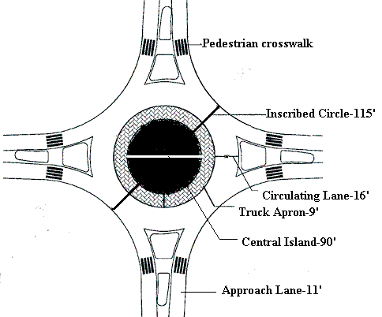
Figure 8.1: Roundabout Selected for the Intersection of 67th Avenue and 44th Street

8.3 Traffic Signal Design
After incrementing the traffic volumes by 25%, the signal warrants in the MUTCD are met. The intersection of 67th avenue and 44th Street has a major and a minor approach (67th Avenue- Major approach, 44th Street- Minor Approach). Hence a semi-actuated signal system had been selected for the intersection. Also SIDRA gives the option of specifying individual approach movements as coordinated or non-coordinated which helps in better handling of semi-actuated type of signals. In this case all the movements were specified as coordinated movements. For this type of signal system, the green split, priority method applies. SIDRA will set all coordinated movements as high priority movements for the purpose of green split calculations.
Cycle time can be specified for the program to determine green splits. For program determined cycle times the user can have the program calculate the cycle times by specifying a lower limit (c_{L}) and an upper limit (c_{U}) and a cycle increment (Δc). The program determines a list of cycle times as provided the lower limit is greater than the minimum cycle time (c_{L}> c_{min}). If the lower limit is less then the minimum cycle time calculated by the program (c_{L}< c_{min}), then c_{L} = c_{min} is set. The upper limit is set to 60 seconds, as this low value generally minimizes delays. [6]
Since Program option “P” is chosen for the cycle time setting, the program itself also calculates phasing.

Chapter 9: Results of Statistical Analysis-Comparison of operational performance of Road Diet Concept, Modern Roundabout and Traffic Signal

9.1 Results
The statistical analysis of the MOEs helps determine if and how the Road Diet Concept (with Two Way Stop Signs as intersection control), Modern Roundabout and Traffic Signal would have differed in operation for the various increased levels of traffic. The analysis provides information to assess the advantages/disadvantages of adopting Road “Dieting”, Modern Roundabout or Traffic Signals. The statistical testing of the SIDRA output for each alternative was done separately for the AM and PM period as was done in the earlier chapters. The overall results of statistical testing for the comparisons are given in Table 9.1 and 9.2. If the data sets are not statistically similar then, based on the average values of the data sets, a ranking of the alternatives is given and a relationship is established. The data set with the “best” value (the one with the least average value) is given the best rank and the values are arranged in an ascending order starting from the least value to the highest value.
Figure 9.1and 9.2 gives the graphical representation of the performance of the Road Diet Concept, Modern Roundabout and Traffic Signal for the six MOEs analyzed. From the graph the trend for further volume increments can be inferred.
The results are discussed below in Chapter 10.
Table 9.1: Final Results: Comparison Of Measures Of Effectiveness - A.M Period
Measures Of Effectiveness | Original Volume
 | 4-Lane |  | 3-Lane |  | R.A |  | Relation
Average Intersection Delay (Sec/Veh) | 5.2 |  | 6.5 |  | 4.9 |  | Statistically Similar
Maximum Approach Delay (Sec/Veh) | 36.9 |  | 59.4 |  | 9.7 |  | R.A<4-Lane<3-Lane*
95% Queue Length (Feet) | 58 |  | 102 |  | 134 |  | 4-Lane<3-Lane<R.A*
Degree Of Saturation (V/C) | 0.33 |  | 0.45 |  | 0.32 |  | Statistically Similar
Proportion Of Vehicles Stopped (%) | 31 |  | 11 |  | 20 |  | 3-Lane<R.A<4-Lane*
Max. Proportion Of Vehicles Stopped (%) | 84 |  | 86 |  | 70 |  | R.A<4-Lane<3-Lane*
Measures Of Effectiveness | 25% Incremented Volume
 | 4-Lane | 3-Lane |  | R.A |  | Signal | Relation
Average Intersection Delay (Sec/Veh) | 12.3 | 10.9 |  | 5.3 |  | 7.8 | R.A<Signal<3-Lane<4-Lane*
Maximum Approach Delay (Sec/Veh) | 105.9 | 105.9 |  | 13.2 |  | 19.7 | R.A<Signal<3-Lane=4-Lane*
95% Queue Length (Feet) | 188 | 158 |  | 193 |  | 309 | 3-Lane<4-lane<R.A<Signal*
Degree Of Saturation (V/C) | 0.61 | 0.62 |  | 0.41 |  | 0.56 | R.A<Signal<4-Lane<3-Lane*
Proportion Of Vehicles Stopped (%) | 34 | 11 |  | 24 |  | 55 | 3-Lane<R.A<4-Lane<Signal*
Max. Proportion Of Vehicles Stopped (%) | 90 | 86 |  | 82 |  | 78 | Statistically Similar
Measures Of Effectiveness | 50% Incremented Volume
 | 4-Lane | 3-Lane |  | R.A |  | Signal | Relation
Average Intersection Delay (Sec/Veh) | 32.2 | 30.7 |  | 5.9 |  | 9 | R.A<Signal<3-Lane<4-Lane*
Maximum Approach Delay (Sec/Veh) | 293.2 | 312.6 |  | 19.2 |  | 20.6 | R.A<Signal<4-Lane<3-Lane*
95% Queue Length (Feet) | 445 | 445 |  | 274 |  | 430 | R.A<Signal<3-Lane=4-Lane*
Degree Of Saturation (V/C) | 1.17 | 1.17 |  | 0.51 |  | 0.66 | R.A<Signal<3-Lane=4-Lane*
Proportion Of Vehicles Stopped (%) | 38 | 12 |  | 28 |  | 60 | 3-Lane<R.A<4-Lane<Signal*
Max. Proportion Of Vehicles Stopped (%) | 96 | 96 |  | 90 |  | 81 | Signal<R.A<3-Lane=4-Lane*
* All differences indicated by < are statistically significant
Table 9.2: Final Results: Comparison Of Measures Of Effectiveness - P.M Period
Measures Of Effectiveness | Original Volume
 | 4-Lane |  | 3-Lane |  | R.A |  | Relation
Average Intersection Delay (Sec/Veh) | 7.3 |  | 7.3 |  | 4.9 |  | R.A<3-Lane=4-Lane*
Maximum Approach Delay (Sec/Veh) | 70.2 |  | 88 |  | 10.4 |  | R.A<4-Lane<3-Lane*
95% Queue Length (Feet) | 93 |  | 146 |  | 170 |  | 4-Lane<3-Lane<R.A*
Degree Of Saturation (V/C) | 0.44 |  | 0.55 |  | 0.36 |  | R.A<4-Lane<3-Lane*
Proportion Of Vehicles Stopped (%) | 33 |  | 10 |  | 20 |  | 3-Lane<R.A<4-Lane*
Max. Proportion Of Vehicles Stopped (%) | 88 |  | 94 |  | 72 |  | R.A<4-Lane<3-Lane*
Measures Of Effectiveness | 25% Incremented Volume
 | 4-Lane | 3-Lane |  | R.A |  | Signal | Relation
Average Intersection Delay (Sec/Veh) | 12.3 | 10.9 |  | 5.3 |  | 7.8 | R.A<Signal<3-Lane<4-Lane*
Maximum Approach Delay (Sec/Veh) | 105.9 | 105.9 |  | 13.2 |  | 19.7 | R.A<Signal<3-Lane=4-Lane*
95% Queue Length (Feet) | 188 | 158 |  | 193 |  | 309 | 3-Lane<4-lane<R.A<Signal*
Degree Of Saturation (V/C) | 0.61 | 0.62 |  | 0.41 |  | 0.56 | R.A<Signal<4-Lane<3-Lane*
Proportion Of Vehicles Stopped (%) | 34 | 11 |  | 24 |  | 55 | 3-Lane<R.A<4-Lane<Signal*
Max. Proportion Of Vehicles Stopped (%) | 90 | 86 |  | 82 |  | 78 | Statistically Similar
Measures Of Effectiveness | 50% Incremented Volume
 | 4-Lane | 3-Lane |  | R.A |  | Signal | Relation
Average Intersection Delay (Sec/Veh) | 32.2 | 30.7 |  | 5.9 |  | 9 | R.A<Signal<3-Lane<4-Lane*
Maximum Approach Delay (Sec/Veh) | 293.2 | 312.6 |  | 19.2 |  | 20.6 | R.A<Signal<4-Lane<3-Lane*
95% Queue Length (Feet) | 445 | 445 |  | 274 |  | 430 | R.A<Signal<3-Lane=4-Lane*
Degree Of Saturation (V/C) | 1.17 | 1.17 |  | 0.51 |  | 0.66 | R.A<Signal<3-Lane=4-Lane*
Proportion Of Vehicles Stopped (%) | 38 | 12 |  | 28 |  | 60 | 3-Lane<R.A<4-Lane<Signal*
Max. Proportion Of Vehicles Stopped (%) | 96 | 96 |  | 90 |  | 81 | Signal<R.A<3-Lane=4-Lane*
* All differences indicated by < are statistically significant
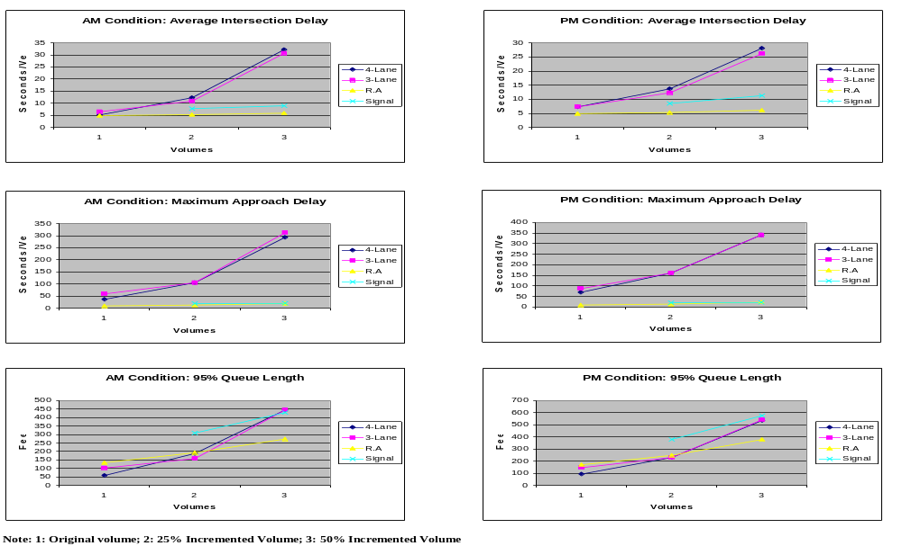
Figure 9.1: Graphical representation of results

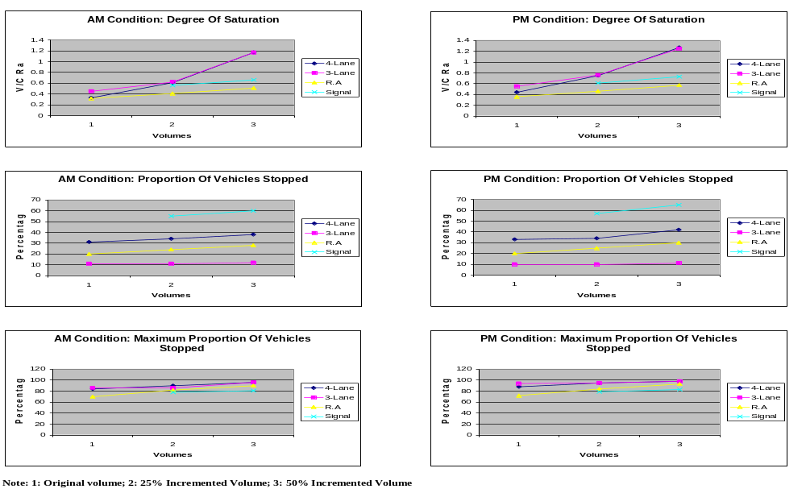
Figure 9.2: Graphical representation of results contd..

Chapter 10: Discussion of Results- Comparison of operational performance of Road Diet Concept, Modern Roundabout and Traffic Signal

10.1 Observations from the results for AM period
- The Average Intersection Delay (seconds/vehicle) is statistically similar for the original volumes for all alternatives. For the incremented volumes the roundabout gives the least delay when compared to the others. It gives a statistically significant difference in delays from the other options for the incremented traffic volumes. See Figure 9.1 for a plot of the results.
- The Maximum Approach Delay (seconds/vehicle) is least when a modern roundabout is used for the original and the incremented volumes. The signal delay values are close to the roundabout delay values. The roundabout and traffic signals give statistically significant differences in delay when compared to road diet for the original and incremented traffic volumes. See Figure 9.1 for a plot of the results.
- The 95% Queue Length is least for the 4-Lane configuration in the case of original volume, least for the 3-Lane configuration in the case of 25% incremented volume and least for roundabout in the case of 50% incremented volume. The differences are statistically significant for the original and incremented traffic volumes. See Figure 9.1 for a plot of the results.
- The Degree Of Saturation (v/c) is statistically similar for the original volumes. For the incremented volumes the roundabout gives the least value, which is statistically significant when compared to the others. See Figure 9.1 for a plot of the results.
- The Proportion Of Vehicles Stopped (%) is least when the 3-Lane configuration is adopted for the original and the incremented volumes. The 3-Lane configuration gives values, which are considerably better than the others. The differences are statistically significant for the original and incremented traffic volumes. See Figure 9.1 for a plot of the results.
- The Maximum Proportion Of Vehicles Stopped (%) is least when a modern roundabout is used for the original volume. For the 25% incremented volume the results are statistically similar. For the 50% incremented volume the signal gives the best result. The differences are statistically significant for the original and incremented traffic volumes. See Figure 9.1 for a plot of the results.

10.2 Observations from the results for PM period
- The Average Intersection Delay (seconds/vehicle) is least when a modern roundabout is used for the original and the incremented volumes. The values given by the roundabout are very less compared to the others. The differences are statistically significant for the original and incremented traffic volumes. See Figure 9.2 for a plot of the results.
- The Maximum Approach Delay (seconds/vehicle) is least when a modern roundabout is used for the original and the 25% incremented volume. For the 50% incremented volume the signals give the least value. The signal delay values are close to the roundabout delay values. The differences are statistically significant for the original and incremented traffic volumes. See Figure 9.2 for a plot of the results.
- The 95% Queue Length is least for the 4-Lane configuration in the case of the original traffic volume, least for the 3-Lane configuration and 4-Lane configuration (same result) in the case of the 25% incremented volume and statistically similar in the case of 50% incremented volume. The differences are statistically significant for the original and incremented traffic volumes. See Figure 9.2 for a plot of the results.
- The Degree Of Saturation (v/c) is least for the modern roundabout for the original and incremented volumes. The differences are statistically significant for the original and incremented traffic volumes. See Figure 9.2 for a plot of the results.
- The Proportion Of Vehicles Stopped (%) is least when the 3-Lane configuration is adopted for the original and for the incremented volumes. The 3-Lane configuration gives values, which are considerably better than the others. The differences are statistically significant for the original and incremented traffic volumes. See Figure 9.2 for a plot of the results.
- The Maximum Proportion Of Vehicles Stopped (%)is least when a modern roundabout is used for the original and incremented volumes. The differences are statistically significant for the original and the 50% incremented traffic volumes. For 25% incremented volumes they are statistically similar. See Figure 9.2 for a plot of the results.

Chapter 11: Conclusion

11.1 Conclusions from the research for the Road Diet Concept
- The total numbers of vehicle conflicts were reduced.
- Based on the videotape data analysis, there was a decrease in the conflict rate for the three-lane configuration. Conflicts have long been considered a valid surrogate for crashes; therefore, the three-lane configuration should experience less crashes.
- There is an increase in the Average Intersection Delay (Seconds/Vehicle) in the three-lane condition. However, this increase was observed only for the AM period and the increase was not statistically significant. There was no change for the PM period, i.e., results were statistically similar.
- There was an increase in the Maximum Approach Delay (Seconds/Vehicle) in the three-lane condition for both the AM and PM periods but the increase was statistically significant only for the AM period and not statistically significant for the PM period.
- There was an increase in the Average Queue Length (feet) in the three-lane condition on the minor approach (44th Avenue) for both the AM and PM periods but neither increase was statistically significant.
- There was a decrease in the Average Queue Length on the major approach (67th Avenue) for both AM and PM periods and the decrease was statistically significant for both the AM and PM periods.
- There was an increase in the Degree Of Saturation (v/c) for the three-lane condition in both the AM and PM periods. The increase was statistically significant for the PM period but not statistically significant for the AM period.
- There was a decrease in Proportion Of Vehicles Stopped (%) at the intersection in the after condition for both AM and PM periods and the decrease was statistically significant for both the AM and PM periods.
- There was an increase in the Maximum Proportion Of Vehicles Stopped (%) on the minor approach (44th Avenue) for both AM and PM periods. The increase was statistically significant for the PM period but not statistically significant for the AM period.

11.2 Conclusions from the comparisons of Road Diet Concept, Modern Roundabout and Traffic Signals
- For the original traffic volumes the single-lane modern roundabouts’ performance is better compared to the road diet concept for four out of six MOEs. Of the remaining two the 4-Lane configuration works better for one and the 3-Lane configuration for the other. So for the original traffic volumes a single-lane modern roundabout would have performed best.
- As the traffic volumes increase by 25% and 50% the modern roundabout performs better than the others in most of the cases except for the Proportion of Vehicles Stopped and Maximum Proportion of Vehicles Stopped. For the Proportion of Vehicles Stopped the Road Diet Concept would have performed best for both 25% and 50% incremented traffic volumes. The results for Maximum Proportion of Vehicles Stopped for the 25% incremented traffic volumes are statistically similar and for 50% incremented traffic volumes the Signal would have performed best.
- From the comparison it can be concluded that a modern roundabout would have given the best results at this intersection, when compared to the Road Diet Concept and traffic signals.

11.3 Overall Conclusion
The conclusions of this research are based on the data collected from one location and may not apply to all situations. This research demonstrates a methodology to demonstrate the benefits of a three-lane roadway configuration vs. a four-lane roadway configuration and operational performance of two other types of Intersection Control; namely a single-lane modern roundabout and traffic signals.
The decrease in conflict rate, likely enhancement of pedestrian and bicycle safety (due to decrease in number of conflict points and separate bike lanes in each direction), and the effective or almost equal operational performance of the three-lane configuration compared to the four-lane configuration, all suggest that the three-lane roadway configuration can be adopted as a viable, safer alternative to the problematic undivided four-lane roadway configurations.
The study suggests that modern roundabouts may be a better alternative when compared to Road Diet Concept and traffic signals, at intersection with conditions and traffic loading similar to those at the intersection in this study.

Chapter 12: References

- Knapp, K.K., Welch.T.M. and Witmer.J.A., Converting Four Lane Undivided Roadways to a Three-Lane Cross Section: Factors to Consider, ITE Annual Meeting,1999.
- Kanpp, K.K., Guidelines For The Conversion Of Urban Four-Lane Undivided Roadways To Three-Lane Two-Way Left-Turn Lane Facilities, Final Report, Center For Transportation Research and Education, Iowa State University, April 2001.
- Walton, C.M., et.al. Accident and Operational Guidelines for Continuous Two Way Left Turn Median Lanes, Transportation Research Record 923, Transportation Research Board, National Research Council, Washington, DC, 1983, pp. 43-54.
- Nemeth, Z.A. Two Way Left-Turn Lanes: State-of-the-Art Overview and Implementation Guide, Transportation Research Record 681, Transportation Research Board, National Research Council, Washington, DC, 1978, pp. 62-69.
- Harwood,D.W. Multilane Design Alternatives for Improving Suburban Highways, National Cooperative Highway Research Program 282, Transportation Research Board, National Research Council, Washington, DC, March 1986.
- Glauz W.D., and Migletz D.J., Application Of Traffic Conflict Analysis At Intersections, National Cooperative Highway Research Program 219, Transportation Research Board, National Research Council, Washington, DC, March 1980.
- aaSIDRA 1.0 Manual, Akcelik and Associates Pty Ltd, Australia
- Russell.E.R., and Mulinazzi.T., Identification, Analysis and Correction of High-Accident Locations, TASK Assistance Services For Kansas, Second Edition-1994.
- Russell.E.R., Rys M.J., and Luttrell.G., Modeling Traffic Flows and Conflicts at Roundabouts, Mac-Blackwell Report.
- Burden.D, Lagerwey.P.,“ Road Diets: Fixing the Big Roads”, Walkable Communities, Inc., March 1999.
- Turner Fairbank Highway Research Center- Safety Research.
- Flannery, A. and T.K. Datta. “Modern Roundabouts and Traffic Crash Experience in the United States.” Transportation Research Record 1553, Transportation Research Board, National Research Council, Washington, DC, 1996.
- San Diego Earth Times, “Roundabouts sharply reduce crashes”, Article by Insurance Institute For Highway Safety, May 2001.
- Arizona Department Of Transportation “Are Traffic Signals Really a Cure-All?”, Website http://www.dot.state.az.us/ROADS/traffic/signal.htm.
- Flannery. A. “Geometric Design and Safety aspects of Roundabouts.” Transportation Research Record 1751, Transportation Research Board, National Research Council, Washington, DC, 2001.
- Persaud N.B., et.al., “ Safety Effect of Roundabout conversions in the United States.” Transportation Research Record 1751, Transportation Research Board, National Research Council, Washington, DC, 2001.
- Sisiopiku V.P. and Un-Oh H. “ Evaluation of Roundabout Performance Using SIDRA” Journal Of transportation Engineering, March/April 2001.
- McShane W.R., Roess R.P., Prass E.S. “ Traffic Engineering- second edition”, Prentice Hall, 1998.
- Robinson, B., et.al., “Roundabouts: An Informational Guide”, Federal Highway Administration, Washington, D.C, 2000

Appendices

Appendix A: Conflict Diagrams
Appendix B: SIDRA Output and Turning Movements

Appendix A: Conflict Diagrams

Conflict Diagrams

4-Lane Condition: AM Period

Conflict 1: (Vehicles North Bound) [7/28/00, 8:33 A.M]

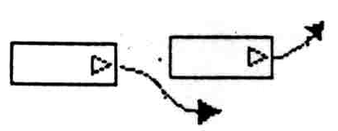

The vehicle in the front stopped to turn left into the driveway located south of the study intersection.

4-Lane Condition: PM Period

Conflict 1: (Vehicles North Bound) [7/27/00, 2:14 P.M]

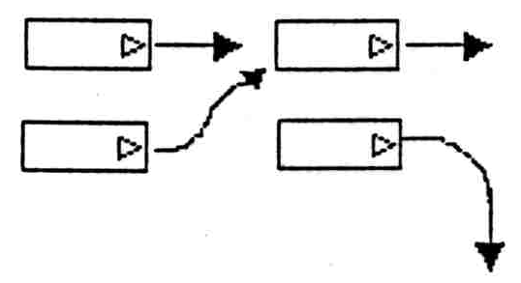

Conflict 2: (Vehicles North Bound) [7/27/00, 3:00 P.M]

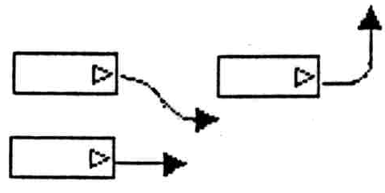

Conflict 3: (Vehicles North Bound) [7/27/00, 3:15 P.M]

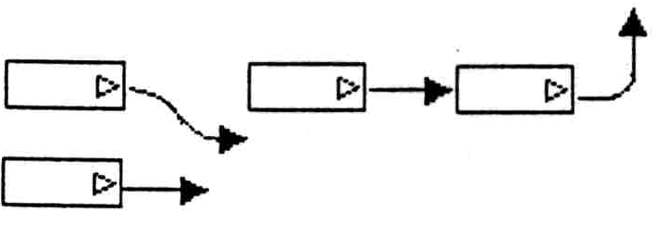

Conflict 4: (Vehicles North Bound) [7/31/00, 4:13P.M]

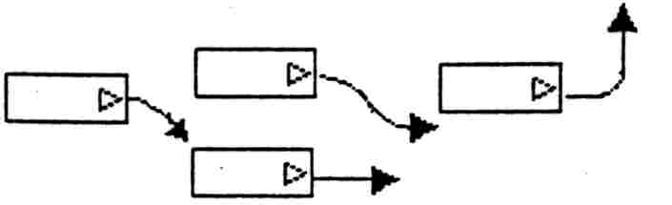

Conflict 5: (Vehicles North Bound) [7/31/00, 4:37P.M]

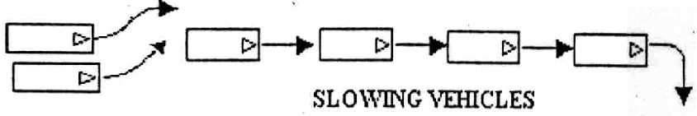

Conflict 6: (Vehicles North Bound) [7/31/00, 4:51P.M]

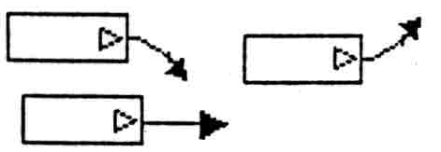

Conflict 7: (Vehicles South Bound) [7/31/00, 5:01P.M]

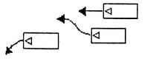

Conflict 8: (Vehicles South Bound) [8/1/00, 4:08P.M]

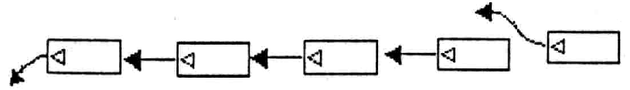

Conflict 9: (Vehicles South Bound) [8/1/00, 5:30P.M]

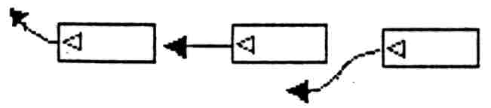

Conflict 10: (Vehicles South Bound) [8/1/00, 5:35P.M]

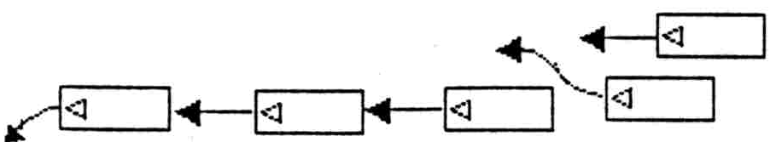

3-Lane Condition: AM Period

Conflict 1: (Vehicles South Bound) [9/27/00, 9:02 A.M]

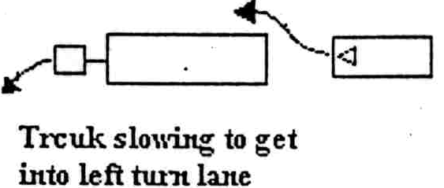

3-Lane Condition: PM Period

Conflict 1: (Vehicles North Bound) [9/28/00, 5:07P.M]

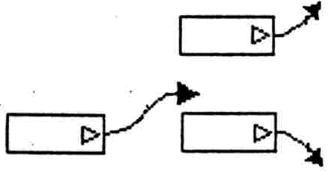

Conflict 2: (Vehicles South Bound) [9/29/00, 5:52P.M]

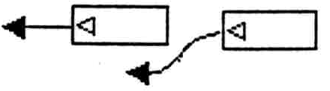

Conflict 3: (Vehicles South Bound) [9/29/00, 5:19P.M]

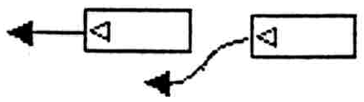

Conflict 4: (Vehicles North Bound) [9/28/00, 5:10P.M]

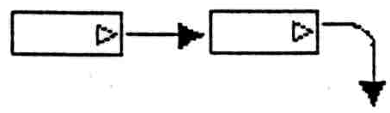

Conflict 5: (Vehicles South Bound) [10/02/00, 2:26P.M]

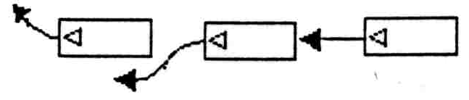

Conflict 6: (Vehicles North Bound) [10/02/00, 3:39P.M]

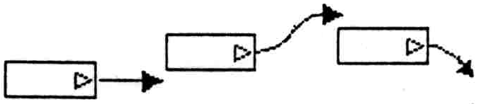

Appendix B: SIDRA Output and Turning Movements

Table B1: AM Final Results

Table B2: Comparison of AM Hourly Counts and Measures Of Effectiveness

Table B3: PM Final Results

Table B4: Comparison of PM Hourly Counts and Measures Of Effectiveness

Table B5: AM Original Volume-Measures Of Effectiveness Comparison

Table B6: PM Original Volume-Measures Of Effectiveness Comparison

Table B7: AM 25% Incremented Volume-Measures Of Effectiveness Comparison

Table B8: PM 25% Incremented Volume-Measures Of Effectiveness Comparison

Table B9: AM 50% Incremented Volume-Measures Of Effectiveness Comparison

Table B10: PM 50% Incremented Volume-Measures Of Effectiveness Comparison

Table B-11: Turning Movements AM Original Volume

Table B-12: Turning Movements AM 25% Incremented Volume

Table B-13: Turning Movements AM 50% Incremented Volume

Table B14: Turning Movements PM Original Volume

Table B15: Turning Movements PM 25% Incremented Volume

Table B16: Turning Movements PM 50% Incremented Volume

